Conceptual Framework for Assuring all BPA Fish Data is Secured in an Approved Data Repository
StreamNet, in cooperation with other interested parties and PNAMP/Monitoring Methods.org, will update and PNAMP should maintain a list of “approved environmental information repositories” for archiving fish metric data from Bonneville Projects.
https://www.monitoringresources.org/Resources/DataRepository/Index
When BPA requires contractors to archive data, specific lists of repositories should be developed for certain types of data (by geography, species, data type, etc.). The repository details page on Monitoring Resources for each repository could specify something like “BPA recommended repository for fish metric data collected by MFWP staff implementing BPA projects”. It may be possible to autopopulate some details page entries with this type of information;
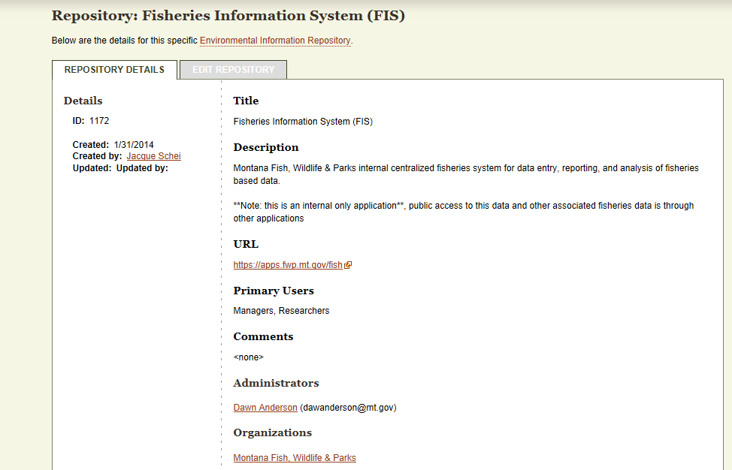
A list of repository recommendations for storing BPA funded data would be developed during 2015 by StreamNet, PNAMP, and CRITFC, with input and consensus from partner agencies and tribes. Mapping of work elements, metrics, and repositories to recommended repositories would be reviewed by StreamNet, PNAMP, and CRITFC staff, with technical recommendations made to BPA for implementation via the Pisces system. Programing and directions should be implemented to avoid “unapproved” repositories appearing on such lists, data projects without repositories listed, “page not found” messages in cbfish, and other such problems. Specifically, unacceptable entrees like “Pisces, Repository #51” should not be permitted as entrees under this system. If you would like StreamNet assistance with QA/QC as contractors are entering information, we could discuss such a role
Implementation of repository direction could begin in calendar year 2016 as contracts are approved. The list of recommended repositories and detailed specifics would be maintained by PNAMP. This list would be referenced and linked on StreamNet, provided instructionally to contractors by BPA, and populate drop-down lists in Pisces when work elements were identified that would likely produce fish data.
The simplest way this might work would be as the contractor entered information in Pisces they would indicate the type of data produced by general category, via Pisces drop down menu. The contractor would identify a repository or repositories specific to each work element from a drop down list in Pisces. As an example, if a project was a sturgeon adult survey conducted by MFWP staff, when they entered Work Element: 158 - Mark/Tag Animals, their data would be given a unique number, and a drop down menu would allow them to select Repository 1172 (along with other possible acceptable selections), and the information tab on Monitoring Resources would indicate that the Montana Fisheries Information System is the recommended repository for this data.
StreamNet would function both as a repository manager for the Data Store, traditional data sets, and CA data; and assist PNAMP (and potentially BPA and contractors) as QA/QC staff for the data repository mapping system, and to help to maintain a dialog between BPA, contractors, and others to ensure that the primary functions of data security and accessibility were efficiently implemented.

