Section 7 Project Narrative
7.1 Project Goals, Outputs and Outcomes
This application proposes the expansion of the existing multi-state Salmonid Coordinated Assessment Data Exchange (SCADE-CAX) to include additional geographic areas, broader partnerships, and additional population metrics and high level indicators. SCADE was developed under a previous 2014 EPA grant # 83546401, in support of a regional Columbia River watershed data sharing effort, the Coordinated Assessments (CA) project. The Coordinated Assessments data exchange (CAX) defines the framework by which the fish and wildlife agencies and tribes compile and provide data for salmon and steelhead populations for access through the EPA data exchange network. The overarching goal of the CA project is to improve the timeliness, reliability, flow, and transparency of data necessary for regional assessments and management decisions for improved environmental effectiveness, including support for biological opinions that affect state and federal agencies. The Pacific Northwest Aquatic Monitoring Partnership (PNAMP) and the Pacific States Marine Fisheries Commission (PSMFC) StreamNet project have collaborated to coordinate the CA project with a 14 member CA Planning Group (CAPG) providing overall leadership. The members represent 4 states, 5 Indian tribes, an inter-tribal consortium, and multiple federal regulatory agencies, all with an interest in collaboratively sharing fish population data for the Columbia River watershed. The federal Columbia River action agencies and fisheries co-managers have also participated through the CA Working Group; comprised of over fifty additional biologists and data managers across the Columbia River Basin representing 26 different tribal, state, federal, and academic organizations. This work benefits from existing facilitation framework provided by StreamNet, PNAMP and substantial cost share contributions from the Bonneville Power Administration.
As work has progressed on the CA project, it has become evident that the greatest need for supporting a salmon and steelhead data exchange is the development of back end enterprise data systems and data management processes within the individual state and tribal organizations necessary for calculating and deriving the VSP indicators. The initial EPA grant (83546401) provided the incentive and opportunity for the states and tribes to begin modifying their systems to support uniform regional reporting of salmon and steelhead indicators. These efforts are significant and require time and resources to implement. With the establishment of the virtual node at StreamNet (CAX) for four VSP indicators for populations in the Columbia River Basin, the agencies and tribes are now ready to expand their work to a larger geographic area, share a broader range of data, include additional partners, and provide support to partners with developing systems.
A key output of the CA effort to date has been the development of an agreed upon data exchange standard (DES) describing the data exchange templates (DETs) for specific data elements needed to support the exchange of four VSP indicators and supporting metrics. These include: natural origin spawner abundance, smolt to adult ratio, and recruit per spawner (adult and juvenile). The DETs for these indicators were developed with wide participation of the larger working group, first through an extensive pilot program to document data flows and availability of the indicator and supporting metrics conducted with Oregon, Washington, and Idaho state agencies, six Columbia River Basin tribes, and one tribal coalition (Columbia River Inter-Tribal Fisheries Commission). This was followed by intensive focus on refining the draft DES by a development team consisting of data management and resource management expertise. The draft DES was then vetted and approved by the CA Working Group for implementation. This DES and the partnership behind it demonstrated the feasibility of successful implementation of data flows, given that work has been completed on data exchange mechanisms for these indicators, without the need to start from scratch on DET development. Documentation for the specific DETs and supporting materials can be found here: http://www.streamnet.org/caxct.html. The DETs for the four Coordinated Assessment indicators are also attached in file: CoordinatedAssessmentsDESv1-0 2012-11-01.pdf. Expansion of the CAX to include additional indicators will be possible due to the initial efforts of the CA Project. Documentation of all project plans and activities may be found on the PNAMP website here: http://www.pnamp.org/project/3129.

The CA project is designed to improve access to environmental information through the creation and maintenance of a standardized database for key fish population metrics for major populations of listed and non-listed salmonids. This information can be shared across multiple agencies and jurisdictions in a common format and with improved efficiencies via the created Web services and application programming interfaces (APIs) that make data available in XML and other standard machine-readable formats. Data is shared across programs within the data collecting organizations, between agencies and tribes, and is available to the public, action agencies, and the courts, all of whom are directly involved in expensive and complex management and regulatory arrangements which are made possible and streamlined through this data management approach.
The current application envisions continuation of the CA project structure supported in EPA grant 83546401, which was structured as a partnership agreement. This structure has successfully resulted in the completion of several major cross-partner infrastructure components. These components included:
- XML Schema and associated documentation
- Flow Configuration Document
- Tribal Data Management Assessment and Coordination
- Development of an integrated repository and web service publishing platform

The current proposal expands the partnership agreement to new geographic areas, additional metrics and indicators, and incorporation of additional professionals in the network via expanded partnerships.
The project will improve access to fisheries population information for federal and state regulatory staff responsible for the recovery of listed stocks of salmonids, who need up to date information to inform ESA implementation decisions that cross federal/state/tribal agency jurisdictions. The shared data system will also allow all fish and wildlife managers, stakeholders, and the public transparent access to information used in decision making. Web services and APIs will make data available in XML format across programs within partner organizations and across agency, state, and tribal lines.
This grant will extend implementation of the virtual node (CAX) to additional geographic areas within the partner States and Tribes, as well as to new communities of interest as additional indicators and metrics are added. As previously, in kind funding and partnerships will magnify the impact of any grant received significantly. Data will flow and be hosted on the StreamNet website and accessed through the EPA exchange network as a virtual node, and data publishing services and new data flows for the CAX are the primary focus of the added areas, metrics, and indicators. This proposal should be considered phase 2 of a larger project. Phase 1 created the flow of data, and this phase will both expand flow geographically and also improve the flow of data critical for environmental decision-making.
The previous Exchange Network grant had as one focus the assessment of tribal capacity for data sharing. While this application includes coordination funding for interested tribes, tribal participation will rely heavily on parallel EPA Exchange Network and e-Enterprise grant proposals that are being submitted separately. Those necessary enhancements are specifically designed to enhance tribal abilities to share environmental data electronically internally, between tribes, and with the CA partners, as prioritized in the needs assessment. Tribes with the highest existing capacity will serve as models for increasing capacity elsewhere, and CRITFC, the inter-tribal consortium that focuses on salmon and steelhead management in the Columbia basin, will provide leadership and expertise as part of the project management team for those proposals.
These infrastructure components are or soon will be available for use by other partners working with salmonid indicator data throughout the Pacific Northwest. This new grant proposal is intended to facilitate that information transfer by expanding the CA project outside of the Columbia River basin and through development of additional indicators and metrics. All services and components created are or will be registered in their respective EPA EN Registries (ENDS and RCS). The current application proposes expanding the existing effort to include additional metrics and indicators, which have been prioritized by the CA Planning Group. This list will potentially include;
- Salmonid populations in Puget Sound and basins on the coasts of Oregon and Washington
- Additional fish indicators as developed by the CA process: Hatchery spawning composition; Proportion natural influence in hatchery broodstock; Hatchery egg to release survival; Hatchery smolt to adult return ratios; Hatchery recruits per spawner; and Juvenile outmigrant abundance.
7.2 Project Goals, Outputs and Outcomes
Implementation of the expanded SCADE-CAX to be organized according to four project goals:
Goal 1: Expand Project Governance – include additional agencies and tribes in the collaborative management of the project scope and intent. Governance and management of the project is expanded to include new partners and geographic areas, including new staff and organizations. The Coordinated Assessments Planning Group (CAPG) has been operational for three years and has already overseen the development of the initial DET. The group is composed of key project stakeholders and is already knowledgeable about the implementation steps needed, with demonstrated success with the first four indicators. The CAPG will be expanded to include additional representatives for new geographic areas and indicators. The StreamNet Technical Committee serves as the technical forum for coordinating data sharing among the project partners, and will again serve as the Exchange Configuration Team (XCT). The expanded CAPG will continue to report to the project manager (Brodie Cox, WDFW) and be responsible for overall project coordination. The high level trading partner agreement has already established the basic data sharing principles and proposals, which will continue to be used to guide project implementation. All teams will be staffed by a contracted Project Coordinator (contractor, assisted by the StreamNet Project Manager). Two sub-teams will continue as sub-committees to the CAPG:
- Exchange Configuration Team (XCT, StreamNet Technical Committee) which coordinates implementation work of partner’s with existing systems, develops XML Schema and APIs for connecting partners to the CAX database, and develops Flow Configuration Documents for new indicators and areas as they are adopted.
- DET Development Team (DDT) which coordinates biologists and data technicians to define data elements for each indicator included in the CAX database.

Each of these teams will continue to include programmatic staff from one or more partners to ensure that programmatic issues are considered in the design and implementation of the project.
Goal | Output | Schedule Completion Date | Outcome(s)
Goal 1: Ensure that Project Governance structure is expanded to include new participants and geographic areas | 1.1 Existing CAX Project Steering Group assumes responsibility for assembling list of additional priority indicators and expanded area. Additional members are recruited to match indictors and areas with state and tribal expertise | ongoing | Project design ensures that primary partners and secondary users are informed and able to integrate expanded SCADE-CAX information into local and regional management systems for additional species, areas, programs, and metrics, yielding more complete and timely data access in support of improved environmental decision making in their individual Agencies
 | 1.2 Expand Project Management Team for project administration as needed to meet and adopt new priorities | 09/01/2015 | Team incorporates new partners and expertise for additional areas and metrics
 | 1.3 Schema Development Team is expanded and commences work on new indicators | 10/01/2015 | Team incorporates new partners and expertise for additional areas and metrics
 | 1.4 Integration of Tribal efforts through participation in Steering and Schema teams. | 10/01/2015 | Tribes develop infrastructure and provide additional expertise to group
 | 1.5 High Level Trading Partner Agreement expanded to include new indicators and areas | 05/01/2016 | Agencies and tribes develop trust and capabilities that allow sharing more data

Goal 2: Flow Design for additional indicators - Refine DET, Develop XML Schema, and Flow Configuration Documents for additional salmon and steelhead population indicators. Expansion of the DET to include additional indicators and the development of the XML Schema and the overall exchange design for those indicators, including web publishing services, as documented in the Flow Configuration Document. This work will be conducted by the XCT. Schema development will include the determination and design of the appropriate spatial enablement of the schema. The team will review the EN Guidelines for Schema Developers, and will continue to search the RCS to identify re-usable schema components wherever appropriate. The Flow Configuration Document will document the major exchange components for new indicators including: flows from data collectors to StreamNet, download of complete data sets for virtual sharing, and publishing web services outbound from StreamNet.

Goal | Output | Schedule Completion Date | Outcome(s)
Goal 2: Flow Design (Additions to DET, Develop XML Schema and Flow Configuration Documents for new Indicators) | 2.1 Identify needed DET refinements and additions for new indicators on an annual basis. Develop XML schema requirements | ongoing | Expansion of the DET and CAX to include additional indicators and geographic areas will expand the accessible data necessary for regulatory and management decision making
 | 2.2 Develop Draft XML Schema for new indicators and share for review by partners | 12/30/2015 | Based on standardization of data format into a shared XML schema, regional partners are better able to access and integrate data from multiple sources and across jurisdictional boundaries, in support of improved decision making
 | 2.3 Test Draft XML Schema for new indicators | 4/01/2016 | The additional metadata included in the XML schema will improve the ability of partners to interpret and use these data in support of improved decision making
 | 2.4 Submit Draft XML Schema for new indicators for EN review and registration | 6/01/2016 | Assure professional review and registration according to national standards
 | 2.5 Finalize XML Schema for new indicators | 10/01/2016 | Schema are tested, proofed, and implemented
 | 2.6 Establish exchange/publishing design for new indicators and document in Flow Configuration Document | 3/01/2017 | Design is published and Flow Configuration Document shared

Goal 3: Ready Partner Local Data Management Systems – support transfer of data sharing tools among new partners and new geographic areas within existing partners. Transfer tools and connect partners to CAX to support expansion both geographically and through inclusion of additional indicators. The project will provide partners with the infrastructure to implement data sharing with the CAX. Additional staff and resources will allow partners to implement needed system modifications and complete data flow for priority indicators. This will consist of work such as database extension, query development and staging table design. It is critical to note that the modifications and exchange connects for state databases will now apply to their entire state under this grant. Existing funding for StreamNet is focused on the Columbia Basin. Receipt of EPA funding under this grant will be used, in part, to expand the CA project to areas outside of the Columbia Basin, including the Oregon and Washington Coast and Puget Sound. This means that statewide data will become available, not just data from populations in the Columbia River Basin.

Goal | Output | Schedule Completion Date | Outcome(s)
Goal 3: Upgrade Partner Data Management Systems | 3.1 The StreamNet Technical Committee will conduct an evaluation of resources needed in the states and participating tribes to successfully expand data sharing of existing and new indicators into non-Columbia basin areas that are underserved | 11/01/2015 | Partner resources are evaluated and resources flow to assess areas needing development. Data sharing infrastructure and technology needs are identified
 | 3.2 Additional resources, including data coordinators, will be deployed to assist Tribal and State Data Management Systems to implement SCADE-CAX sharing by transferring XML Schema and APIs to automate data flow for all CAX indicators | 11/01/2016 | Identified needs are addressed through deployment of staff, who build permanent infrastructure to assure continuing data flow. Tribal and State Data Management Systems are flowing data using automated means.
 | 3.3 Conduct needed data entry, organization and facilitate state/tribal involvement in the development of new indicators | 3/01/2017 | Partner systems support and improve local data availability and integrate functionality with the CAX to better support Agency’s local, place based management decisions. Improved local data accessibility for use in improving environmental decision making is provided, along with statewide and regional accessibility

Goal 4: Implement Virtual Data Sharing - connect data systems for automated sharing and enhance node at StreamNet for ongoing service for new areas, indicators, and metrics. Use the system improvements to implement client and node web services to support virtual sharing of these data. State and tribal partners will use either local client applications or the EPA Virtual Node services to expand sharing to new indicators as these come on line. Sharing would first be enabled by aggregating partner data in a repository managed by StreamNet. Once testing is completed, sharing could be accessed via a web sharing application. Authorized partners can use this application for virtual sharing by accessing partner data from the StreamNet repository. Development and implementation of additional data sharing agreements and the security configuration for sharing and publishing services will be ensured. Sharable data in Washington, Oregon, and Idaho will also be mounted on the Washington Salmon Conservation Reporting Engine (SCoRE) , Oregon Salmon Recovery Tracker, and Idaho Fish and Wildlife Information System (IFWIS) to provide for additional, and easy to implement, public sharing mechanisms.

Goal | Output | Schedule Completion Date | Outcome(s)
Goal 4: Implement Data Exchange to Support Virtual Sharing and Data Publishing | 4.1 Map partner data sources to CAX XML Schema for new indicators | 03/30/2016 | Partner data sources are mapped as new indicators and areas are adopted by CAPG
 | 4.2 Configure virtual node for exchange functions as defined in Flow Configuration Document for new indicators | 5/01/2016 | Virtual node configuration is tested and shared
 | 4.3 Configure partner client applications for exchange functions as defined in Flow Configuration Document for new indicators | 6/01/2016 | Partner applications are configured and preliminary QA/QC conducted
 | 4.4 Test virtual data sharing functionality for new indicators | 10/01/2016 | Testing is completed and functional data sharing is confirmed
 | 4.5 Refine Trading Partner Agreements needed for new indicators to document security/sharing procedures | 10/01/2016 | Trading Partner Agreements are modified as new indicators and areas are added
 | 4.6 Mount sharable data for new indicators on WA SCoRE, Oregon Salmon recovery tracker and IFWIS for improved public access | 12/01/2016 | Virtual Sharing of CAX supports improved access to additional documented data for new indicators, which improves local environmental decision making

The architecture for the CAX project is shown in Figure 1. State partners have modified their existing systems to manage and exchange the data specified in the DET. They use either local EN clients (obtained from the RCS) or virtual node services, depending on their local IT policies and requirements, to share this data. State and tribal clients provide data to the StreamNet managed virtual node service, which transfers that data to the CAX Repository. The Columbia River Intertribal Fish Commission (CRITFC) and its Tribal Partners are also proposing two grants under the EPA program, which will be of great benefit if implemented. All data in the CAX Repository will be published via EN web services via the virtual node services. StreamNet will also publish CAX and other web services using an existing platform (not shown). StreamNet will also host, an integrated client able to show data from additional EN and other web services such as WQX, JMX, and PNWWQX to provide public access to these data.
State and tribal partners are sharing data electronically into the StreamNet CAX data repository designed to be consistent with the CA DET. That data is pushed via shared APIs into the CAX by data providers, or pulled using web services, depending on the preference of the data sharing partner. The CAX data repository is registered on the EPA EN as a virtual node and provides web access through EN client services (obtained through RCS). This data is shared directly through the EPA EN with regulatory agencies and through existing web platforms for local and public access.
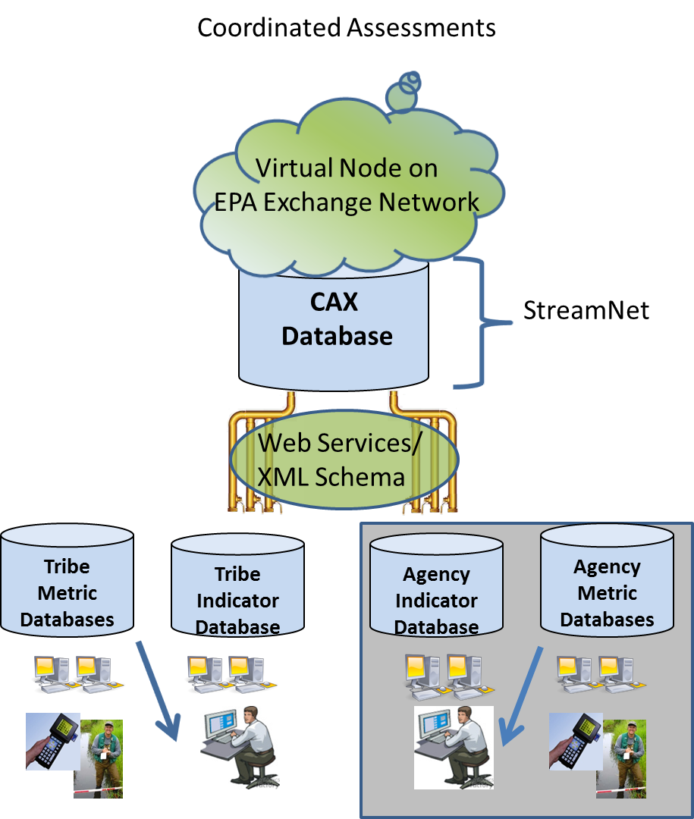
Figure 1
7.3 Exchange Network Priorities
The project continues to implement three Tier I priorities:
- 24/7 Data Publishing: the project aggregates and publishes CAX data into a cloud based data repository, allowing updates and consumption of this data by contributors, client applications and private/public websites. Data is published in both standard EN format and as EN REST based services.
- Use of the Exchange Network for Virtual Sharing: the project allows sharing of data sets across State/State, State/Tribal, and Tribal/Tribal jurisdictions. Data sharing configuration allows authorized partner access to datasets without the need to access partner local systems. Because this capability is provided across jurisdictions it supports improved regional environmental management across the entire Columbia Basin Watershed. This phase of the project supports further development in the Region outside of the Columbia Basin.
- Virtual Node Implementation: the project supports and expands data publishing services and data flows using the EPA Virtual Node services, including expanding the types of data and the areas of data. Data providing partner clients interact with the Virtual Node to aggregate data in a cloud based repository for data set sharing and re-publishing as described above.

In addition to these Exchange Network Priorities, the CAX project produces several re-usable components of relevance to other entities managing fisheries data, including all of the environmental and wildlife Agencies and Tribes on the west coast including Alaska. These components include:

- The CAX Schema, which can be used for fisheries indicator data from any watershed
- The CAX data repository which can be re-used by any data providing partner. Selection of a hosted solution for this application means that new partners can implement the flow with no local software installation and only minimal central security configuration.

7.4 Ensuring Programmatic Participation
Key programmatic expertise and involvement required for this project consists primarily of fish biologists who can advise on the DET refinements, and most useful functionality, outbound web services and access formats. To ensure programmatic involvement expert fish biologists will continue their assignment on the CAPG, XML Schema and DET Development teams. Additional experts will be recruited as new Indicators and areas require. These will include:
- Dan Rawding, Northwest Power and Conservation Council Policy Coordinator (WDFW)
- Rich Carmichael, NE – Central Research & Monitoring Program Director (ODFW)
- Lance Hebdon, Wild Salmon and Steelhead Program Coordinator (IDFG)
- Jay Hesse, (Nez Perce Tribe)
- Julie Firman, Oregon Plan Research Analyst (ODFW)
- Mike Banach, Biological Data Coordinator (StreamNet)
- John Arterburn, Anadromous Fish Biologist (Colville Tribes)
- Kelly Doerksen, Fisheries Biologist (Confederated Tribes of the Grand Ronde)

Governance and management of the project is a function of the CAPG, which consists of over 60 programmatic and technical staff. The Exchange Configuration Team and DET Development Team report to the project manager (Brodie Cox, WDFW), as well as the CAPG. All teams will be staffed with a contracted Project Coordinator (contractor, assisted by the StreamNet Project Manager).
7.5 Business Need Addressed
The CA project had its origins in a series of sub-regional and regional workshops held in 2009, the Columbia Basin Anadromous Salmonid Monitoring Workshops. From those workshops an Anadromous Salmonid Monitoring Strategy emerged, and agreements were made among federal action agencies and the state and tribal co-managers for uniform monitoring of salmonid populations. The key business need identified in the strategy was the need to improve the process for obtaining and combining Viable Salmonid Population (VSP) data from the various collectors of this data in order to maximize the use of coordinated and advanced monitoring. The CAX defines the framework by which the fish and wildlife agencies and tribes agree to compile data for salmon and steelhead populations for access through the EPA data exchange network. The overarching goal of the CA project is to improve the timeliness, reliability, flow, and transparency of data necessary for regional assessments and management decisions for improved environmental effectiveness, including support for salmon and steelhead biological opinions that affect state and federal agencies. This data is used for regulatory processes and water management in the Columbia River. Key customers of these data include the participating States and Tribes, Bonneville Power Administration (BPA), Northwest Power and Conservation Council (NPCC), NOAA Fisheries (NOAAF), and other federal agencies.
The need for regionally coordinated, securely stored, and readily accessible salmon and steelhead data has been identified by the NPCC, BPA, and NOAAF. The states and tribes that are partners in the application are active co-managers of the region’s salmon and steelhead resources. They collect, analyze, record, and report data for many fish populations. Their data is used by NOAAF, state co-managers, local salmon recovery boards, public utility districts and others on a routine basis. Sharing that data can be cumbersome and protracted. This funding will be used to expand and streamline the data management systems that provide comprehensive, reliable, and transparent data in a timely manner.

7.6 Budget by Goal
Goal | Amount
Goal 1: Ensure that Project Governance structure is expanded to include new indicators and geographic areas | $63,181
Goal 2: Flow Design (Additional DETs, Develop XML Schema and Flow Configuration Documents for new Indicators) | $34,719
Goal 3: Upgrade Partner Data Management Systems | $269,759
Goal 4: Implement Virtual Data Sharing and Publishing | $97,349
Total (not including Travel/Indirect) | $465,008

