June 14, 2018
StreamNet Executive Committee Meeting Notes
Attendees (in person): Chris Wheaton (PSMFC), Angie Schmidt (IDFG), Bill Kinney (PSMFC), Bryan Mercier (BPA), Dan Rawding (WDFW), Doug Threloff (USFWS), George Batten (CCT/Sitka), Greg Sieglitz (NMFS), Jeff Lane (BPA), John Arterburn (CCT), Johnna Roy (USFWS), Tim Copeland attending for Lance Hebdon (IDFG), Mike Banach (PSMFC), Nancy Leonard (NPCC), Patty O'Toole (NPCC), Roy Elicker (USFWS), Scott Donahue (BPA), Stan Allen (PSMFC), Tom Iverson (Iverson International, Ltd.), Tom Pansky (BPA), Tom Stahl (ODFW), Tony Grover (NPCC)

Attendees (telephone): Brodie Cox (WDFW), Cedric Cooney (ODFW), Colleen Roe (CRITFC) David Liberty (CRITFC), Jen Bayer (USGS/PNAMP), Mari Williams (NMFS), Russell Scranton (BPA), Tabitha Whitefoot (CRITFC), Don Skaar (MFWP)

Time Topic Lead

Agenda as laid out below was approved. Zach Penney was unable to make this meeting due to illness, so David Liberty and Colleen Roe made the presentations on Zach’s agenda items.

9:30 AM Plans and Adjustments for Next Year’s Budgets: BPA Guidance All

NOTES:
- Chris showed the current FY 19 budget. A retirement at PSMFC will happen before FY19, that savings is currently allocated out to the partners.
- Bryan Mercier: Data management is identified for budget cuts. They would like the PSMFC retirement money to contribute, and would like the states/tribes to also help. They say data delivered is less than they were hoping, recognizing it is a tough job to do. So it’s not “performance”, but a difficult process that they want to make sure will improve to supply information for their priority populations. They want the intended priorities handled first. No specific numbers at this time – they want a conversation. They have not received all the data they need for the BiOp they are currently working on with NMFS.
- Chris showed current state of Tier-1 indicator data.
- Bryan is hoping we can “right size” the budget to the priority needs. Wants Bill Kinney’s retirement money to go back to BPA, and wants states/tribes to also help.
- This conversation will happen with 100 different projects. BPA wants to make strategic decisions, and avoid ending whole projects if possible. They are discussing what of data management is essential for BPA’s priorities, and what are “soft” uses of funds. They are looking at direct contracts to states and tribes rather than through PSMFC as one possibility, but they don’t prefer that approach.
- BPA had been meaning to move into resident fishes next, but CA has been discussing hatchery data instead.
- He asked that everyone please honestly say what’s possible for getting data for priority populations, and how much budget is truly needed for that.
- Chris asked if a summary where everyone estimates what’s possible and what it would cost to get all the indicators for the priority populations would be useful. Answer – yes.
- Dan Rawding shared a different perspective of where we’ve been over the past 5 years. Priorities and work plans have shifted, and we’ve responded. The priority pops didn’t exist back then, and we’ve been adding data types (i.e. juvenile indicators), and focusing as best as possible. Dan suggests maybe which populations and data types are provided could be discussed. Bryan agreed we have come a long way and SN/CA has been responsive. But still Bryan wonders if maybe the pace of data development couldn’t be better than it has been – is it up to the amount of money that’s been spent?
- Nancy Leonard agreed with Dan. She’s impressed with the changes made to meet the NMFS/BPA/NPCC data needs. They now get data much easier and more completely and at the population level, which was not the case 5 years ago. She thinks the SN model does work. She suggests that getting better agreement to deliver data from data-creating projects, not SN, is the better place to focus efforts to get more data. She says the data flow mechanism is good. Bryan said the SN partners are not getting data as well as BPA wants; Nancy said the bottleneck is the field biologists. Bryan clarified: with the level of current investment, how much is needed to keep the current things flowing/updating? Now that we are where we are, how much do we need to continue this, and how much is needed to do other things?
- John A. said from CCT perspective, they came as a participant without the ability to do it, so needed a bit of money to get up to speed. They “spread the money around” to their other projects to make the whole data delivery system work. Taking money from here will require putting money somewhere else if BPA still wants the data. Bryan understood and agreed.
- But, Bryan said, what budget level is needed to “maintain” rather than grow? How much is needed at the agencies to do our current CA work?
- Tom Stahl said the whole ODFW group is working on the priorities identified. Dan R. said the same for WDFW.
- Chris asked that this discussion today end with a definition of what “success” means. Recently it has been the tier 1/2 populations, but it sounds like today the definition is changing. Bryan responded BPA feels the level of funding provided is not really needed for the data being provided. But he asks how much money is really needed, and how much could go back to BPA to help solve the financial problem. They have a hard time believing the whole 1.5 million dollars SN passes thru to partner agencies is really all going to developing the data that are currently delivered.
- Greg S said from NOAA’s perspective SN/CA is a highly successful program – one of the best. Lack of data has been a problem for a long time, and this project is solving that. He agreed this conversation should be about budget, or priorities, or both. Bryan said there is no set budget number they have in mind right now, though they do have to cut the F/W program along with all their other costs. Greg also pointed out the in-kind contributions the agencies make. Nancy added for 10 years SN budget has been flat. Bryan said there have actually been inflation adjustments.
- Chris suggested that we split this discussion into two parts - a clear picture of budget and how we would help with budget savings, and separately s clear definition of what “success” means for this project. These are 2 different, but both important, conversations.
- BPA spends almost 10 million/year on data projects, and they all will be asked to contribute to savings. They want to avoid impacting on-the-ground projects to the degree possible.
- Efficiencies/cost savings: how might that happen? BPA says +/- $50,000 savings (the allocated retirement savings) is a starting place for us.

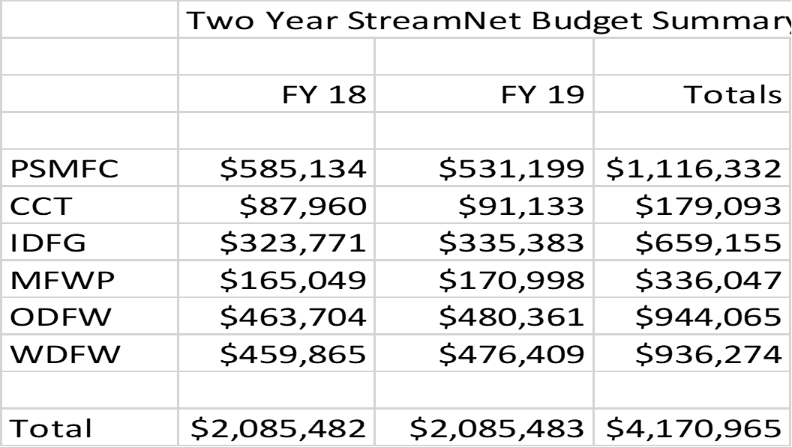

  - Bryan would like all the agencies to tell them what they could live without.
  - Tony said that Bryan recently presented this need to the Council. Tony said if any group anywhere has a chance to collaborate to decide on cuts rather than have them imposed, it’s this group. So he’s hoping that can be done.
  - Dan said maybe everyone stays at FY18, except PSMFC goes down. The problem is going into the weeds to tell what’s possible/needed at agency level is a lot of work but can be done. We need to show what won’t get done with the cuts that are taken.
  - Nancy said if this process is done, hopefully it produces a plan that BPA will continue to support.
  - Several comments that any proposed cuts should also relate how cutting would impact CA priorities.
  - Chris suggests: FY18 budgets except for PSMFC; PSMFC will start with the lower FY 19 figure. Everyone asked to go back and look for more savings. Everyone agreed to that. Bryan said that’s an acceptable approach. Chris said that’s a 2.5 percent savings. Bryan declined to give a percentage goal we should shoot for. He said much depends too on how the hydro income goes next year. BPA needs to save about 30,000,000.
  - End of July deadline for all of the 1st quarter budgets to be loaded.
  - How we will do that:
    - Stan Allen said analyze work to do and how much is needed. But Tom P. said that’s not going to work this time.
    - Dan said to work with Brodie because he’s more involved in the details of the budget and work. Tom said the same for Cedric for ODFW. John said he will be the CCT contact rather than George. Everyone agreed the SNSC and tech staff should be consulted. Bryan said non-BPA cost-shares are good reasons to not cut funding, so let them know that.
  - In FY19 BPA will not allow last quarter transfers.
  - Final Decision on Process and Timeline;
    - Record this initial decision and send out with the notes (by June 20)
    - Solicit PSMFC & partners – do you have additional savings? (input by 6/30)
    - Draft proposal for total savings out for review (by 7/6)
    - Comments due back on proposal (by 7/13)
    - Final Proposal approved (by 7/20)
    - Final conveyed to BPA (by 7/25)

10:30 AM Current Year Budget Update – All
Budget savings anticipated?
Budget shortfall issues to address?
Can we use this year savings next year?
Please come prepared to discuss your situation

NOTES:
- No problems were identified. Any savings in FY 18 are good but don’t “count” for the FY 19 budget savings exercise. No rolling of savings into FY 19.

10:45 AM Progress on our Priorities this Year - Partner Updates All
Please come prepared to discuss your situation

NOTES:
- Chris reviewed current SN priorities

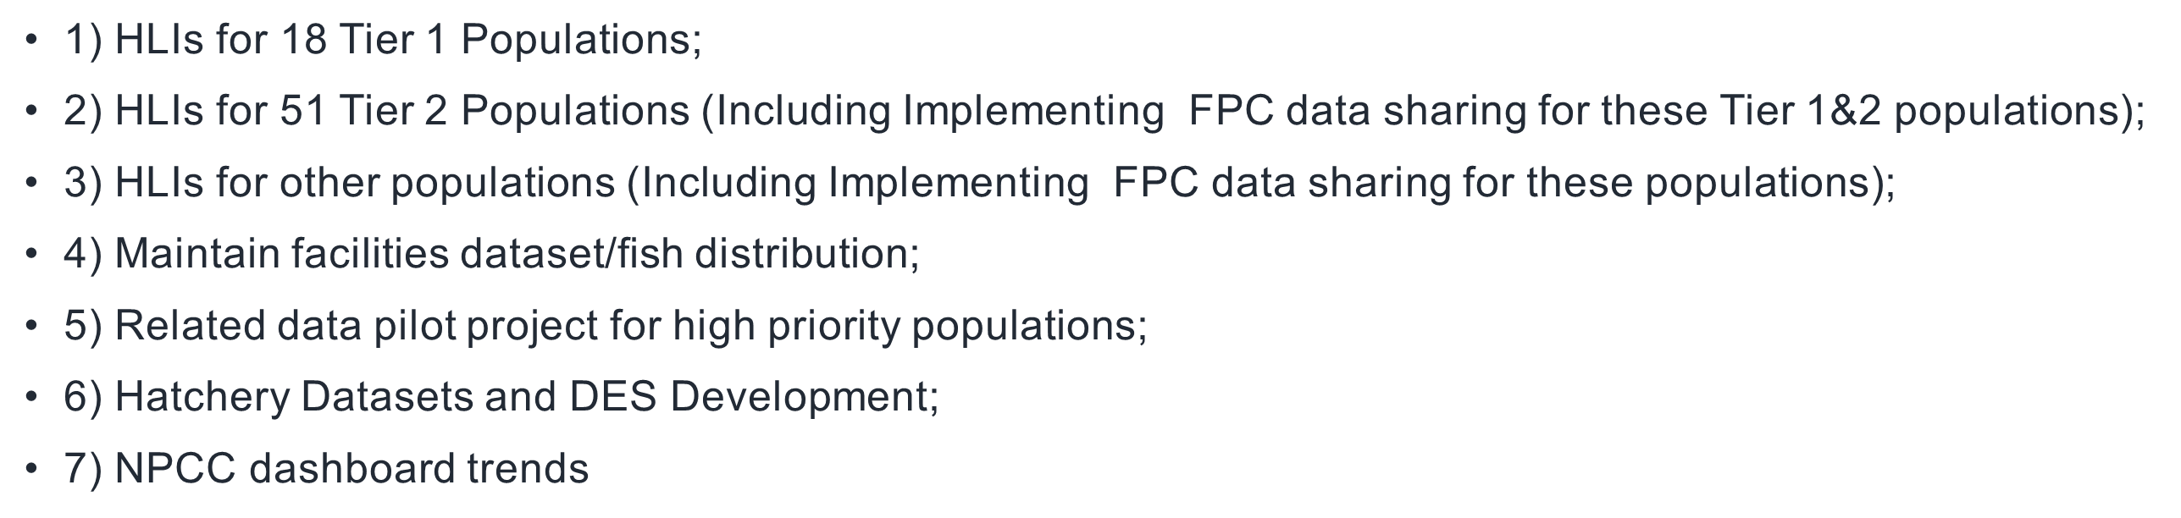

- Predictions for FY 18 data flow was shown on a slide. Data providers indicate that they are on track to update natural origin indicators this year, with emphasis on BPA priority populations.
- Tony said moving slowly on hatchery CA data was preferred at a NPCC meeting recently so nobody is left behind. Hatchery indicators will likely be the next thing we add, but have been “stuck” on making progress as the need for data that is different from that already available has not been clearly defined/requested by anyone. Hatchery data is not a BPA work priority for SC/CA. Greg S. said there are already regulatory performance measures for hatcheries, but there is no region-wide need even if the data type is important. But still they would like these data and would like the region to start thinking about doing these data at some point. Tony said the HGMPs are done and recent and available, and can be used. But is SN the right group to do this sort of data collection process? PNAMP was suggested as possibly being a good place to have the discussion. Greg thought maybe data part of this could be SN, while other aspects are elsewhere. Dan said mitigation goals are important and what would be of interest for some hatchery programs. States do have databases of juveniles released so should be easy; returns are more difficult.
- Chris asked, given the NPCC discussion this week and this morning’s discussion, what do we do with hatchery indicators? Bryan said he doesn’t know where the tribes are on this, and he would like to know there is buy-in from them, and also make sure they will be able to participate in a unified effort rather than something separate. Tony said they will test the buy-in process from tribes at a meeting next week where they will discuss hatchery production and harvest. He said the reaction then should give us an idea about the feasibility and priority of broad-scale hatchery indicators. Chris said nobody has yet told us exactly what the needs are; instead we hear about what could be or is possible, rather than specific data SN should pursue. So should we drop hatchery data conversations until and unless someone gives us specific data needs not already served by existing data managers, like FPC? Nancy said NPCC does have a need for hatchery releases on their mapper – they would like that to automated via SN. Number and locations of releases. Tony recognizes SN has received conflicting opinions. Dan reviewed the several steps that are needed to finally get new data types going: general data types; DES development; data system development; and data calculation mechanisms and staff. Our bottom line: SN can think about hatchery indicators and will participate in conversations to try to further the effort, but at this time we will not spend much time with data efforts. SNEC will continue to participate in regional efforts to decide what hatchery indicators may be of interest. Greg S. said it’s on NMFS’s plan to pursue the hatchery data, and they will be proposing things.

11:15 AM Setting CA/StreamNet Priorities for Next Fiscal Year All
What Constitutes Success?
Potential Modifications to the DES/New Indicators?
Hatchery Indicator(s) (e.g. For BPA funded programs
Adult-equivalents to mouth of river)?

NOTES:
- Russell suggested escapement estimates may be of interested, because NOSA is not possible everywhere that escapement is. Juveniles per adult, carrying capacity, juvenile density. Juvenile outmigrants data seem out of step with existing reports, and data reported do not always match what the indicators are. So, are there additional measures that could be added to the DES tables. Russell would like to have discussions of all this. Everyone agreed DES meetings would be a good idea.
- BiOp changes may result in a different set of priority populations. NMFS and BPA need to communicate this to SN if/when changes are made.
- John A. suggested “related” (trend) data are lower priority. Nancy said they are useful where HLI data are not available. Russell said BPA at this time are not using these data much, but instead are using HLIs – however, juvenile outmigrants, redd counts, and smolt trap counts are used as indexes of abundance.

  - Final Decision on Priorities for next FY (2019);
    - Maintain automated flow of data to existing indicators, including retaining focus on BPA priority populations
    - Maintain facilities dataset/fish distribution
    - Convene DES team(s) to review and update DES’s for existing indicators
    - Update a more narrow and clearly defined set of related data records
    - Retain involvement in hatchery indicator discussions but take no action pending leadership decisions on specific indicators needed (assist NPCC in hatchery data capture efforts)
  - We will prepare a report for BPA on Tier 1 & 2 data we have in CAX, including why we don’t have all the data they would like to see for them. Another part of the report is what would help get more data in those instances where they are available theoretically but not actually done yet. Will shoot for next several months (September completion). Mike will lead effort, will be seeking help/input from all the partners providing data on these populations.

1. HLI for Tier 1
2. HLI for Tier 2
3. HLI for other populations
4. facilities/distribution dataset maintenance
5. DES updates and revisions
6. NPCC dashboard trend updates
7. Hatchery DES/data – explore indicators through PNAMP
8. Related Data – focused

Noon Lunch break

1: 15 PM Council F&W Amendment Process Patty O’Toole
Data Management Recommendations?

NOTES:
- “Protected Areas” are an important part of the program. There have been 2 projects proposed in the past year that didn’t happen because FERC honors the Protected Areas provisions.
- F&W program is amended every 5 years. One is coming up. Recommendation deadline is September 14. Then the recommendations are made public for 60 days for everyone to be able to review and comment on the recommendations. After that a new draft Program is made, which also has a 60-90 day comment period before a final new Program is made.
- There are 5 principles and 3 measures in the Program. These are available on the NPCC web site.
- Should we as a StreamNet executive committee propose amendments to the F&W Program?
- Should the ExComm develop draft language on data management for use by member organizations (and others)?
- The best way to make effective comments is to work with many agencies and tribes, and to make specific recommendations that can be implemented. We can even explicitly say StreamNet should be in the Program, if the agency and tribal higher-ups agree to say that. Patty said starting in 2000 the Council went away from such specific items in the Plan, and were replaced with much more general guidance. However, that does not mean we can’t propose it.
- Chris suggested we do this. Greg said it would be better if it reflected on things in the current Plan.
  - Final Decision on Amendment and StreamNet
    - Will draft language for review via email
    - Chris will work with Tom I., anyone else that is interested please let Chris know/send language.
    - Will send around electronically for review and discussion. (NOTE: do not include NPCC staff in draft distributions to avoid confusion over what is the submission (public access – legal issues)
    - Can decide then whether to submit from SNEC, suggested as language to F&W managers, or both
    - Will need to get drafts to people in next month or so to start the ball rolling

1:45 PM CRITFC Library Update and Discussion Zach Penney

NOTES:
- David Liberty spoke for Zach.
- Library now has new leadership. A new librarian will be hired soon.
- Currently inventorying entire library, starting with StreamNet documents.
- Making all PDF files searchable.
- Current collection is not sustainable, so they will be focusing, discarding many things that are not priorities.
- 2012 ISRP review has been an important guidance document for them.
- Plan to rename the library, and are interested in hearing suggestions.
- Dan asked how library would like with cbfish.org and all those annual report documents. David says hyperlinks to those documents at BPA would be his preference, though links changing over time is a problem, so maybe obtaining those documents and housing them would be another option. Dan says it would be good to have those documents available because many people may not know about the documents at cbfish.org. Jeff and Tom with BPA said they are interested in how people think would work well. BPA physical library is being reduced.
- Nancy asked for guidance on how to submit documents to the library. David said he would get that to her.

2:15 PM Tribal ITMD Project Update and Discussion Zach Penney

NOTES:
- Colleen Roe spoke for Zach. Described how ITMD project is helping tribes manage and share data. See slide show for details.
- Two funding sources: BPA and EPA. EPA for 2016-2019.
- CDMS coming online soon. (CDMS=”Centralized Data Management System” designed and created by CTUIR.) Recently installed at NPT, CTWS, and CRITFC. YIN will be using a different system.
- Chris and Tom I both spoke up in strong support of this project, see it as a Columbia River tribal corollary to StreamNet. Essential to getting data flow from all entities into the CAX. Making great progress under leadership of Zach and Colleen. Helps to answer some concerns expressed over full participation in CA project.

2:45 PM Roundtable Discussion All

NOTES:
- George Batten (CCT): CCT doing a good job giving him data. Close to pushing data to SN.
- Angie (IDFG): New, so not really anything to report yet as she is just learning.
- Dan (WDFW): Have lots of data pre-ad clip marking of Chinook. It’s hard to figure out what’s hatchery, what’s wild, so NOSA is very hard. They are trying to figure it out. Dan would like Chris to go over next steps for budget process before we leave today (see notes on first topic).
- Jeff (BPA): BPA is sharing the budget pain, as all sections are taking cuts.
- Tony (NPCC): Suggested people check out Spokane Tribe fish harvest data in real time creel survey tool. From the last Council meeting.
- Tom S (ODFW): They have been developing harvest info system too.
- John (CCT): Just finished habitat data collection tool. Can share with anyone interested. He will bring to data visualization workgroup soon.
- Greg (NMFS): Appreciate effort of SN staff. Data available have been really helpful. Working on new BO. Another in 2021 coming up. NMFS and NPCC have been working on displays together. He likes the results of the collaborations.
- Jen (PNAMP): Data visualization workgroup meeting next Friday morning. Asking for planning help for PNAMP – watch for a survey. There are a couple empty PNAMP steering committee slots – if you’re interested for you agency let Jen know.
- Brodie (WDFW): WDFW continues to refine harvest reporting system. Starting work on a hunting application. Started iPhone data collection application. Updating systems that report to CA.
- Doug (USFWS): In February FWS decided to adopt FINS database system for hatchery data. Will be a learning curve and take a while to get everybody using it. Once it’s used, transfer to CA should be relatively easy (assuming hatchery data become part of CA). Working on guidance document for how to handle and share NFH data. Question: will existing data be migrated to FINS? Answer was yes.

4:00 PM Adjourned

