Coordinated Assessments Partnership
Work Group Roles and Responsibilities

Purpose
The Coordinated Assessments Partnership (CAP) is a collaborative process to efficiently share fish information within the Pacific Northwest by providing access to standardized derived information needed for reporting and decision-making by natural resource managers and regulators. The information shared through the CAP represents the partners’ best available science and, when appropriate, these entities’ (federal/tribal/state agencies or others) endorsed official records such as those used in regulatory fish assessments for the Endangered Species Act (ESA) or other reporting requirements. The CAP is co-sponsored by the Pacific Northwest Aquatic Monitoring Partnership (PNAMP) and Pacific States Marine Fisheries Commission (PSMFC) StreamNet Program (StreamNet), with participation by federal, tribes, states and tribal consortia fish biologists and data stewards who ensures the data quality and flow.

Background
The CAP initiated in the Columbia River Basin during 2010 with PNAMP and StreamNet co-sponsoring the effort. The CAP has been funded through multiple sources secured by the co-sponsors, PNAMP and StreamNet, and the numerous federal, tribes, states and tribal consortia that engage in the CAP. Participation in the CAP has thus far has reflected the early focus of the CAP on providing coordinated assessments for Columbia River Basin salmon and steelhead populations. Bonneville Power Administration (BPA) has been an important source of funding for CAP activities that support BPA’s work consistent with the Northwest Power and Conservation Council’s (NPCC) Columbia River Basin Fish and Wildlife Program (F&W Program) and Endangered Species Act. Progress made by the CAP also has been made possible by significant in-kind contribution from all CAP partners, National Oceanic and Atmospheric Administration (NOAA) funding, and several Environmental Protection Agency Exchange Network grants secured by CAP partners since 2010 that have significantly advanced infrastructure and sharing.

The geographic scope of the CAP is the Pacific Northwest with a focus on sharing natural and hatchery origin fish information and fish habitat-related information, such as fish population high level indicators (HLIs) and supporting metrics. The CAP 5-year Plan and annual revisions includes sharing Pacific Northwest information for: population estimates for natural origin and hatchery origin salmon and steelhead, as well as sharing information for white sturgeon; habitat carrying capacity and other HLIs that would inform regional decision-making and reporting. The HLIs shared through the CAP are made accessible through the CA Exchange (CAX) data system, with the data informing the HLIs and metrics being maintained in multiple state, tribal, federal and other partners’ data management system. The CAP relies on collaboratively developed Data Exchange Standards (DES) with documentation of relevant metadata, such as protocol/method documentation, to ensure usability of the shared indicators and metrics. Information made accessible through the CAX follows the data sharing agreements and DES agreed to by the CAP partners. HLIs and metrics currently accessible through the CAP’s CAX data system consist of salmon and steelhead HLIs, such as population level estimates of natural spawner abundance and juvenile outmigrants, and supporting trend metrics for ESA and non-ESA listed Columbia River Basin. As the scope of the CAP expands the CAX is also providing access to HLIs for Oregon Coast and Puget Sound salmon and steelhead populations and superpopulations.

Information shared through the CAP provides standardized information that informs status assessments for and management of ESA-listed and non-listed species. The CAP also supports the NPCC’s F&W Program performance assessments such as the Program Tracker, BPA reporting, and analytical tools such as life cycle models that informs environmental resource management.

Approach
The CAP is co-sponsored by PNAMP and StreamNet, with its successful implementation relying on the support and expertise of federal, tribal and state partners, the Columbia Basin Fish & Wildlife Library, and the Columbia River Inter-Tribal Fisheries Commission’s (CRITFC) Inter-tribal Monitoring Data (ITMD) project (Figure 1). The CAP partners reflect the entities engaged in providing and managing the HLI data shared through the CAX and the regional entities relying on these HLIs for their decision-making processes and reporting. As the scope of the CAP expands to encompass more of the Pacific Northwest and additional fish related topics, the partners assemblage will reflect that expansion. The CAP is guided by a 5-year Plan and coordination of its implementation is accomplished through the CAP Core Team.

Implementation of the CAP in the Columbia River Basin is informed by the CAP 5-year Plan that is annually revisited by the StreamNet Executive Committee (SN ExCom) to ensure alignment with regional priorities. The SN ExCom includes Columbia River Basin representatives of CAP participating entities and provides high level policy guidance to the StreamNet Steering Committee (SN SC) which contributes to the CAP 5-year plan implementation. The SN SC in turn guides the work accomplished by the StreamNet Technical Team which coordinates with the DES Development Team. The broader overarching CAP Core Team coordinates implementation of the CAP 5-year Plan among CAP partners, including StreamNet participants (Figure 2).

Data from the CAP are maintained and shared via the CAX (https://cax.streamnet.org/), which is hosted by the StreamNet Program at PSMFC. The PNAMP facilitates discussions and activities needed to support implementation of CAP, maintains the historical records of CA, and coordinates regional communication via the CAP Outreach Forum’s distribution list. The CRITFC ITMD Project serves a coordination and support role with the CRITFC member tribes in facilitating their participation in the CAP. StreamNet also supports Columbia River Basin implementation of the CAP 5-year Plan by funding data stewards in state agencies and the Colville Tribes, supporting the CAX data system and its quality control/validation processes, and as possible, by funding specific infrastructure and sharing capacity tasks with Columbia River Basin partners.

Work Groups and Related Projects (see also Figure 1 and 2)
CAP Core Team - The CAP Core Team meets monthly to coordinate implementation of the CAP amongst partners, including partners receiving funding from BPA and other federal grants. The Core Team is made up of representatives from BPA, PNAMP, PSMFC-StreamNet Program Manager, StreamNet Steering Committee representative, NOAA Fisheries, and the ITMD Project – staff who are directly responsible for ensuring that CAP produces usable results. Depending on the tasks being addressed by the CAP Core Team additional representatives may be invited such as representatives from US Fish and Wildlife Service and WA Governor’s Salmon Recovery Office. The CAP Core team supports discussion amongst projects implementing the CAP 5-year Plan, directs requests for work to the appropriate CAP team or committee level, monitors implementation, reports to SN ExCom and SN SC, and generally serves to maintain forward momentum. The CAP Core Team also informs and directs periodic CAP Workshops, as needed. The CAP's history and related documents are maintained on the PNAMP website at https://www.pnamp.org/project/coordinated-assessments-for-salmon-and-steelhead. All detailed technical documents for the CAX are available at http://www.streamnet.org/coordinated-assessments-xct-development/.

CAP Data Exchange Standard Development Team (CAP DDT) – The CAP DDT determines Data Exchange Standard (DES) fields and definitions and import/export guidelines. The DES is the document that defines the data in the CAX data system. This group consists of both data management professionals and the biologists who are responsible for calculating indicators and metrics. Actual team membership is fluid and depends on the species/indicators/geography of the data. Ad Hoc workgroups may form to address specific data categories and issues. The chair of the DDT is the PSMFC StreamNet biologist. The most current DES is available on the StreamNet website at: http://www.streamnet.org/coordinated-assessments-des/. The CAP DDT activities are guided by its charter.

CAP Outreach Forum – This is the broadest group of participants in CAP. The individuals that belong to this group are kept informed about the CAP mainly through email updates including general information, when new versions of the DES are completed, and for workshop invitations. For example, these participants are invited to periodic CAP workshops, as well as invited, as needed, to provide broader regional input on DES updates, high-level strategic guidance for CAP, annual and five-year CAP work plans, CAX status, and other CAP activities in the region. Typically, the workshops and other events to receive input from this group are hosted and facilitated by the Pacific Northwest Aquatic Monitoring Partnership (PNAMP) with support from StreamNet staff.

StreamNet Executive Committee (SN ExCom) –This group provides the annual high-level guidance and decision-making for CA. This includes review of the CAP high-level goals, products, the 5-year CAP work plan, StreamNet Strategic Plan, and making decisions on priorities in terms of species, populations, and indicators addressed in the CAP. The SN ExCom is currently made up of mainly Columbia River Basin policy staff and project leaders from representatives of tribal, federal, state and other organizations managing and using fisheries data, including the entities funded through the StreamNet Program, the StreamNet funding entities (BPA and NPCC), and regulatory agencies (NOAA and US Fish and Wildlife Service, USFWS); current members are listed on the StreamNet website. An invitation to interested tribes to join this committee has been made and they participate as feasible. The chair is the PSMFC Executive Director or representative. All agendas, documents, and meeting notes are available on the StreamNet website at https://www.streamnet.org/resources/documents-and-publications/streamnet-executive-committee/.

StreamNet Steering Committee (SN SC) – The SN SC helps to implement the decisions of the SN ExCom, with emphasis on the Columbia River Basin tasks included in the CAP 5-year Plan, StreamNet Strategic Plan, and what is within contracted scope of work. This group includes active participation by representatives of tribal, federal, state and other organizations managing and using fisheries data including the entities funded by BPA through the StreamNet project as well as BPA, NPCC, NOAA and USFWS. This committee is composed of representatives at the data manager level; current members are listed on the StreamNet website. The chair is the PSMFC StreamNet Program Manager. The SN SC meet twice a year with some conference calls as needed in-between meetings. All agendas, documents, and meeting notes are available on the StreamNet website at https://www.streamnet.org/resources/documents-and-publications/streamnet-steering-committee/.

StreamNet Technical Team – This group is responsible for the programming details necessary to adequately flow data from partner data systems to the CAX and other StreamNet systems. This group is composed primarily of PSMFC and state and tribal agency staff from entities funded through the StreamNet project who implement data management actions. The chair is one of the PSMFC StreamNet technical experts.

StreamNet Data Exchange Standard Development Team (SN DDT) – The DDT determines Data Exchange Standard (DES) fields and definitions and import/export guidelines. The DES is the document that defines the data in the StreamNet Fish Count data system. This group consists of both data management professionals and the biologists who are responsible for submitting these data. Ad Hoc workgroups may form to address specific data categories and issues. The chair of the DDT is the PSMFC StreamNet biologist. The most current DES is available on the StreamNet website. The SN DDT activities are guided by its charter.

CRITFC ITMD Project –The purpose of the CRITFC ITMD project is to assist CRITFC and its member tribes in the timely and accurate capture, storage, processing, and dissemination of data for management of anadromous fish and their habitats. There are four main objectives for the ITMD project: 1) assist CRITFC and member tribes to develop cost effective computer architectures and data management strategies for anadromous fish and habitat data, 2) provide data management services to the tribes, 3) assist member tribes to build internal capacity for improved data management, and 4) enable tribal participation in regional data management and coordination processes. It is important that the ITMD Project fully coordinate and integrate appropriate activities with the CAP to ensure consistent data sharing for Columbia Basin salmon and steelhead.

Pacific Northwest Aquatic Monitoring Partnership (PNAMP) – PNAMP supports collaboration and coordination around aquatic monitoring, including discussion of data collection, sharing, and documentation. One of PNAMP’s key projects is MonitoringResources.org, a tool to document monitoring metadata (metadata is required as part of the CAX exchange, though use of MonitoringResources.org is not required). PNAMP members include, tribal, and federal entities (see PNAMP website for current members) collaborating to support aquatic resource monitoring and information sharing. PNAMP contributes to the CAP by facilitating monthly CAP Core Team meetings, the PNAMP Fish Monitoring Work and CAP workshops. PNAMP maintains the historical records of the CAP, maintains the CAP Outreach Forum distribution lists and coordinates regional communication with the CAP Outreach Forum. The CAP history and related documents are maintained on the PNAMP website at: https://www.pnamp.org/project/coordinated-assessments-for-salmon-and-steelhead.

PNAMP Fish Monitoring Work Group (FMWG) – The FMWG supports collaboration, communication and coordination among fish monitoring practitioners in the Pacific Northwest for effective monitoring assessment methods and efficient data sharing. The tasks addressed by the FMWG are identified by PNAMP partners as well as through the CAP and StreamNet Program. The FMWG contributes to the CAP and StreamNet Program by providing a venue for discussion of topics related to CAP/StreamNet task implementation (Figure 1 and 2). Membership of this workgroup is fluid to reflect the appropriate subject matter experts (e.g. fisheries biologists, program managers, etc.) to address specific tasks, and is drawn from the CAP Outreach Forum list of participants.
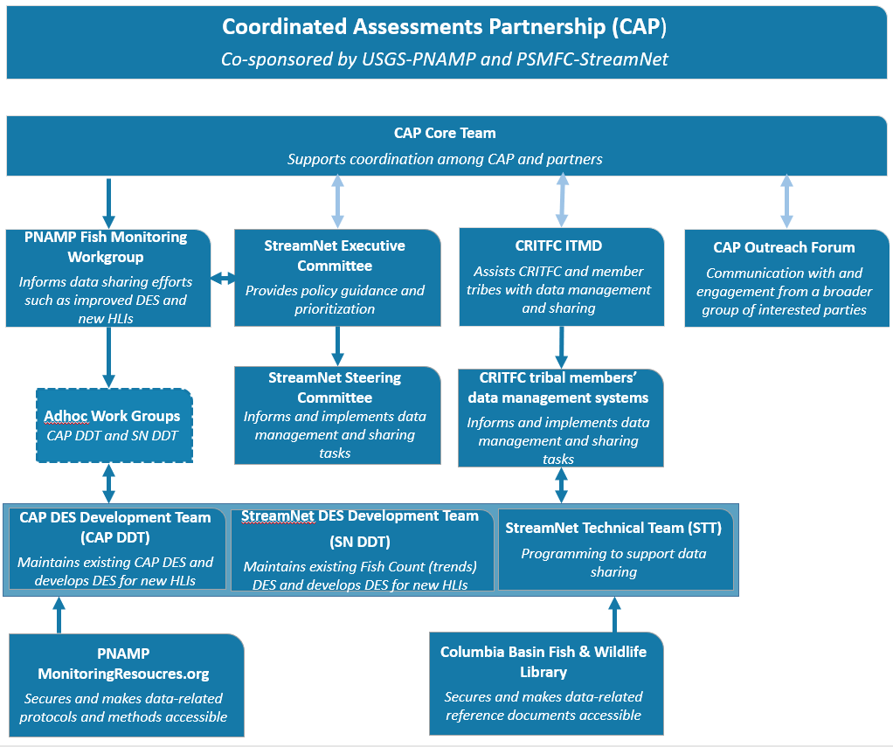
Figure 1: Relationship among the groups supporting and informing implementation of the Coordinated Assessments Partnership. The three pale double-headed arrows indicated a back and forth exchange between the CAP and these three groups: StreamNet Executive Committee, CRITFC ITMD, and CAP Outreach Forum. The darker double headed arrows indicate the interaction between the biological and data technical experts to exchange quality data. The other single headed arrows indicate guidance provided to another group related to CAP implementation.
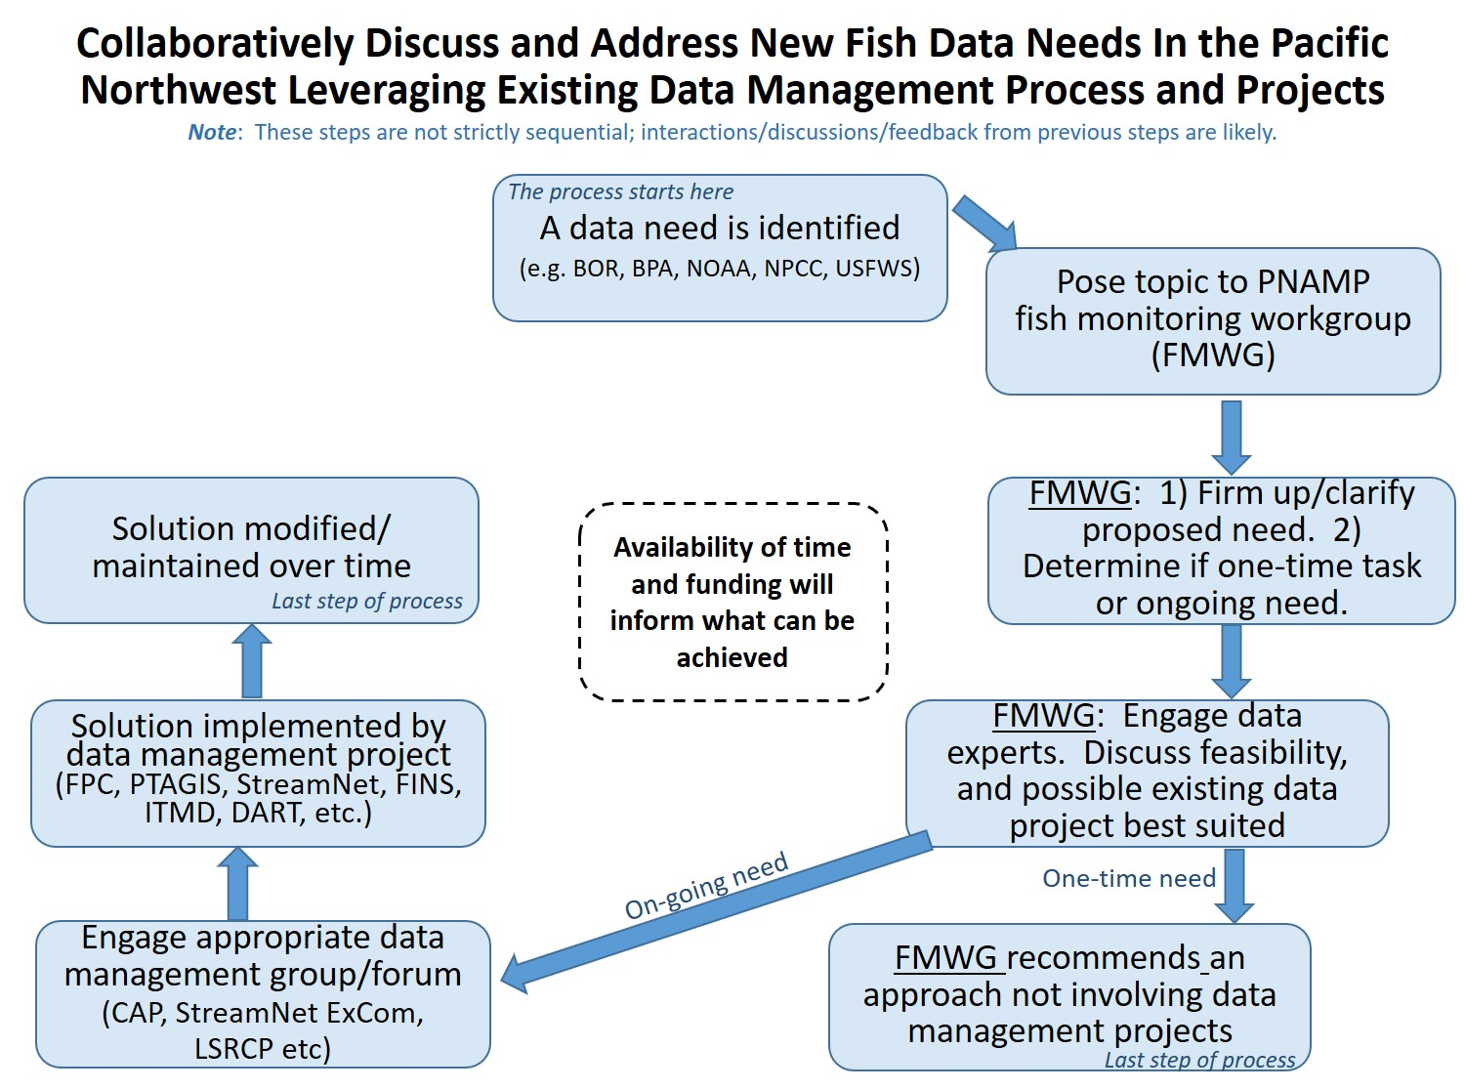
Figure 2. Process leveraging the PNAMP FMWG to discuss how best to address new fish data needs and interactions with the CAP, StreamNet and other regional efforts.

