Bull Trout Workshop
2014 Council’s Program Objectives Task and Discussing Data Opportunities
April 12th 1-4 PM (Mountain Time Zone)
Missoula, Montana (in Conjunction with Council Meeting)
DoubleTree by Hilton Hotel Missoula - Edgewater
100 Madison, Missoula, Montana, 59802

Co-convened: Montana Fish Wildlife and Parks, Northwest Power and Conservation Council, and StreamNet
Remote Participation: https://global.gotomeeting.com/join/892904389 & Conference call: 800-356-8278, code 186685
Invitees: Fish and Wildlife Managers with an Interest in Bull Trout
Purpose: To identify existing Bull Trout objectives to inform the Council’s task, to discuss existing reporting needs in the region, and to explore opportunities to facilitate data sharing.
Draft Agenda
Time | Item
1:00 (MST) | Introductions.
1:10 | Overview of workshop purpose.
1:20 | 2014 Council Program Objectives Task - Delineating existing goals and objectives that exist across the region for bull trout  - Council staff will discuss draft list of documents and existing Program objectives  - Brief discussion with participants about other sources of objectives
2:00 | Bull trout existing data and reporting needs  - Council staff brief review of the Program’s current/potential information needs.  - Each Organization give a 5 minute overview about their bull trout related reporting, including  - Tools/databases/web-reporting used  - Desired tools that would make reporting easier.
3:15 | Discuss opportunities and interest to share data  - Brief discussion of opportunity (example of CA with salmon & steelhead) and need for data sharing  Discussion sharing across jurisdictional lines to address regional or common reporting needs by the Program, state agencies and Tribes, federal agencies, and others (i.e. Program HLIs, Fish Information site, reporting on objectives, status reviews, BiOps, etc.)
3:45 | Next Steps
4:00 | Adjourn
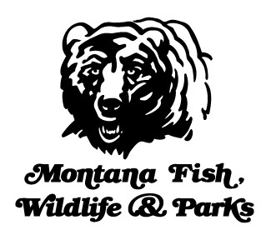 | 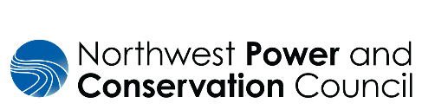

Background: this workshop initiates discussions with bull trout managers about two efforts:
- Northwest Power and Conservation Council’s 2014 Columbia River Basin Fish and Wildlife
  - Council staff, in collaboration with managers and others in the region, is tasked to survey, collect, identify and refine realistic set of quantitative objectives for the program focal species and their habitat (see Program Task).
  - Council staff, with manager oversight, has completed the task of compiling and displaying existing salmon and steelhead natural origin adult objectives (see fish objectives map and query tool) which will be informing regional discussions and, potentially, future program amendments.
  - Council staff is now initiating work on the next focal species, bull trout. Council staff will provide an overview of this task during this workshop and seek input from managers about where to locate existing goals and objectives. This work will rely mainly on Council staff with oversight from the managers to ensure accurate communication about the compiled objectives and goals.
- Discussion
  - Currently, as part of the Programs High Level Indicators (HLI) and supporting Fish Information sites, the Council display data and related information about Bull Trout. Some of this information, such as the Bull Trout HLI is still considered draft. The 2014 Program describes under the section Tracking the status of the basin’s fish and wildlife resources the intent and need to update annually status and trends information relying on information from program-funded projects and from managers. The sections on Program Goals and Objectives and Adaptive Management describe the intent to report on the Program progress by reporting on the quantitative objectives and by relying on Program indicators (graphics on HLI and Fish Information site). The Program acknowledges that achieving program objectives depends on the coordinated actions of many parties.
  - As part of this workshop, we want to understand the existing Bull trout reporting needs of federal, state, and tribal fish managers in the region. We also want to explore whether there are, or could be, opportunities to meet both existing managers’ reporting needs and the Program’s current and future need to report on the status of bull trout. For example, does the ESA status of bull trout mean that there is a need to share data for periodic review of species status?
Example of facilitated information sharing for specific salmon and steelhead indicators to inform NOAA’s 5-yr Status Reports and the Program’s Fish Information Site graphics (see Coordinated Assessments (CA) of Salmon and Steelhead). This has resulted in improving information access and refining regional salmon and steelhead monitoring and reporting, as well as reducing the number of individual requests to managers for data (see CAX web tool). We want to discuss a similar approach with bull trout managers in the region to determine if there is support for such an effort.

