Data Exchange Standard Development and Revision Procedures

Approved by StreamNet Steering Committee

May 10, 2021

Figure 1: The process followed for developing a new Data Exchange Standard (DES) is shown on the left side (lighter boxes). The process followed for revising an existing DES is shown on the right side (darker boxes).

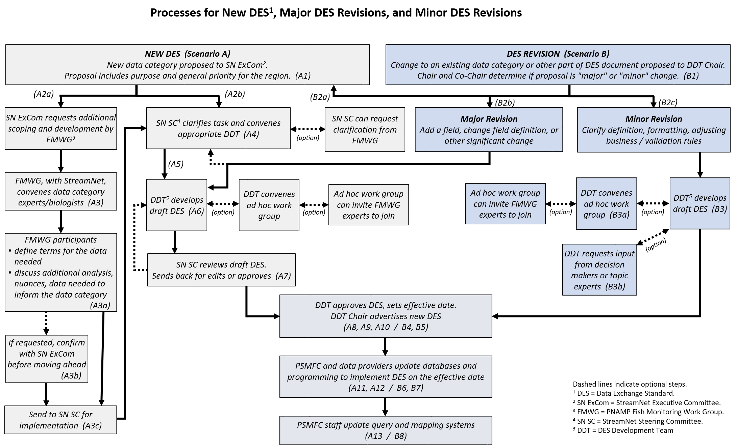

Background
A Data Exchange Standard (DES) is the set of formal rules for the structure of data elements for a data category, such as "the smolt to adult return rate DES" or "the fish monitoring data DES". These rules are agreements among partners on the representation, format, definition, structuring, tagging, transmission, manipulation, use, and management of shared data. Exchange standards developed for StreamNet's fish monitoring data ("trends"), Coordinated Assessments Partnership's fish high level indicators, and related efforts also contain fields to reference metadata in 1) a document housed at the Columbia Basin Fish & Wildlife Library or 2) sampling and analysis documentation (study design, sampling design, protocols, methods) housed in MonitoringResources.org. Two DES scenarios are covered in this appendix:

- Creating a new DES.
- Revising an existing DES.

A. Creating a new DES (see Figure 1, left side gray boxes)

Direction to develop a new DES comes from the StreamNet Executive Committee (SN ExCom), based on the level of interest at the regional level. A new DES is scoped and implemented following these steps. Some steps may be repeated, as required.

- A new data category is identified as a priority at the regional level. The proponent for the new data category prepares a synopsis for consideration by the SN ExCom that includes information about:
  - Why the data category is of interest to the region, such as the question or decision to be informed by the new data category.
  - The general priority at the regional level.
  - Data availability.
- SN ExCom determines if the data category is of regional interest and whether the data category as presented
- requires more scoping by the data category experts through the PNAMP Fish Monitoring Work Group (FMWG) (go to step A3), or
- is ready to move forward to the StreamNet Steering Committee (SN SC) to develop tasks for the appropriate DES Development Team (DDT; SN DDT or CAP DDT) (go to step A4).
- The FMWG convenes subject matter experts to further scope out the new data category.
  - FMWG participants define the overarching indicator and metric terms that will be used to guide the discussion of additional analyses, nuances, and data elements needed to inform the data category. Specific terms used in the DES will be defined by the DDT.
  - If requested by the SN ExCom, the FMWG reports back on their work before the data category moves forward to the SN SC.
  - If the data category has the go ahead to be implemented, the FMWG work is passed on to the SN SC
- The SN SC reviews the data category provided to them from either the SN ExCom or the FMWG. If additional clarification is needed from data category experts the SN SC can request a subset of the FMWG provide this clarification.
- The SN SC directs the appropriate DDT to convene.
- The DDT reviews the information provided to develop a draft DES following the process outlined in the Team Operating Guidelines of that DDT's Charter. If deemed necessary, an ad hoc work group will be convened as outlined in the DDT Charter and a work group lead identified to address specific tasks related to the proposal. If the work group determines data category experts are needed, the work group lead can request a subset of the FMWG join the work group.
- The SN SC reviews the draft DES to ensure alignment with regional needs, and a summary of the output that will be exchanged using the DES is shared with the FMWG. If necessary, the DDT makes modifications to the draft DES document based on feedback from the SN SC and FMWG.
- The DDT finalizes the DES.
- The new DES document is reviewed and, if approved, adopted by the SN SC, and an effective date is assigned. This may occur during a meeting or via email. The effective date shall be at least two months after formal adoption.
- The DDT Chair advertises the new version of the DES document to all data providers before its effective date as outlined in the DDT Charter, and publishes the new version on the StreamNet website.
- PSMFC StreamNet staff modify the database and programming to support and enforce the new version of the DES document on the effective date.
- Data providers are responsible for submitting data following the new DES document as of the effective date.
- PSMFC staff are responsible for adding the various query and mapping tools.

B. Revising an existing DES (Figure 1, right side blue boxes)

Proposals for revisions to an existing DES can originate from a DDT member, the SN SC, the SN ExCom, the FMWG, or technical staff of any StreamNet partner.

- Revision proposals are submitted to the Chair of the appropriate DDT.
- The Chair, in consultation with the Co-Chair, will analyze the proposal for impact and implications and determine whether it triggers the 'new DES', 'major revision', or 'minor revision' process.
  - The New DES process (see "Creating a new DES" above) will be followed for proposals to add a new data category and develop a new DES. (Go to step A1).
  - The Major revision process will be followed for proposals to add a new field, change the definition of an existing field, or other significant change(s) to other parts of the DES document. This process follows steps A6 to A13 of "Creating a new DES" (above). In some cases, the Chair and Co-Chair will determine if the process will also require going through step A5. (Go to step A5/A6).
  - The Minor revision process will be followed for proposals that are considered to be minor changes to the DES document, including formatting modifications to an existing field, clarifying the definition of an existing field, and adjusting business rules. (Continue to step B3).
- The proposal is added to the DDT agenda and options to address the proposal are discussed by the DDT members (see Charter's Team Operating Guidelines). The DDT members, as they discuss the proposal, may determine that additional work is needed before deciding, and may, if deemed necessary:
  - convene an ad hoc work group to address specific tasks related to the proposal. If the work group lead determines that data category experts are needed, the work group lead can request that a subset of the FMWG join the work group.
  - determine that the issue requires further input from decision makers or topic experts and request assistance from the appropriate group.
- The DDT members, upon coming to a decision, finalize the DES document change(s), and an effective date is assigned. This may occur during a meeting or via email. The effective date shall be at least two months after formal adoption.
- The DDT Chair advertises the new version of the DES document to all data providers before its effective date as outlined in the DDT Charter, and publishes the new version on the StreamNet website.
- PSMFC StreamNet staff modify the database and programming to support and enforce the revised version of the DES document on the effective date.
- Data providers are responsible for submitting data following the revised DES document as of the effective date.
- PSMFC staff are responsible for modifying the various query and mapping tools.

APPENDIX

Acronyms used in this document.

CAP Coordinated Assessments Partnership.

DES Data Exchange Standard.
The set of formal rules for the structure of data elements for a data category, such as "the smolt to adult return rate DES" or "the fish monitoring data DES". These rules document agreements on the representation, format, definition, structuring, tagging, transmission, manipulation, use, and management of data in which data are shared.

DDT Data Exchange Standard Development Team.

SN StreamNet.

SN ExCom StreamNet Executive Committee.

SN SC StreamNet Steering Committee.

EPA. (2020, November 9). Data Standards. Retrieved from https://www.epa.gov/data-standards/learn-about-data-standards#What

