StreamNet Executive Committee Meeting
Sept 21, 2021

Portland State Office Building, Room 1E-70
800 NE Oregon St, Portland, OR 97232
Microsoft Teams Hybrid Meeting
Meeting Notes

Agenda
9:00 Welcome and introductions
9:05 Next StreamNet Executive Committee proposed for Oct 2023
9:15 SN ExCom members’ verbal updates and announcements (~2-5 min each)
10:15 Discussion of proposed updates to Coordinated Assessments Partnership (CAP) 5-year plan
11:15 Break
11:25 Discussion of proposed changes to the CAP Fish HLIs user interface
12:00 Lunch Break

Attendees:
IDFG: John Cassinelli
BPA: Jody Lando, Rodrigo George, Russell Scranton, Tom Pansky
NPC: Patty O’Toole, Leslie Bach
CCT: John Arterburn, George Batten (ESA)
CRITFC: Sheryn Olson
ODFW: Tom Stahl, Cedric Cooney, Kasey Bliesner, Nadine Craft
WDFW: Dan Rawding, Brodie Cox
NOAAF: Greg Sieglitz
USGS/PNAMP: Jen Beyer, Megan Dethloff, Amy Puls
MFWP: Dawn Anderson, Eric Roberts
PSMFC: Nancy Leonard, Mike Banach, Mari Williams (PSMFC/NOAAF)
YN: Tom Iverson

Action Items:
- Doodle poll and try for October for ExCom meetings going forward
- Nancy will send out Five Year Plan document for a “final” review to the group; email her with any other requested changes/ edits
- Nancy will send out an email with HLI map query feedback requests; may schedule another meeting for review as needed

Meeting Documents:
All meeting documents are available from the StreamNet Executive Committee webpage:
- Five-Year Plan for the Coordinated Assessments Partnership adopted 20190731 (revised 9Sept2021)
- PowerPoint slide deck
- Agenda

Meeting Notes:
The meeting PowerPoint presentation with slides for the below items will be posted on the StreamNet website along with the meeting notes. Afternoon joint PNAMP and StreamNet session notes added at the end, as well as available on the PNAMP website with the afternoon Joint session presentation file here.

Welcome and Introductions (Nancy Leonard)
- No changes were made to the agenda
- All attendees were invited to sign in and provide introductions in the Chat. Attendees in person introduced themselves verbally.
- Tim Copeland has been replaced by John Cassinelli for IDFG
- USFWS representative is John Netto, not in attendance

Round Robin:
Colville Tribes: John Arterburn
- Busy with field season, keeping up with data flow, working on getting data ready for EDT model that is run every four year
- Habitat monitoring and evaluation program published an article, presented at AFS, and received an award for their work from the Society for Ecological Restoration NW
https://afspubs.onlinelibrary.wiley.com/doi/epdf/10.1002/fsh.10721
https://ecosystems.azurewebsites.net/hstr-okanogan/
https://ecosystems.azurewebsites.net/hstr-methow/
https://www.okanoganmonitoring.org/

CRITFC: Sheryn Olson / Doug Hatch
- Lots of staffing changes at CRITFC (hiring a deputy director, fish science manager, watershed manager, etc) and lots of open positions within the tribes (https://critfc.org/jobs/). Jamie Pinkham is new CRITFC Executive Director
- April 2022 annual workshop Presentations of ITMD group’s tribal data systems on CRITFC.org here:
- https://critfc.org/tribal-data-network-workshop-documents/
- and more from NezPerce tribe:
  - Kus: https://nptfisheries.shinyapps.io/kus-data/;
  - R package cdmsR: https://github.com/ryankinzer/cdmsR;
  - R package cuyem: https://github.com/ryankinzer/cuyemAnnual workshop held in April; had a lot of
- Implementing Survey123

IDFG: John Cassinelli
- All data is up-to-date in the system. No change in IDFG staff participating in StreamNet / PNAMP processes this year.
- Flat funding presents a challenge to do more with less resources. IDFG adjusted staff compensation stemming from federal minimum wage adjustment and raises at the state level, so the budget is being stretched thinly even with the anticipated BPA budget increase in FY24
- Interested in getting GSI data as an HLI as it doesn’t have a formal home at the moment, e.g. GSI collected from Lower Granite Dam fish and would contribute toe the genetic diversity Strategy Performance Indicator for NPCC

ODFW: Tom Stahl / Art Martin
- No new staff. On track with data submissions; a few projects were defunded so those data streams have ended
- Have entered some John Day spring Chinook data in the systems which is an important population for ODFW
- Working on 12 year assessments for lower Columbia stocks, will start on upper Willamette in 2023

MFWP: Dawn Anderson
- Will get data in the exchange by end of month; a lot of genetics work going on for yellow and westslope cutthroat
- Have two vacancies to try and fill. The StreamNet position is filled.
- Working on updates to fish distribution and hydrography
- Developed web mapping app for BPA to use for filtering StreamNet data

WDFW: Dan Rawding
- Developing apps for electronically capturing commercial fishing sampling, pikeminnow sport reward program
- Working on updates to databases (Juvenile outmigrants, spawning ground surveys for salmon and bull trout)
- Working on State of Salmon analysis (2-year cycle)
- All IT functions are now consolidated into one unit so no longer have IT staff within the Fish Division
- Have databases for genetics data, sampling is primarily outside of the Columbia basin, since the 70’s

USFWS: John Netto
- Not in attendance

BPA: Jody Lando / Rodrigo George
- Experiencing record level staffing changes; Jason Sweet took over for Crystal Ball as Executive Manager of the Fish and Wildlife Program at BPA
- Developing tributary habitat RM&E strategy; has a section on data management that describes the type of indicators that are prioritized for consistency
- BPA, ACE looking to improve PIT detection
- Upcoming emphasis on data access in the next year; focusing on ways to work with their funded entities to ensure that those data are accessible to BPA in a way that works for all involved
- 22-23 Rate Period is still under flat funding, which has been the situation since 2018. BPA has awarded an increase of 8.7% to the Fish and Wildlife Program for FY24 to address inflation, cover CSRO mitigation costs and to fund O&M (asset management). Allocation of new funds will follow the standard approach and Accords negotiation. Question: will the ‘fast-track’ projects funded in 2010 also receive an increase? Response: important to raise the issue above increasing funding as soon as possible following end of FY22 in October to inform FY24 budget increase
- Invoices for this fiscal year are due by 3pm on 9/27; start conversations on needs for next budget cycle on 10/1 so highest priorities are identified ASAP
- Question: How will the CY22 surplus revenue f $850 million to allocated, is any being allocated to the Fish and Wildlife Program? Response: It is unknown where/ how surplus funds will be allocated. Usually any surplus is first allocated wot the reserve, cash on hand, customers, and then what is left is allocated to other uses such as Fish and Wildlife Program

NPCC: Patty O'Toole
- Focused on 2020 Fish and Wildlife Program addendum implementation and its Strategy Performance Indicators (SPI). Have QW Consulting under contact for FY23 to manage the data flow. In recent meetings have been focused on the FW Program retrospective (40years) to set the stage. Want to have as much info out as possible prior to the next amendment process
- New Public Affairs Director starts at end of September
- Jennifer Light is new director of the Power Division

NOAA: Greg Sieglitz
- Kudos to StreamNet team for work accomplished
- Barry Thom left to be new PSMFC Executive Director
- Changes in Sustainable Fisheries Division staffing which manages hatchery consultation and indicators
- In process of moving offices, won’t be able to host meetings for awhile
- 5 Year Status Reviews are being rolled out now and over the next few months, with the first being the Interior Columbia River/Snake River
- https://www.fisheries.noaa.gov/west-coast/endangered-species-conservation/report-card-recovery-reviews-assess-28-salmon-and
- https://www.fisheries.noaa.gov/feature-story/interior-columbia-and-snake-river-salmon-and-steelhead-maintain-listing-status
- Tributary Habitat Steering Committee working on process for implementation of the BiOp and the details on data needs might be an opportunity

PNAMP: Jen Bayer
- PNAMP/StreamNet hosted the AFS 2022 Bringing it all together: data integration for fisheries research and management success symposium and also presented at the meeting.
- All are welcome to join the PNAMP steering committee meeting tomorrow 9/22 for updates on their projects/ programs

StreamNet: Nancy Leonard
- Nancy is now also managing the RMPC and FINS programs, as well as some additional smaller data projects- spreading out her time (and Mike and Greg’s time) between these programs allows funding to bring on Mari and Monica Diaz to assist with StreamNet
- Secured two additional funding proposals from IJFA to help support work with PNAMP and to explore expanding to Harvest indicators

Discussion of proposed updates to Coordinated Assessments Partnership (CAP) 5-year plan
Reviewed the plan at the Steering Committee on 9/19 and now with ExCom for further comment and real-time edits to document. The five year plan won’t have the level of detail that an annual work plan would have.

Group Discussion:
- MAFAC/CBPTF has finished and will not be updating documents or goals, but they will be used throughout the region and comparative updates will be needed to gauge progress. The Columbia Basin Collaborative has established to advance the goals. The NPCC has adopted the goals. NOAAF is using the goals as guidance - https://www.fisheries.noaa.gov/vision-salmon-and-steelhead-goals-restore-thriving-salmon-and-steelhead-columbia-river-basin
- Important to be realistic about what can be added and when (re: genetics, carrying capacity, bull trout, white sturgeon, pacific lamprey, other species) as well as what is realistic to expect under limited/ reduced funding
- Feedback from partners on what their priorities are and what is feasible under funding levels is critical
- BPA supports work on juvenile distribution and density as part of their reporting to NOAAF
- Add species and life history descriptors when describing the scoping exercise so clear whether it is the adult data or juvenile data or both that should be included in the scoping work, and which species is the focus
- Bull Trout has a list and map of populations, but poor abundance data. Using redd counts by stream
- Add Lamprey – T Stahl
- CAP Workshop – how can we redefine the work plan to use a strategic planning document?
- Genetic HLIs – What data is available to share regionally and is this a need that should be developed or proposed within the five year plan? IDFG has GSI at population level data at LGR, but if there isn’t a regional need to collaborate this might not be the place. CRITFC has data coming from Hagerman genetics lab, including data for lamprey. They have their own database. Should we include discussions of genetics data sharing in the five year plan?
- Concerns over additions to the five year plan requiring action within a specific timeframe – in the past as an annual work plan, it was not a place to house unfunded development projects. Shifting to a strategic plan reflecting regional interest can allow it to guide how we pursue funding and allow managers to invest via in kind participation in efforts they want moved forward. Yearly dataflow is not a requirement for additions such as lamprey, sturgeon, bull trout, or genetics.
- General comment related to support for FMWG task group to continue their work to expand and refine the Recruit per Spawner

Nancy will send out document for a “final” review to the group; email her with any other requested changes/ edits

Summary of proposed changes thus far, for approval by Executive Committee:
Correct old URLs, typos, remove obsolete info (e.g. priority populations, StreamNet trends),
Clarify and update CAP/StreamNet specific target text (e.g., Fish Monitoring Data etc.),
Add Bull Trout DES development steps in anticipation of regional support for development,
Clarify white sturgeon DES text and steps,
Update HCAX hatchery indicator content based on what has happened in 2021-22,
Completed 2021, 2022 tasks; and postponed harvest indicator task,
Add something on data visualization MAFAC/partnership goals,
Add Columbia Basin Collaborative - moving forward to advance some of those goals,
Add note about following the direction of the ExCom,
Add URLs to the document for each FMWG task group page to track their progress and tasks,
See track changes in the document for additional details.

Discussion of proposed changes to the CAP Fish HLIs user interface
Online query system that allows for exploration of HLIs. Last year the ExCom requested that filters be added to make it easier to find HLI info; have developed a tabular option that allows for filtering. Per ExCom request, also did some clean up to remove non-TRT from pop names. During 2022 performed additional work to gather input for content display regarding data availability for populations that don’t have HLI estimates in the query system, as well as how to organize/ spatially display data that relates to MAFAC/CBPTF process.

Group Discussion:
- Make MAP lowercase so it is not confused with an acronym (or drop the word ‘MAP’)
- Spell out MAFAC acronym at least once on the site (and all others that get used)
- Should have some clarifying language to accompany the bar chart
- Could have a landing page or a pop-out that provides more clarifying user info
- Important to be consistent with naming definitions (goals, targets, thresholds), etc
- This version just has to do with MAFAC stock goals, but the idea of applying population-level scale goals for other purposes is a future conversation to have
- Contact box pops up with contact info on populations without HLIs
- Population naming conventions prior to the CBPTF were only adopted for listed stocks by the TRTs. The CBPTF used state, tribal, and other (legal/litigation) processes over the last 40 years to develop the names of the stock groups. They should not be changed. Should they include information about how they were designated, i.e. FRN/MAFAC?

Nancy will send out an email with feedback requests; may schedule another meeting for review as needed

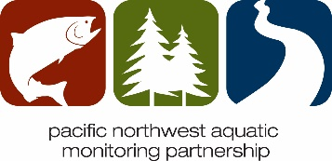
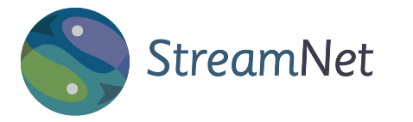
Joint Session StreamNet Executive Committee and PNAMP Steering Committee Meeting NOTES
September 21, 2022, 1:00 pm – 3:30 pm
Location: Portland State Office Building 800 NE Oregon St,
Portland, OR 97232 Room 1E
PNAMP Distribution: see list at end of notes

Agenda
1:00 | Welcome and Introductions
1:10 | Brief Progress Updates:  - Hatchery Coordinated Assessments Exchange (HCAX)  - StreamNet-MonitoringResources.org progress  - Coordinated Assessments Partnership (CAP) Workshop Planning  - Fish Monitoring Work Group (FMWG) Update on Current Tasks
1:55 | Introduce idea of partner needs that StreamNet & PNAMP could support together
2:00 | Partner Presentation: Columbia Basin Collaborative Information Needs - Mike Edmondson, Idaho Governor’s Office of Species Conservation Administrator
2:20  2:30 | Break  What's next? Group discussion of tasks to meet partner needs
3:30 | Adjourn
Attendees
Jody Lando (BPA), Russell Scranton (BPA), Scott Donahue (BPA), Tom Pansky (BPA), Tami Wilkerson (CBFWL), John Arterburn (Colville Tribes) George Batton (ESA/Colville), Denise Kelsey (CRITFC), Doug Hatch (CRITFC), Sheryn Olson (CRITFC), John Cassinelli (IDFG), Mike Edmondson (ID GO), Dawn Anderson (MFWP) Eric Roberts (MFWP), Greg Sieglitz (NOAA), Mari Williams (PSMFC/NOAA), Leslie Bach (NPCC), Art Martin (ODFW), Cedric Cooney (ODFW), Jake Chambers (ODFW), Jamie Anthony (ODFW) Kasey Bliesner (ODFW), Nadine Craft (ODFW), Tom Stahl (ODFW), Ken Fetcho (OWEB), Barry Thom (PSMFC), Lara Erikson (PSMFC), Jeff McLaughlin (USBR), Susan Camp (USBR), Chris Hirsch (USFS), Erin Dlabola (PSMFC/USGS), Rachael Paul-Wilson (USGS), Dan Rawding (WDFW), Brodie Cox (WDFW), Keith Dublanica (WA GSRO), and Tom Iverson (YNFP)
StreamNet Staff: Nancy Leonard, Mike Banach
PNAMP Staff: Jen Bayer, Amy Puls, and Meg Dethloff
Event page with meeting materials: https://www.pnamp.org/event/pnamp-steering-committee-meeting-and-joint-session-with-the-streamnet-executive-committee

Action Items
- Please provide feedback for the joint meeting of StreamNet and PNAMP even if you were not in attendance. Your input helps us improve our meetings to better serve you.
  - MS Survey Form https://forms.office.com/g/8zDqPR4JpQ
Links Shared:
- HCAX project page https://www.pnamp.org/project/hatchery-data-sharing-hcax
- FMWG project page https://www.pnamp.org/project/fish-monitoring-work-group
Notes
Brief Project Updates: Additional information on the project updates below, can be found in the meeting presentation file here: https://www.pnamp.org/document/15225
- Hatchery Coordinated Assessments Exchange (HCAX)
- StreamNet-MonitoringResources.org progress
- Coordinated Assessments Partnership (CAP) Workshop Planning
- Fish Monitoring Work Group (FMWG) Update on Current Tasks

Partner Presentation: Mike Edmondson
Mike Edmonson, Idaho Governor’s Office of Species Conservation Administrator, presented information on the Columbia Basin Collaborative. Mike gave a short background, describing differences between the past Columbia River Partnership Task Force efforts and the Collaborative’s current focus; discussed roles; and emphasized the current focus to establish technical work groups (see Mike’s slides here in the meeting’s presentation). For more background information, see the final CBPTF report: A Vision for Salmon and Steelhead: Goals to Restore Thriving Salmon and Steelhead to the Columbia River Basin: Phase 2 Report of the Columbia River Partnership Task Force of the Marine Fisheries Advisory Committee. A list of the current working groups and contacts is attached to the meeting follow-up email; note that additional names are still being added to the working groups. For more information, please contact Mike at mike.edmondson@osc.idaho.gov.
Polling results
During this part of the meeting, we discussed potential tasks for future work that span both StreamNet and PNAMP. To improve efficiencies and collaboration, we posed a few questions in a live poll format to help identify focused topics. Below are the results from those three questions. Committee members noted that this is relevant to the CAP 5-year plan that was discussed with only the StreamNet Executive Committee meeting earlier in the day. Staff will consider how to streamline the discussion in the future. If you have additional input or would like to add a recommendation, please contact Jen, jbayer@usgs.gov, or Nancy, nleonard@psmfc.org.
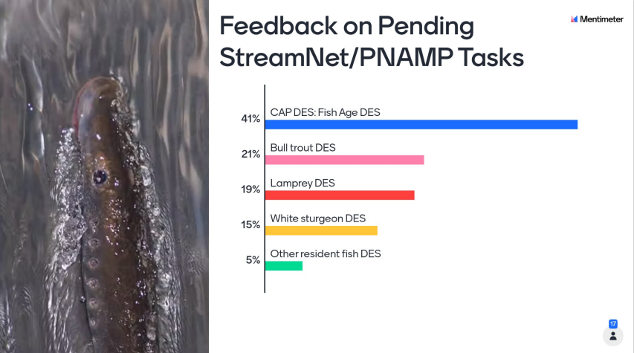
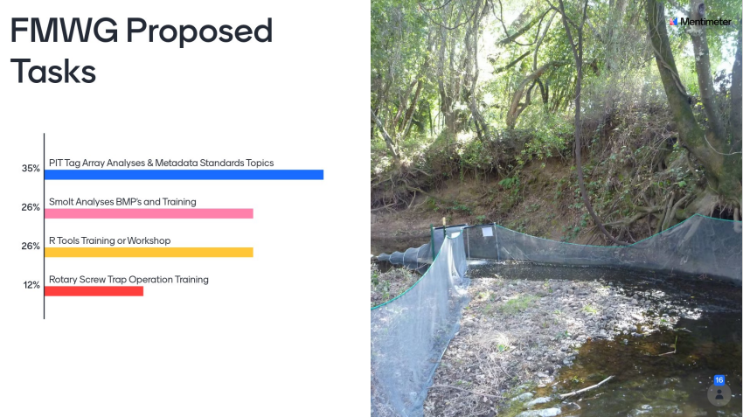
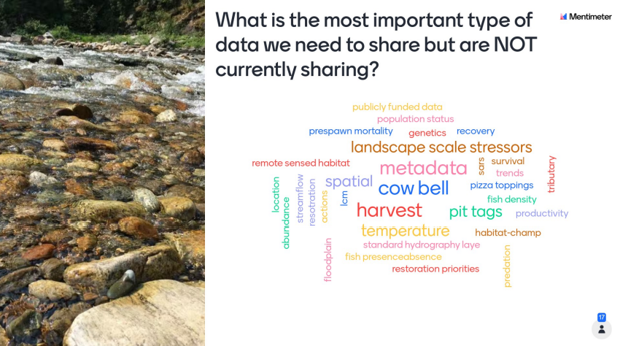

Distribution: PNAMP Steering Committee Signatory Representatives, Alternates, and Courtesy Members as of September 20, 2022.
Partner Entities | Acronym | Type | Name
Bonneville Power Administration | BPA | Signatory Representative | Jody Lando
California Department of Fish and Wildlife | CDFW | Signatory Representative | VACANT
Columbia River Inter-Tribal Fish Commission | CRITFC | Signatory Representative | Denise Kelsey
Colville Confederated Tribes | Colville Tribes | Signatory Representative | John Arterburn
Idaho Department of Fish and Game | IDFG | Signatory Representative | Tim Copeland
NOAA-Northwest Fisheries Science Center | NOAA-NW Fisheries SC | Signatory Representative | Chris Jordan
NOAA-Northwest Region | NOAA-NW Region | Signatory Representative | Greg Sieglitz
Northwest Indian Fisheries Commission | NWIFC | Signatory Representative | Bruce Jones
Northwest Power and Conservation Council | NPCC | Signatory Representative | Leslie Bach
Oregon Watershed Enhancement Board | OWEB | Signatory Representative | Stephanie Page
Pacific States Marine Fisheries Commission | PSMFC | Signatory Representative | Nancy Leonard
U.S. Army Corps of Engineers | USACE | Signatory Representative | VACANT
U.S. Bureau of Land Management | US BLM | Signatory Representative | Mike Brown, Scott Lightcap
U.S. Bureau of Reclamation | USBR | Signatory Representative | Jeff McLaughlin
U.S. Environmental Protection Agency Region 10 | US EPA | Signatory Representative | Lisa Kusnierz
U.S. Geological Survey Northwest Region | USGS | Signatory Representative | Steve Waste
USDA Forest Service, Region 6 | USDA FS | Signatory Representative | Christine Hirsch
Washington Department of Fish and Wildlife | WDFW | Signatory Representative | Dan Rawding
Washington State Department of Ecology | WA ECY | Signatory Representative | Scott Collyard
Washington Governor's Salmon Recovery Office | WA GSRO | Signatory Representative | Keith Dublanica
Bonneville Power Administration | BPA | Alternate SC | Scott Donahue
Bonneville Power Administration | BPA | Alternate SC | Russell Scranton
Idaho Department of Fish and Game | IDFG | Alternate SC | John Cassinelli
Oregon Watershed Enhancement Board | OWEB | Alternate SC | Ken Fetcho
Washington Department of Fish and Wildlife | WDFW | Alternate SC | Brodie Cox
Yakama Nation Fisheries | YNFP | Courtesy | Tom Iverson
Idaho Governor's Office of Species Conservation | ID OSC | Courtesy | Mike Edmondson
National Resource Conservation Service | NRCS | Courtesy | Timmie Mandish
Oregon Department of Environmental Quality | ODEQ | Courtesy | Aaron Borisenko
Oregon Department of Fish & Wildlife | ODFW | Courtesy | Jamie Anthony
USDA Forest Service | USDA FS | Courtesy | Kimberly Conley

