StreamNet Steering Committee Meeting
September 19, 2022
9:30 to 3:30 (PT)
PSMFC (Sellwood), Suite 100
205 SE Spokane Street, Portland, OR 97202
Microsoft Teams Hybrid Meeting

Agenda
9:30 Welcome and introductions (Nancy Leonard, StreamNet)
9:45 Member Updates (Round Robin)
Special spotlight on MFWP, ODFW, and Colville Tribes
11:45 Lunch Break
1:00 Discussion on CAP QA/QC pilot and next steps (Nancy and group)
1:30 Check in on SN Tech Team/DDT and CAP DDT (Mike Banach)
- Connections / SN exchange with monitoringresources.org
- DES refinements
2:00 Discuss draft changes to the CAP Fish HLIs user interface for display groups of population, adding data status for populations without HLIs (Greg Wilke, Nancy)
2:15 CAP 5-year plan - propose and discuss CY23 revisions (Nancy and group)
2:35 2023 CAP WORKSHOP DISCUSSION (JEN BAYER, CAP CORE TEAM, AND GROUP)
2:50 Update November ETIS 2022 (Lara Erikson)
3:00 FY23 Budget and February 2023 SC meeting
3:15 ADJOURN

Attendees:
Attendees: Nancy Leonard, Mike Banach, Cedric Cooney, Brodie Cox, Dawn Anderson, Evan Brown, Russell Scranton, Tom Pansky, Tami Wilkerson, Jacob Chambers, Kasey Bliesner, Jen Bayer, Nadine Craft, Lara Erikson, Mari Williams, Todd Gilmore, John Arterburn, Kris Homel, Angie Schmidt, Stan Allen, Ryan Klett, Megan Detloff, George Batten, Matt Schwartz, Neil Ward, Denise Kelsey, Michelle Groesbeck, Sheryn Olson

Action Items:
- Add to future meeting agenda
  - data sharing agreements
  - Could we have a ‘success in hiring’ presentation/something? How can we help each other figure out ways to invest in staff in order to retain/attract staff?
- Expand CAP QA/QC pilot to capture more metrics to inform ROI assessment, and expand to include Trends records. When Greg returns, they will look at tools and how to improve the exercise and will circulate proposal to group for review; then move forward with a new set of records in 2023-2024 for an expanded pilot
- Mike will share the age query mockup slides with the group to receive input on the proposed query
- Mike and Mari will suggest to CA DDT to standardize population names
- Nancy will present the CAP map query mock up for displaying data availability and CAP HLIs by MAFAC Stocks from today’s meeting to the SN ExCom for their review then finalize for implementation.
- Nancy will present the proposed track changes to the CAP 5-year Plan to the SN ExCom for their review and to finalize updating the plan for this year.
- Jen will send out a doodle poll to identify the CAP Workshop date for 2023
- Next SN SC Feb 21-22; group dinner evening of Feb 21, meeting will be hosted by IDFG in Boise, ID still with a remote option

Meeting Documents:
All meeting documents are available from the StreamNet Steering Committee webpage:
- Five-Year Plan for the Coordinated Assessments Partnership adopted 20190731 (revised 9Sept2021)
- PowerPoint slide deck
- Agenda

Meeting Notes:

Welcome and introductions
ODFW: Cedric Cooney, Kasey Bliesner for Spotlight (See slide images at end of minutes)
Spotlight: Grande Ronde Basin Creel Surveys done to estimate harvest of summer steelhead, track wild fish impacts, estimate hatchery fish harvest and hatchery program success (did both angler interviews and angler/ boat/ trailer counts- found that anglers were targeting more species than anticipated)
- Transitioning from paper data collection and now using ArcGis Survey 1-2-3 for mobile data collection; can use even when disconnected from wifi/ cell service; added in species ID guides for surveyor use; data is stored on the device until back in service and can download to server
- Did a complete database redesign over the course of a year (updated structure, interface, added missing data, creel survey harvest expansions)
- Saved one person’s worth of time for the season by updating the database structure and implementing Survey123
- Prefer using an iPhone (newer ones are fairly waterproof) over a ruggedized tablet
- Data has not yet been downloaded into FINS
- They are deleting the data from Survey 1-2-3 each year to avoid cloud storage fees.
Other info: submitted NOSA for John Day populations, received bump in funding for StreamNet work from ODFW portfolio management, rolled into Information Systems division, have positions to fill, data sharing and non-disclosure agreement is taking up a lot of time (may be modified in next legislative session to be able to share with partners more easily). Could add data sharing agreements topic to future meeting agenda

Colville Tribes: John Arterburn, George Batten and Ryan Klett for Spotlight (Sees slide images at end of minutes)

Spotlight: Performed the 4-year EDT update. This year had more work when running the 3-year modeling cycle due to changing protocols/ processes as they are transitioning from transect-based data collection framework to GIS-based data collection framework to support more rapid, mobile mapping of habitat and metadata and the ability to store/ manipulate the date in SQL. This better represents the landscape, as sometimes the sampled reach was not representative of the section.
- Have nearly complete LIDAR modeling to utilize across the floodplain with the ability to track changes over fine resolution
- Their updated process was published in Fisheries magazine and received an award from Society for Ecological Restoration NW for their work
https://ecosystems.azurewebsites.net/hstr-okanogan/
https://ecosystems.azurewebsites.net/hstr-methow/
https://www.okanoganmonitoring.org/
Other info: Ryan and George handling all the work well, while John is handling lots of other tasks

MFWP: Dawn Anderson and Spotlight (See image at end of minutes)
Spotlight: Closures and Restrictions Web Mapping Application (ESRI Experience Builder) for all FWP owned and managed lands. Public could not see a statewide view of the closures/ restrictions so a comprehensive web map was built that displays info from various internal systems. Data is displayed by site type about closures, such as fire related closures and use restrictions. The content displayed is provided by the responsible divisions. The division determines who is responsible for the data management for their division, and then the responsible person updates the content. For content that requires Commissioners' approval, the content can be entered in' stage' and then released once approved.
- Are the symbols (shape / colors) visible for color blind individuals? ESRI states that accessibility is a key framework component of Experience Builder. It’s unclear if all symbol selections and colors are ADA compliant however. .
https://experience.arcgis.com/experience/ba378e9a50ec4d53bbe92e406b647d3e
Other info: trying to fill positions that are currently on fourth round of recruitment, focusing on high priority items, working on a geospatial strategy and implementation plan for the agency (Dawn will share draft when it’s ready to go), assisted BPA by creating a web map of Montana’s data they can view and filter.

Shoshone-Bannock Tribes: Kurt Tardy
Not in Attendance; No update provided

IDFG: Angie Schmidt and Evan Brown
- Reorganized into new Technical Services Bureau and moved into new headquarters building
- Working on
  - pulling together a data warehouse,
  - transitioning from paper collection to Survey 123,
  - StreamNet metrics and CA HLIs are on track,
  - working on expanding and updating mobile apps

CRITFC: Sheryn Olson and Denise Kelsey
- Annual Inter-Tribal Monitoring Data (ITMD) Project meeting held in April: Agenda and Presentations available here on CRITFC.org
- Continuing to use the Data Management Maturity Model. It is an assessment tool that was piloted in 2019 and was applied in 2020-2021 to assess status of datasets and systems; can help identify prioritizations of resources and track progress of data systems.
- Using Survey123 for data collection for many of the tribe’s projects- ESRI offers great discounts for the tribes; as long as you are only using it to move data to the cloud and to your systems it’s not very expensive (they charge more for data storage)
- Planning to hire a consultant by February 2023 to improve the tribal centralized data management systems software.
- CRITFC and its member tribes now have most of their legacy datasets stored in centralized data repositories.

NPCC: Kris Homel
- Working on compiling info for performance indicators and migrating info into program tracker
- Working on performance assessment, and has spent some time reviewing the program history. Now moving to program category assessments

BPA: Russell Scranton, Matthew Schwartz, Tom Pansky
- 2020 CRSO population status and trend includes identifying which projects support which populations and providing that information to NOAA
- Working on DES development for sharing juvenile density data and carrying capacity (FishDataAnalysisTool- FDAT)
- FMWG task group focused on standardizing snorkeling and electrofishing data fields to facilitate exchange. ODFW and IDFG participating in the pilot exchange
- May be opportunities for sharing hydrography and NHD layers to make sure naming conventions are consistent across the region, and increase access to standardized names and their use by biologists.
- Data exchanged on red survey would benefit by standardizing/coordinating name of reaches and streams

CRITFC Library: Tami Wilkerson
- Working on reconciling source docs for SN references since 2020- currently 60% of the way through the project
- Sending out quarterly lists of newly published journal articles to anyone who would like to receive it; open to suggestions on format/ content of lists. Content is not restricted to Columbia River Basin. Next quarterly list of publications coming out October 15.

USFWS: Todd Gilmore
- Wrapping up initial testing of AquaManager software to manage hatchery production; same program used by CDFW

WDFW: Brodie Cox
- Commercial Catch Accounting mobile reporting system rollout on Oct 1 to complement ETix
- Working on
  - electronic catch record card,
  - expanding creel system (Tier 2 Harvest Data Database),
  - turning SASI database into SPI database to mimic CAX pieces (reverse engineering of CAX) and allows adding on additional indicators as needed
  - MOU with Puget Sounds for data sharing
- Hiring to revamp hatchery database, hired new GIS employee, new commercial data reporter
- Been absorbed by central IT
- StreamNet metrics and CA HLIs are on track

NOAA: Mari Williams
- Released status review for interior Columbia populations; no info on when others will be released
- Working with PSMFC Staff (Nancy Leonard) and NOAA staff on Salmon Dashboard that would make more NOAA data sets publicly accessible

PNAMP: Jen Bayer
- Great AFS symposium and content is available for 6 months
- Becca Scully now with USFWS as data manager for the Pacific Seabird Program
- WA RCO Salmon Recovery Conference is calling for abstracts through Oct 5
- PNAMP Habitat Metrics Integration project has produced a paper hat is being published with suggestions on improvements to apply FAIR to data sets

StreamNet: Nancy, Greg, Mike, Van
- No update provided

Discussion on CAP QA/QC pilot and next steps (Nancy and group)
Pilot tested whether CAX records would benefit from being reviewed by the data stewards from the data providing agency/tribe to review the biological data, and having data stewards from another agency/tribe reviewing records for comprehension of text fields and meaningful URLS. Part of the outcome is to document which records have gone through the additional QA/QC step and share that with the data consumers.
Summary of Pilot Tasks
- Review assigned records using QA/QC web app
- Data Stewards focus on accuracy (IDFG, ODFW, WDFW reviewed their own records)
- Independent focus on comprehension (MFWP reviewed a subset of all the records)
- Provide input on process and the review tool
- QA/QC plan & pilot implementation plan are posted on website
Summary of Pilot Outcome
- Time range of record reviews 5 min to 3:30 hrs (Most took about 7 minutes)
- Review identified: broken links (biggest problem), some questionable data entry, and potential validation rules that could be added
Questions
Was this value added?
- Yes, in general. Many issues could be resolved with data validation rules in the future, better flagging of issues by the data consumer; would like to know what errors were found in the data – provide results from the QA/QC form that describe input from MFWP on the data providers’ records so that they can respond to feedback and make clarifications.
- Should do more ROI assessment to determine the scope of what should be done going forward, which fields/data categories to focus on. Would be informative to know what types of errors and discovered and how many records were impacted
- Mining for broken URLs could be done automatically. But appropriateness of the URL still requires human review.
- Those data stewards who will be performing the QA/QC should participate in refining the online QA/QC form to capture additional details that would inform ROI assessments.
- Would like to know what triggered the time discrepancies in the review time per records
- Would be beneficial in the future to review others data, but for now will continue with reviewing own data (comprehensive and biological)
If value added how can we improve documentation?
- Capture in web-app via comment box?
- Is timestamp of updated field in CAX enough?
- Add separate fields/assignments in web-app for independent reviewer
- Expand to include Trend records
If value added, how many records should we aim to complete per year or per quarter?
- Would be a TBD percentage of records per year that got reviewed

Group will continue with pilot into 2023-2024 and plan to expand metrics to inform ROI assessments to determine out-years, as well as expand to include Trends records.
When Greg returns, they will look at tools and how to improve the exercise and will circulate proposal to group for review; then move forward with a new set of records in 2023-2024 for an expanded pilot

Check in on SN Tech Team/DDT and CAP DDT (Mike Banach)
Connections / SN exchange with monitoringresources.org
DES refinements
Update on connecting StreamNet and monitoringresources.org
- February 2022: SN Technical Team discussed concepts for connecting MR Study Plans to SN Fish Monitoring Data (FMD; aka “trends”) and CAP HLIs
- April 2022: agreement on data connections to pursue in 2022-2023 for FMD only and SN DES changes.
- July 2022: MR developed a plan and resources to facilitate connecting BPA Project & study plan to FMD and StreamNet implemented DES modifications.
- Sept 27th: Kick-off meeting to begin collecting data starting with IDFG & ODFW data compilers
Fish Monitoring Data ("trends")
- Summary of DES refinements (do not reuse trend ID, make sure hatchery names are unique)
Age data query
- A separate query system will be made for age data. Will be able to query and display by brood year and/or sampling year. Mike will share the age query mockup slides with the group to receive input on the proposed query
CAP Populations table cleanup
- Removal of MPG & ESU from non-listed populations (done)
We will suggest to CA DDT to standardize population names:
- All natural populations and hatchery stocks have names in the form <location(s)> <run(s)> <species>. For example, "Big Creek winter Steelhead".
- Include specifiers such as "River" and "Creek" and "Hatchery" in the name.
- Do not use hyphens unless necessary, such as for "mid-Columbia".
- Use "and" for multiple locations; use ampersand for multiple runs.
- Do the best possible when those rules cannot apply perfectly. For example, "John Day Basin wild summer Steelhead".
- Clarifying information goes in parentheses; information in addition to the name goes in square brackets.
- Capitalization: The first word, and proper nouns, are capitalized; other words are not. AFS considers official common names to be proper nouns, e.g. "Bull Trout". We will follow AFS's lead.
Mike and Mari will work with group on finalizing proposed changes

Discuss draft changes to the CAP Fish HLIs user interface for display groups of population, adding data status for populations without HLIs (Greg Wilke, Nancy)
Received suggestions from Fish Monitoring Workgroup and ExCom approved in 2021 moving forward with several:
- Provide additional filters (e.g. population name, HLI, pop fit, methods, compiled by)
- Remove ‘non-trt’ from pop names
- Display partial population estimates (subpop) with whole population estimates; place whole estimate at top and differentiate clearly from partial.
- Provide info on data availability for all populations without CAP Fish HLIs/related trend
- FMWG Data Display reviewed data and provided input on display
- Mock up display for map query ready for input
Several of the proposed changes have already implemented (see slide). Some, such as separate out HLIs for different groupings (e.g. Multiple pop; MAFAC-NPCC groups) was implemented for the new tabular query but not yet implemented on the CAP Map query pending better understanding of how to display the MAFAC CBTFP stocks.

For today’s meeting we are proposing how to implement the requested changes related to: data availability, and MAFAC CBTFP stocks. The mock up shared today was informed by a follow on FMWG Data Display task group that further discussed how to implement these changes to the CAP HLI map query. The FMWG Data Display participants provided input on how to implement these items as well as reviewed the content to be displayed.

Questions
- Overall supportive of the mock up.
- Possible to also add a minimum abundance threshold or other ‘delisting criteria’ for populations with HLIs? This can be misleading and was not standardized between TRTs; that will require further discussions and clarifications on those variable targets

Nancy will present the mock up from today’s meeting to the SN ExCom for their review then finalize for implementation.

CAP 5-year plan - propose and discuss CY23 revisions (Nancy and group)
Summary of proposed changes thus far:
- Correct old URLs, typos, remove obsolete info (e.g. priority populations, StreamNet trends)
- Clarify and update CAP/StreamNet specific target text (e.g., Fish Monitoring Data etc.)
- Add Bull Trout DES development steps in anticipation of regional support for development
- Clarify white sturgeon DES text and steps
- Update HCAX hatchery indicator content, working on pilot for data flow
Completed 2021, 2022 tasks; and postponed harvest indicator task

Questions
Would it be beneficial to be able to aggregate juvenile distribution data and capture that for the status assessments and 5-year plan?
- Fish Monitoring Workgroup is beginning to talk about how to do that, how to standardize it, how to develop the database, etc. StreamNet already has that data available (Russell can’t find option to select Juvenile Distribution)
- It would be helpful to know what has already been defined in the DES.
- We also need to know what NOAA wants in terms of juvenile density or presence/absence (not carrying capacity) for ESA reporting for VSP attributes in the 5-year status review cycle

Nancy will present the proposed track changes to the CAP 5-year Plan to the SN ExCom for their review and to finalize updating the plan for this year.

2023 CAP Workshop Discussion (Jen Bayer, Cap Core Team, and group)
Why:
- support CAP community of practice to collaboratively agree on important metrics and indicators benefiting from a standardized and efficient exchange process to inform regional assessments and reporting;
- been 5 years since last workshop
Expected outcomes:
- Identify current and future data access challenges (provider/user perspectives) and propose solutions
- Confirm data that inform regional assessments (research, management) that would benefit from inclusion
- Strategies for collaborative approaches and funding to address needs and challenges
When: TBD April 2023 (watch out for Spring Break); 1 or 1 1/2 days; dependent on final agenda
Who: All CAP Data Providers and Data Users, and including:
- StreamNet Steering Committee, DDT, Tech Team
- StreamNet Executive Committee
- PNAMP FMWG members active in relevant tasks
- PNAMP Steering Committee
Workshop Agenda Will Focus on Problem Solving:
Data Submittal Issues
- Issue 1: Connecting quality metadata to datasets
- Issue 2: Expected Content is not being submitted in existing DES for natural origin salmon and steelhead
Data Retrieval/Data User Issues
- Issue 1: Data Consumers accessing CAP CAX and other salmonid related regional data systems can’t easily map stocks, species, populations between these systems e.g., FishGen, RMIS, PTAGIS, CAP CAX, FINS, etc. How can we streamline access for data consumers?
- Issue 2: Mismatch between field names shown in CAP queries and the data providers’ public website. How can we alleviate confusion or concerns about the data in CAP CAX?
- Issue 3: Other ways we can improve data for the same stock/population that resides in multiple systems more easily accessible?
- Issue 4: Discuss whether updated data queries for accessing data for groups/stocks is adequate to support Columba Basin Collaborative data needs, another target user, or are other improvements needed?
Review Accomplishments and Plan for the Future:
- Refresher on the CAP structure and processes
- Results from the past 6 years (what has changed since the last CAP Workshop in 2017)
- CAP’s Next Data Categories
- Review the data categories/species identified in the CAP 5-year Plan
- Discuss intent to explore development for next HLI data category DES (perhaps Bull Trout) in FY24-25 and possible grant funding
- Discuss other data category/species to be tackled next – what and when? Habitat? Sturgeon?
- Preparing for the future of efficient data exchanges
- Funding opportunities
- Future of data mobilization

Questions/Discussion
Overall supportive to hold the CAP Workshop in 2023 with potential April date.

Jen will send out a doodle poll to identify the CAP Workshop date for 2023

Update November ETIS 2022 (Lara Erikson)
https://www.pnamp.org/project/emerging-technologies-information-sessions-2022
Conference Dates | 14 to 16 November 2022
Registration Deadline | November 10, 2022 or until sold out
2022 Emerging Technologies Information Sessions for Aquatic Monitoring and Data Management
- 63 presentations (50 oral and 13 as posters)
- Registration fee is $150 for in-person or virtual.
- All attendees will have access to the recordings afterwards.
- This is the perfect event for you if you want to...
  - Learn about the latest technologies in aquatic monitoring for data collection, data management, and data visualization.
  - Share how you’ve improved your work with technology.
  - Network with other monitoring professionals implementing technologies in new ways.
Lodging Reduced Rate Deadline | October 15, 2022 Best Western Plus Hood River Inn
Rooms available at the reduced rate of $149 per night plus tax. Call 1-800-828-7873 and indicate that you are attending ETIS. Reduced rate deadline is October 15, 2022. FY23 federal government per diem rate available for federal employees through October 15, 2022; government ID and travel authorization required upon check-in.
Key Note Speakers
Monday: Mark Saunders from the Pacific Region International Year of the Salmon/North Pacific Anadromous Fish Commission: The High-Tech Future of Salmon Resource Management: Marvel or Muddle?
Tuesday: Samantha Chisholm-Hatfield from the Oregon State University: Traditional Ecological Knowledge (TEK)
Wednesday: Leila Kaneda from SightLine Applications: Machine Learning – Your New Best Friend

FY23 Budget
- Mari Williams & Monica Diaz are being brought on due to Nancy being partially covered by RMPC and FINS
- Subcontracts for FY23 are in process (cost & time amendments for some, others receiving new subcontracts.
- IJFA funding has been secured

Next SN SC meeting Feb 21-23, 2023; group dinner evening of Feb 21, meeting will be hosted by IDFG in Boise, ID still with a remote option

SLIDES / IMAGES FROM THE 3 SPOTLIGHTS

ODFW
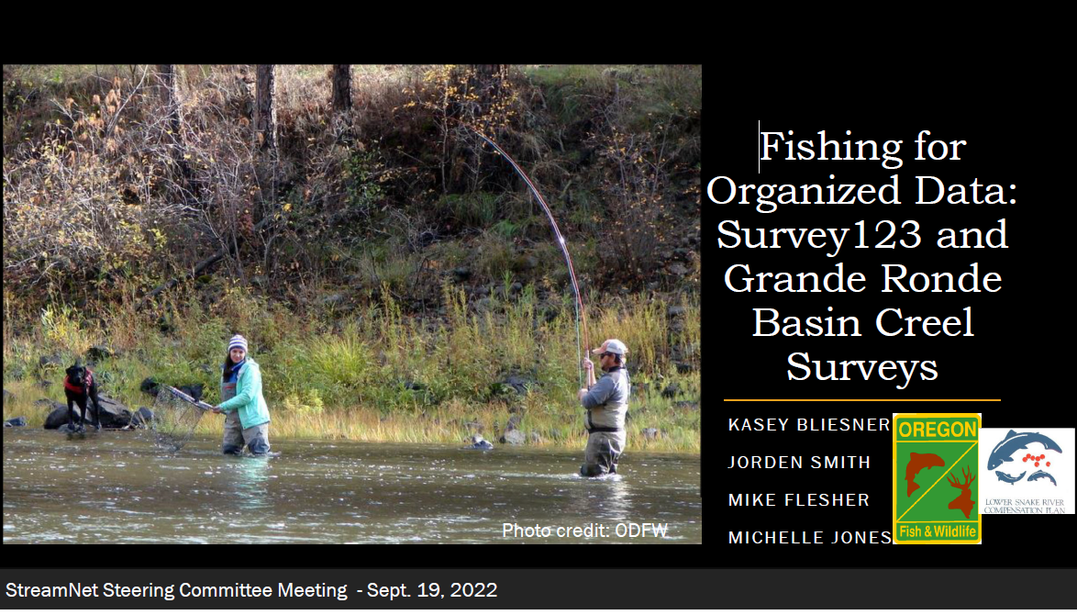
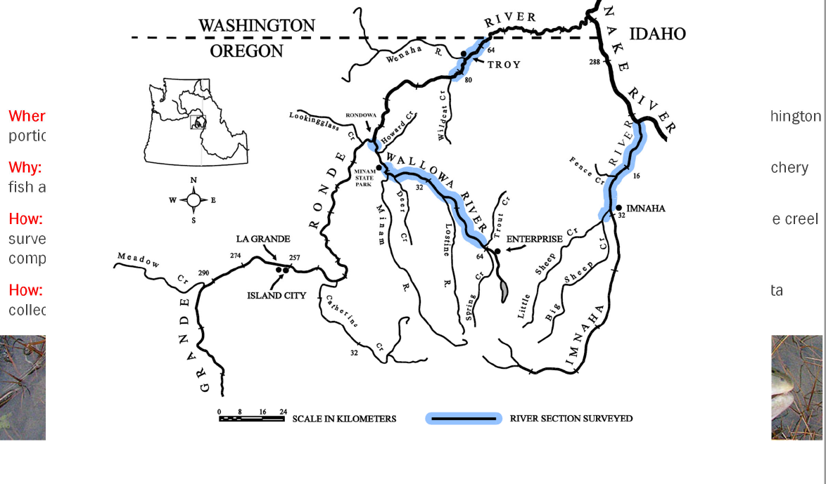
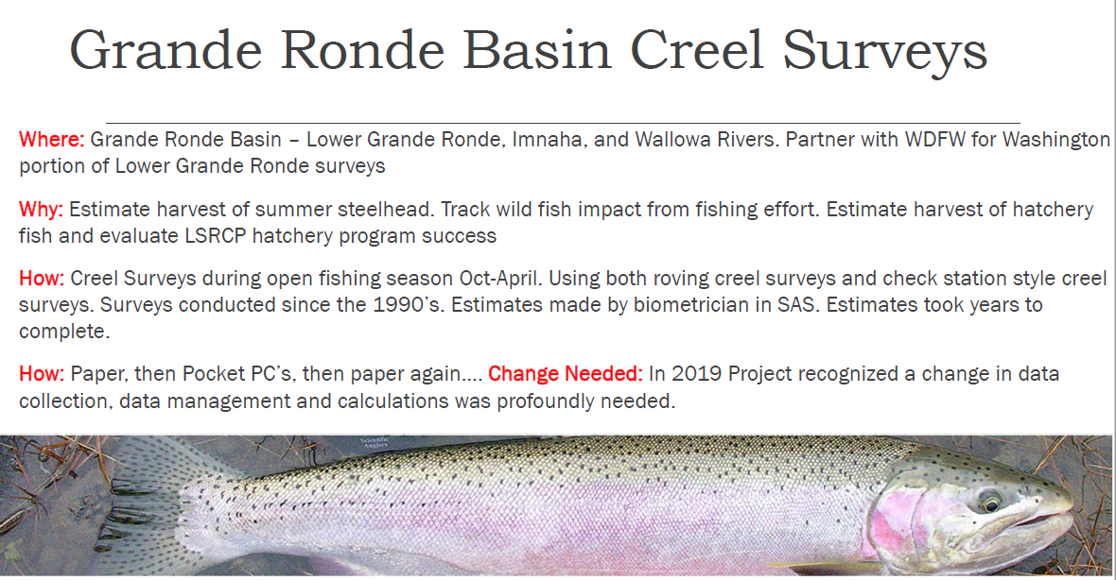
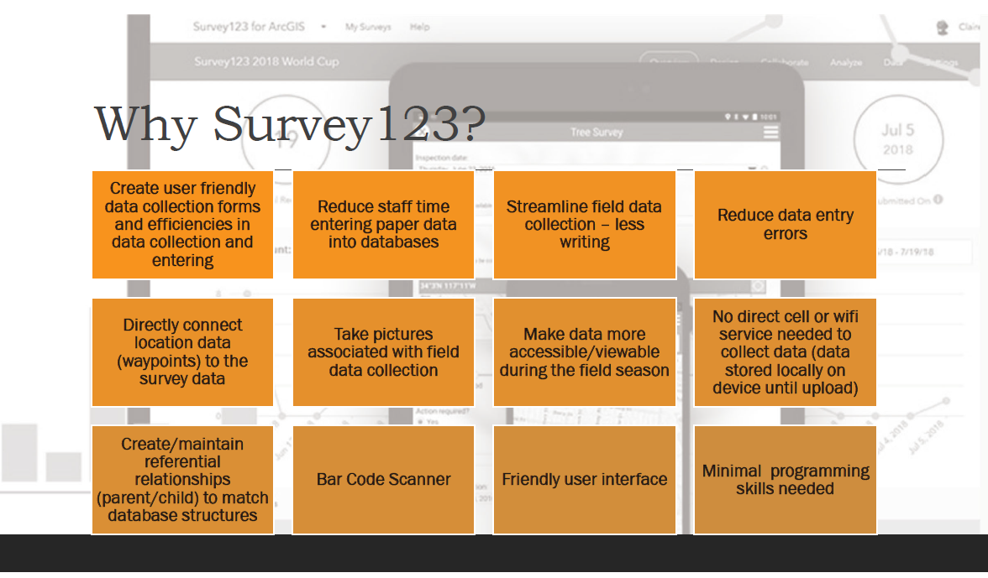
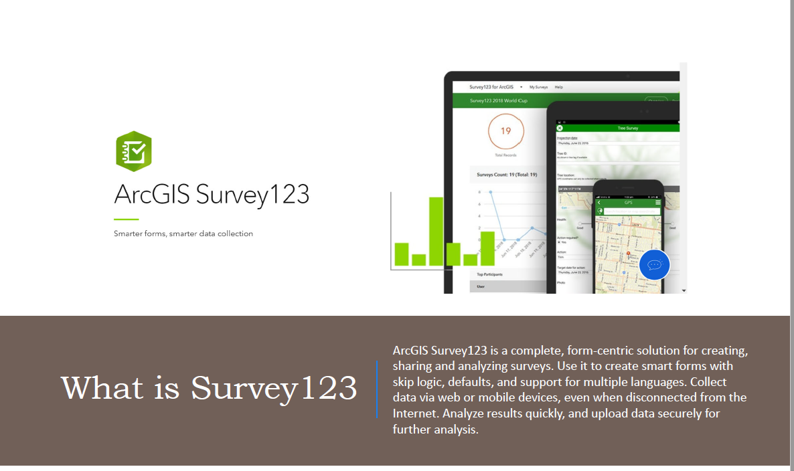
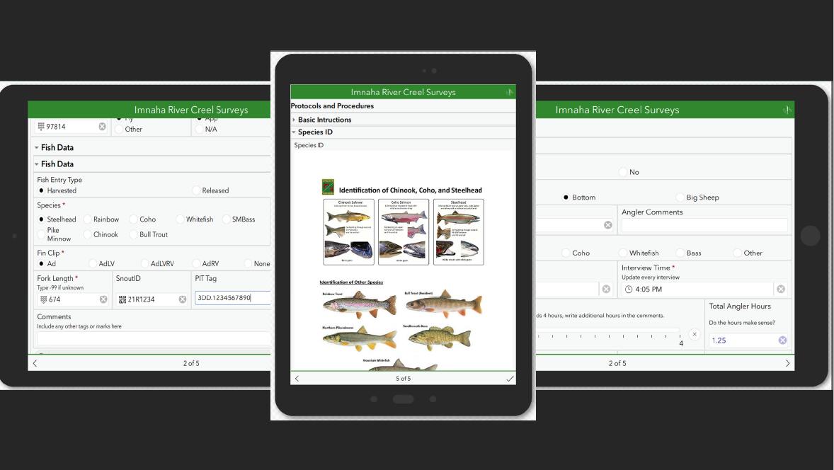
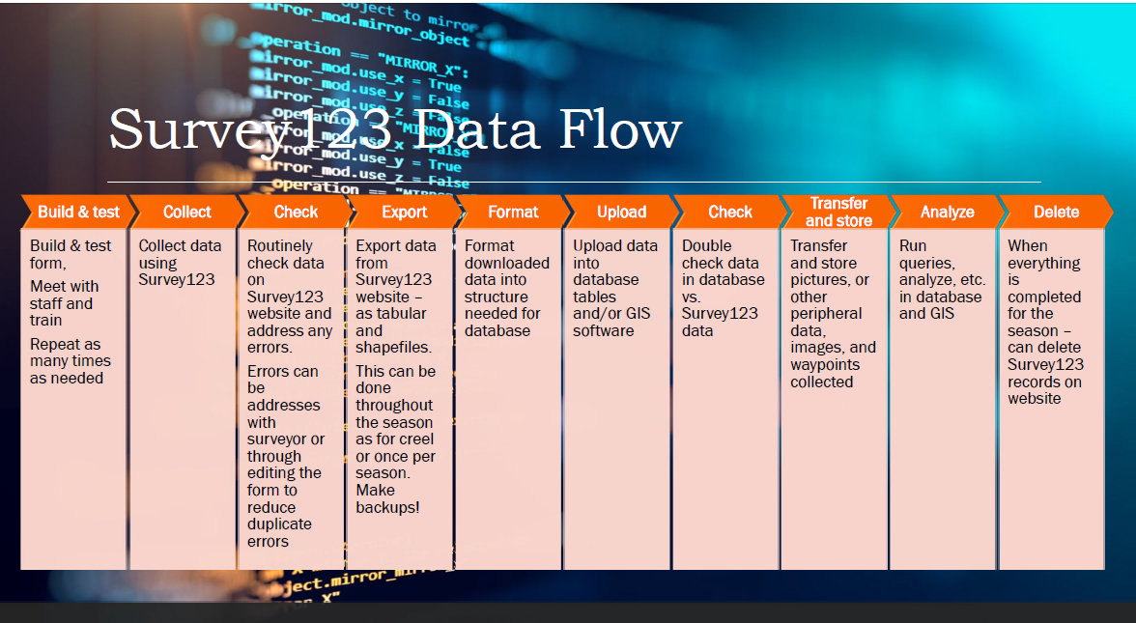
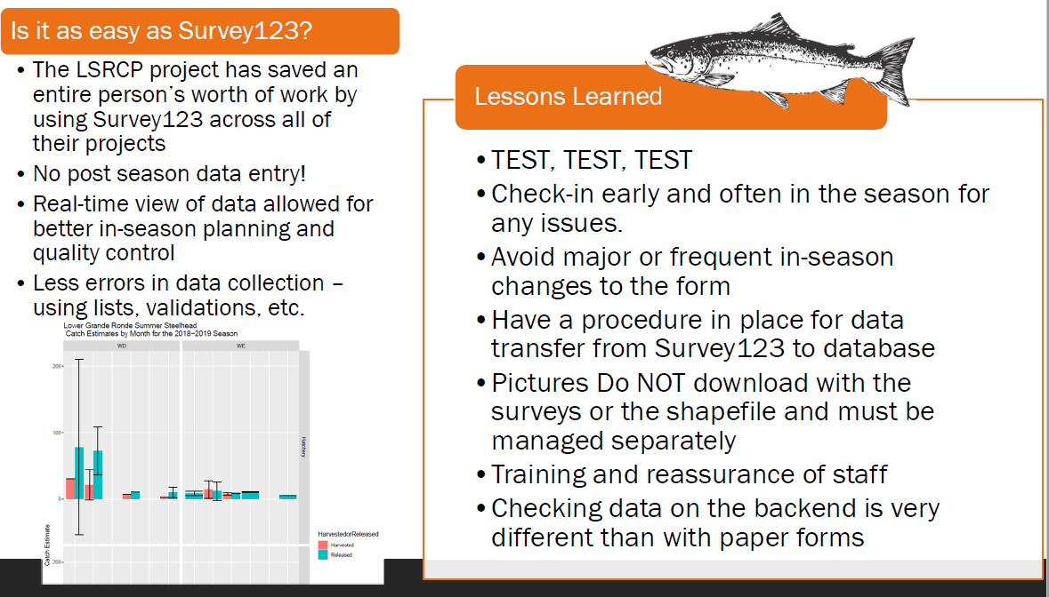
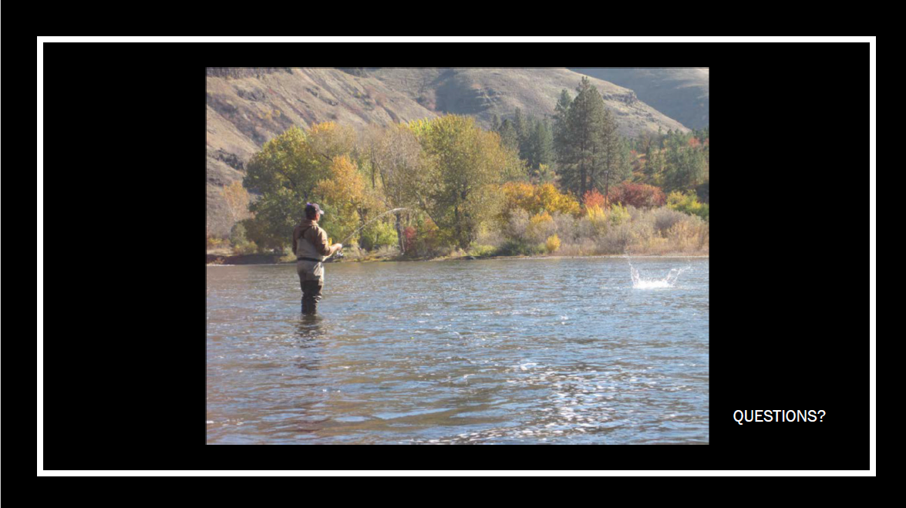

Colville Tribes

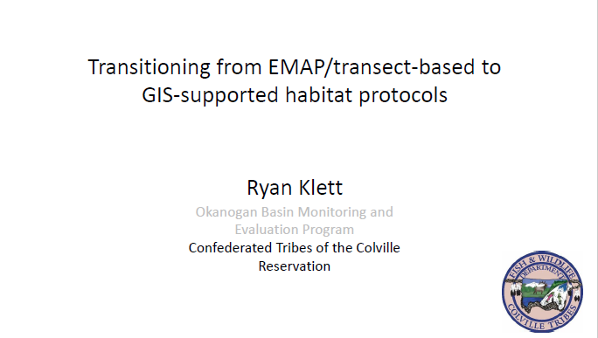
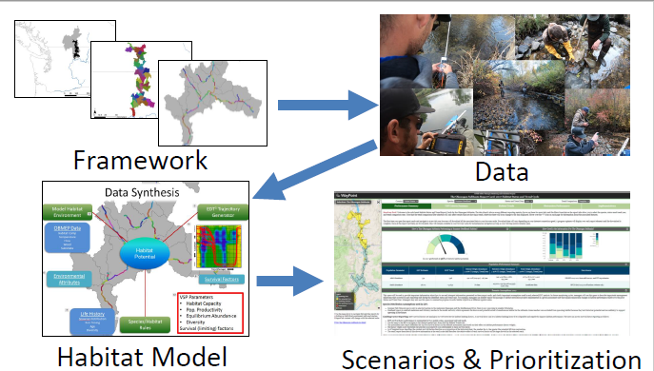
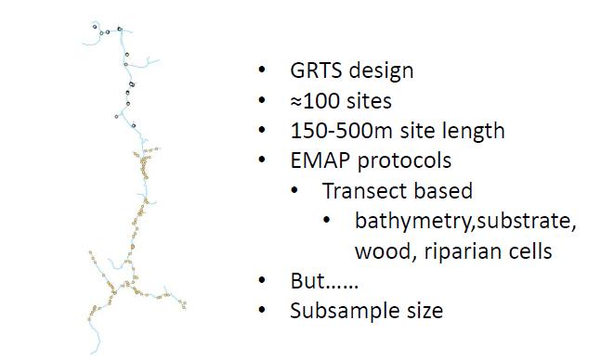
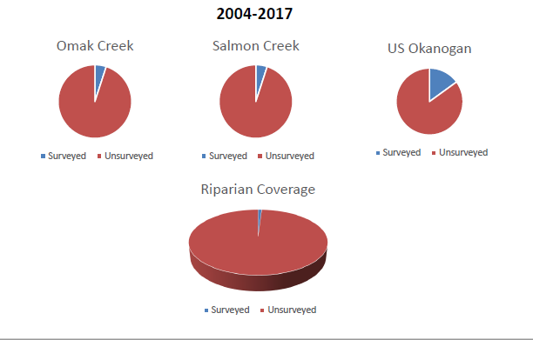
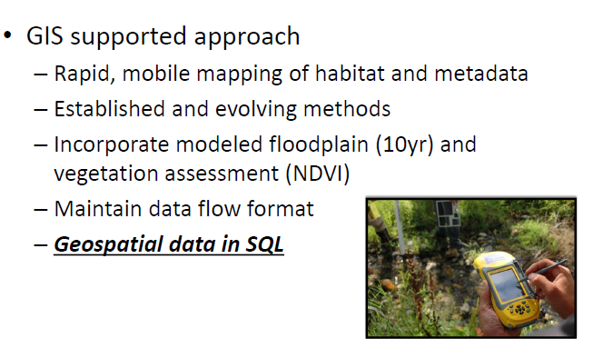
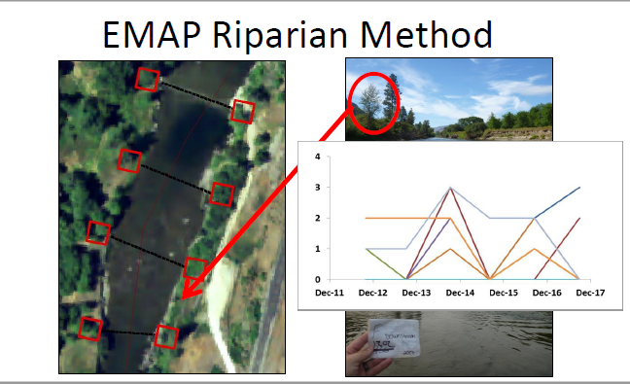
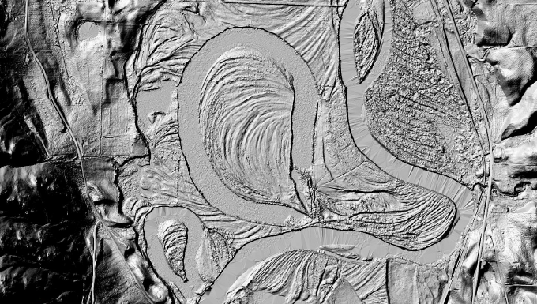
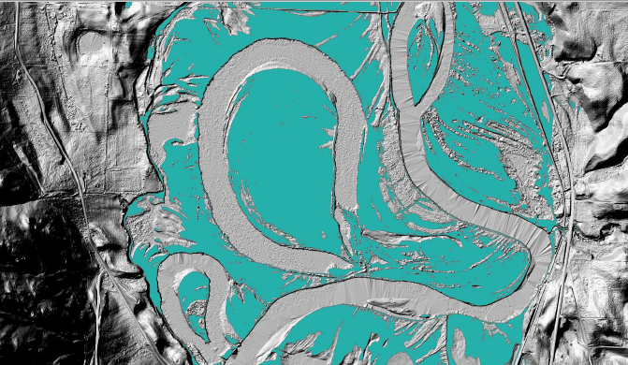
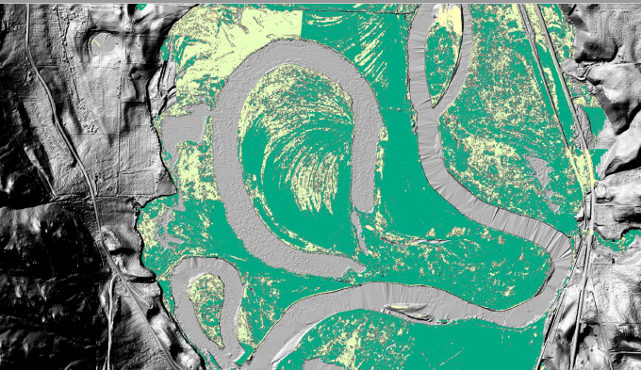
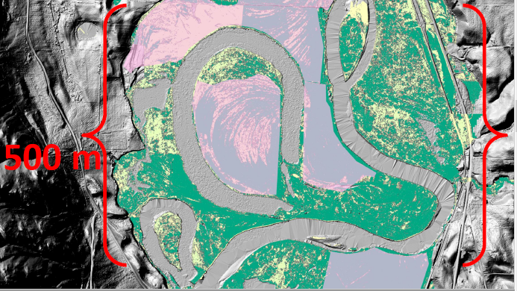
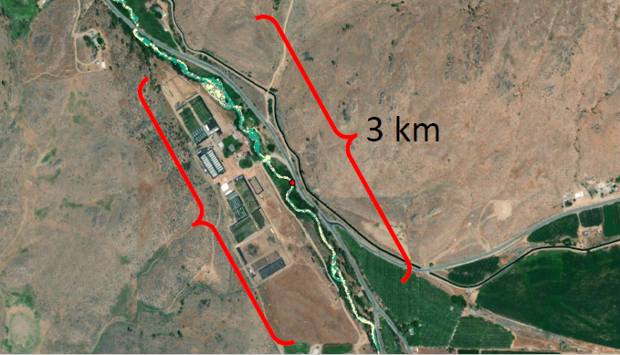
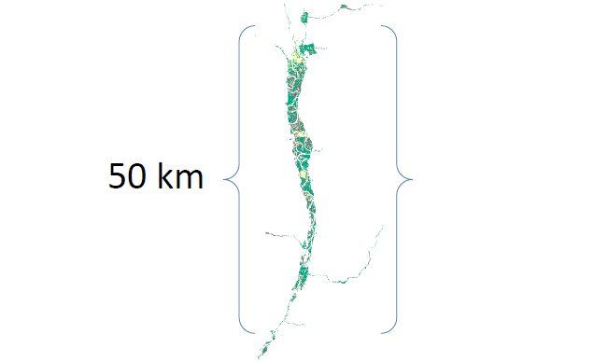
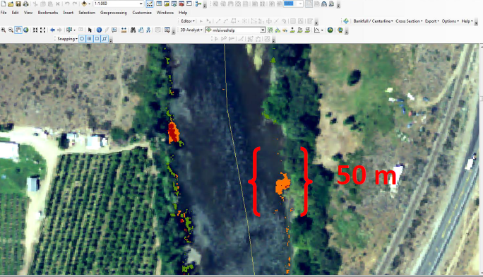
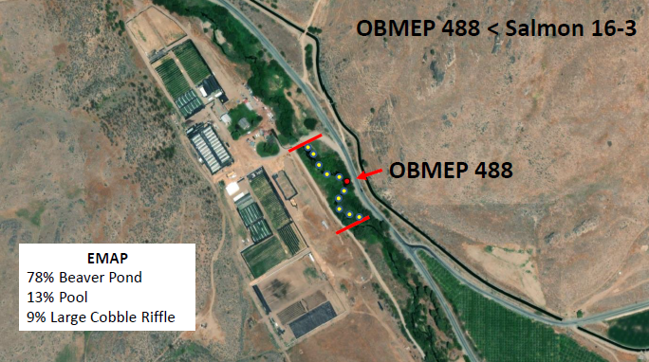
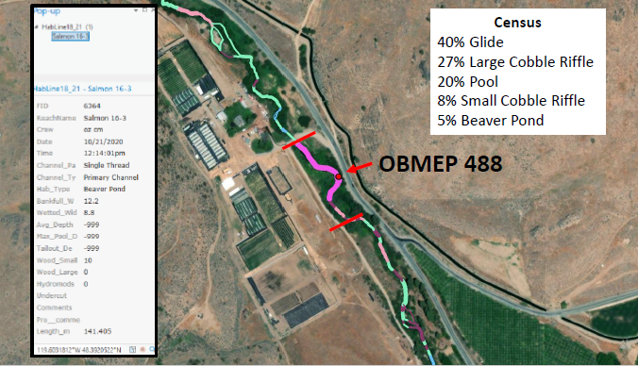
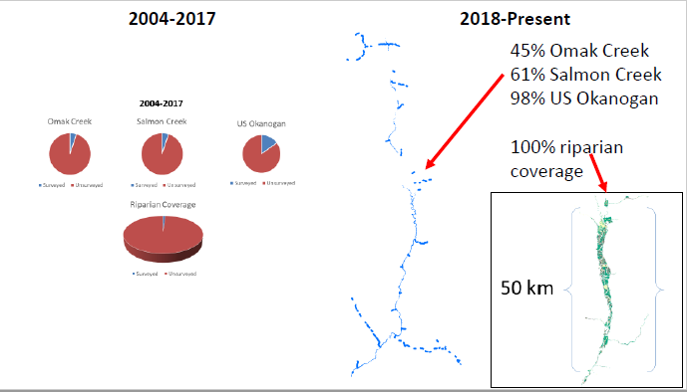
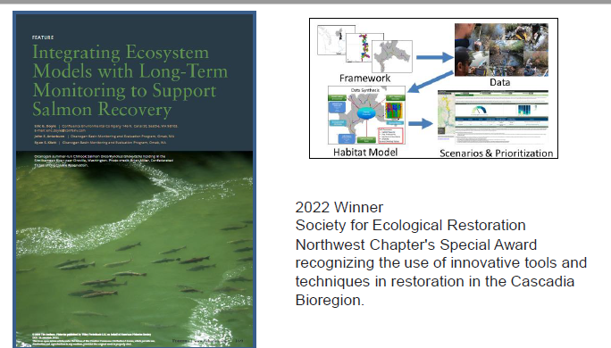
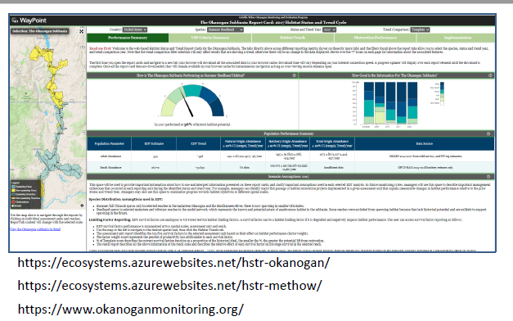
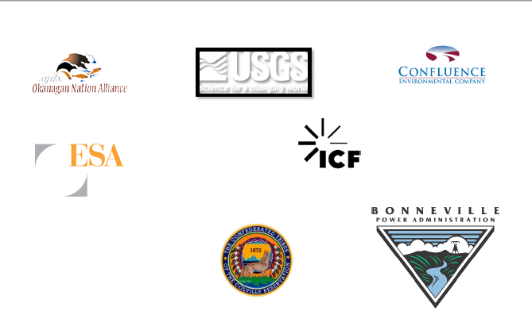
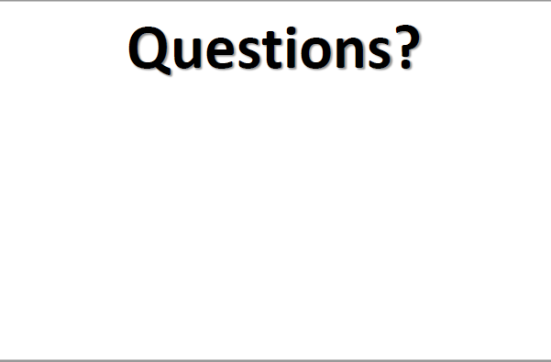

MFWP
Closures and Restrictions Web Mapping Application (ESRI Experience Builder) https://experience.arcgis.com/experience/ba378e9a50ec4d53bbe92e406b647d3e

