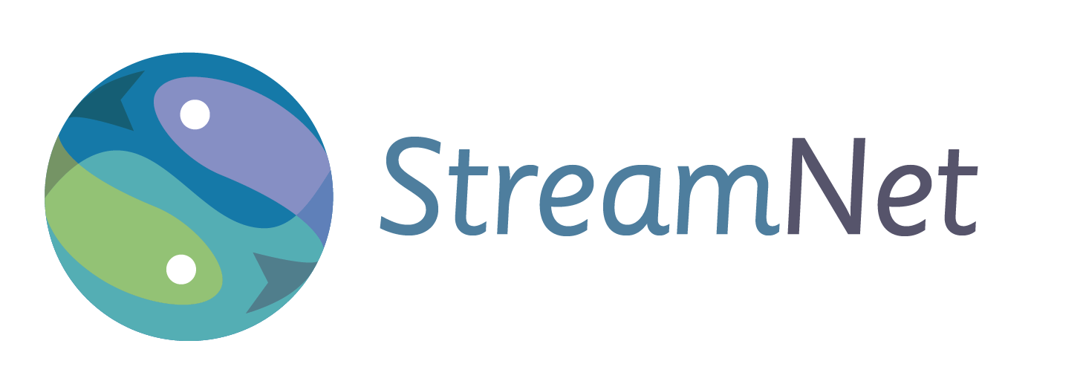
StreamNet 2015 Annual Report

StreamNet provides access to regional fish data by maintaining a coordinated, standardized, web-based distributed information network. The need for regionally coordinated and readily accessible data has been identified by the Northwest Power and Conservation Council (NPCC), the Bonneville Power Administration (BPA), and the National Oceanic and Atmospheric Administration’s National Marine Fisheries Service (NOAA-NMFS). StreamNet works cooperatively with the agencies that create the data through StreamNet-supported technical staff inside these agencies and by leading or coordinating a number of initiatives to aid in assuring a regional approach to data management.

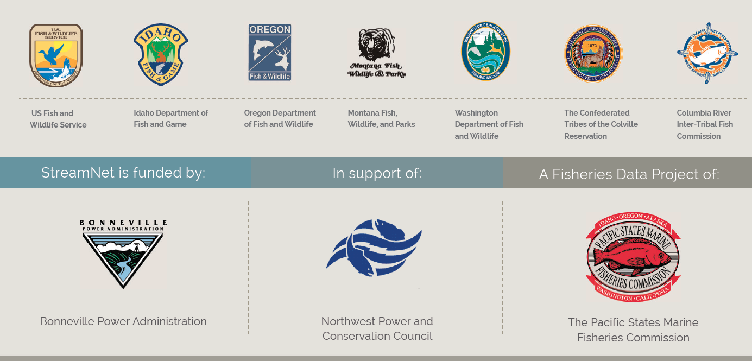

During 2015 StreamNet continued to help lead implementation of the Coordinated Assessments (CA) project. Accomplishments included adoption of a 5-year Plan for the project by the StreamNet Executive Committee, collection of data from partners on the first indicators, and continuing development of Data Exchange Standards (DES). In 2015 a decision was also made to resume updates of certain prioritized standard data trends, such as those related to the CA project or feeding the NPCC dashboards. CA focuses on the key indicators and metrics that have been identified as priorities for reporting progress on implementation of the Federal Columbia River Power System (FCRPS) Biological Opinion (BiOp). At the end of 2015 BPA identified a need to gather as much data as possible for populations they determined were priorities, and efforts were begun to assist in this effort.

States and tribes provided available data for the first indicators to StreamNet in 2015. This table shows the data flow for populations (as outlined by the Technical Recovery Teams (TRT));

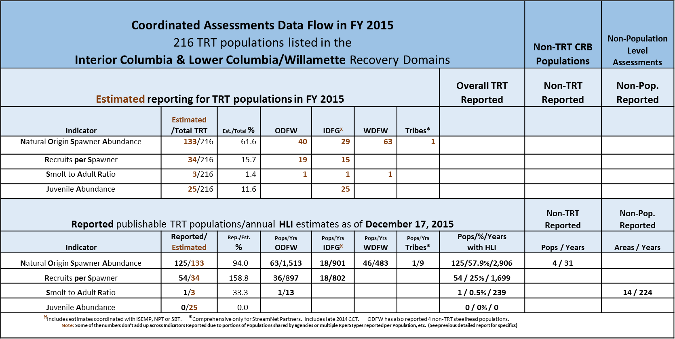
^{Ӿ}Includes estimates coordinated with ISEMP and/or NPT *Comprehensive only for StreamNet Partner Tribes * HLI = High Level Indicators; TRT = Technical Recovery Team; CRB = Columbia River Basin
Staff at PSMFC and subcontracting agencies also continued implementation of the BPA secure data repository initiative, and StreamNet maintained the Data Store as a Repository for any BPA projects without identified secure repositories. Staff provided leadership and support for a second workshop on hand held technology for fish data projects, in collaboration with the Western Forestry Association, PNAMP and Sitka Technologies. StreamNet partner staff participated in or presented findings at this workshop.

A wide variety of data types were disseminated through the StreamNet website in 2015 (www.streamnet.org). Improvements to the appearance and accessibility of data on the website were made in 2015. Work commenced on a new query system for use and display of the CA data. Average time on site, average number of page views per visitor, and use by key data providers/users such as state and federal agencies all increased from 2014 to 2015, but total views declined. The goal of the project is to facilitate the flow of data “from the stream to the screen”.

