StreamNet 2016 Annual Report

StreamNet provides access to regional fish data by maintaining a coordinated, standardized, web-based distributed information network. The need for regionally coordinated and readily accessible salmon and steelhead data has been identified by the Northwest Power and Conservation Council (NPCC), the Bonneville Power Administration (BPA), and the National Oceanic and Atmospheric Administration’s National Marine Fisheries Service (NOAA-NMFS). StreamNet works cooperatively with the agencies that create the data by supporting technical staff inside these agencies and by leading or coordinating a number of initiatives to implement regional approaches to data management.

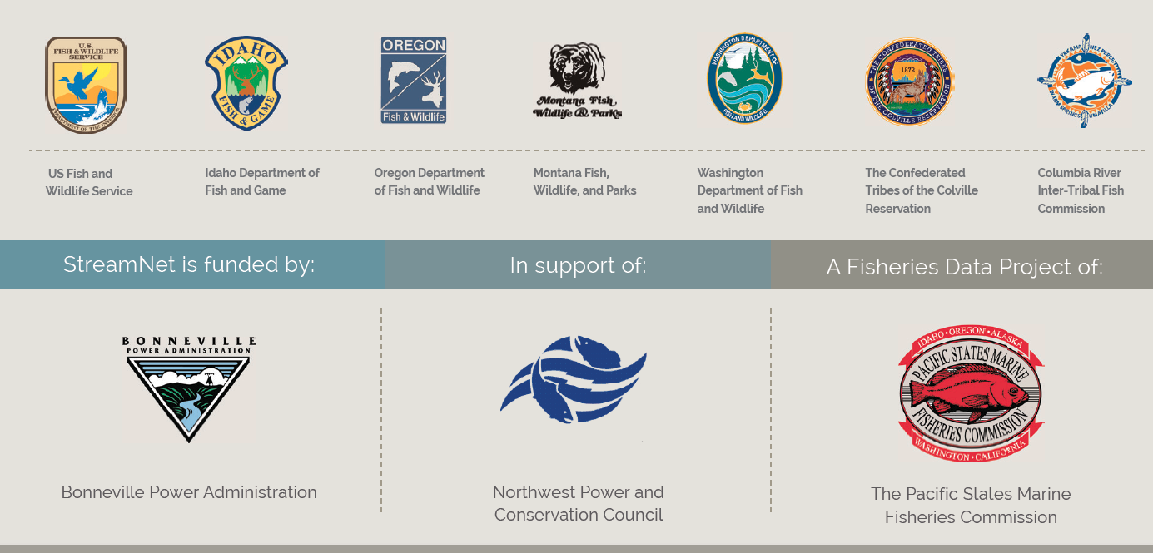

During 2016 StreamNet continued to help lead the Coordinated Assessments (CA) project. CA focuses on the key indicators and metrics for salmon and steelhead populations identified as priorities for reporting progress on implementation of the Federal Columbia River Power System Biological Opinion (BiOp). In 2016 BPA requested that StreamNet help to gather as much data as possible for certain populations they determined were priorities, and StreamNet assisted in this effort.

States and tribes continued to provide available data for these and other indicators to StreamNet in 2016, with an emphasis on the BPA priority populations. The following table shows the data flow for all populations, including ESA - listed populations as identified by the Technical Recovery Teams (TRT);
Publishable Coordinated Assessments December 30, 2016
High Level Indicator | Agency | Populations Reported (includes partial & multiple popfit) | Years of Valid data | TRT Populations Reported | TRT Pop. Years with HLIs | % of 213 TRT Populations
Natural Origin Spawner Abundance | ODFW | 72 | 2,027 | 47 | 1,517 | 22.1%
 | IDFG | 24 | 1,162 | 24 | 1,087 | 11.3%
 | WDFW | 64 | 1,825 | 64 | 795 | 30.0%
 | CCT | 1 | 11 | 1 | 11 | 0.5%
 | All Agencies | 155 | 5,025 | 130 | 3,410 | 61.0%
Recruits per Spawner | ODFW | 42 | 1,642 | 21 | 1,202 | 9.9%
 | IDFG | 18 | 931 | 18 | 820 | 8.5%
 | WDFW | 26 | 272 | 26 | 271 | 12.2%
 | CCT | 1 | 2 | 1 | 2 | 0.5%
 | All Agencies | 86 | 2,847 | 65 | 2,295 | 30.5%
Smolt to Adult Ratios | CRITFC | 25 | 366 | 4 | 33 | 1.9%
 | ODFW | 4 | 62 | 4 | 56 | 1.9%
 | WDFW | 3 | 24 | 3 | 24 | 1.4%
 | CCT | 1 | 7 | 1 | 7 | 0.5%
 | All Agencies | 33 | 459 | 12 | 120 | 5.6%
Juvenile  Outmigrants | WDFW | 18 | 268 | 18 | 261 | 8.5%
 | IDFG | 8 | 134 | 8 | 130 | 3.8%
 | ODFW | 5 | 91 | 5 | 84 | 2.3%
 | CCT | 1 | 9 | 1 | 9 | 0.5%
 | All Agencies | 32 | 502 | 32 | 484 | 15.0%
Presmolt  Abundance | ODFW | 4 | 73 | 4 | 58 | 1.9%
 | WDFW | 2 | 20 | 2 | 20 | 0.9%
 | All Agencies | 6 | 93 | 6 | 78 | 2.8%
All HLIs | All Agencies |  | 8,926 |  | 7,525
Population totals for All Agencies may be less than column sum due to shared pops.
Table sums 213 TRT Populations in 'Interior Columbia' & 'Willamette/Lower Columbia' Recovery Domains.
Total HLIs Reported for NOSA includes both HLIs if reported. TRT Pop. Years with HLIs only counts 1 year if either or both HLIs are reported.

Staff at Pacific States Marine Fisheries Commission and subcontracting agencies also continued implementation of the BPA secure data repository initiative, and StreamNet maintained the Data Store as a Repository for any BPA projects without available secure repositories. Staff provided leadership and support for a second workshop on hand held technology for fish data projects, in collaboration with the Western Forestry Association, the Pacific Northwest Aquatic Monitoring Partnership and Sitka Technologies. StreamNet partner staff participated in or presented findings at this workshop.

A wide variety of data types were disseminated through the StreamNet website in 2016 (www.streamnet.org). Overall use of the site has been relatively stable over the last few years, except that automated data exchange via Application Programming Interface (API) has increased dramatically. This is an encouraging trend in that it indicates that StreamNet partners are building networks to exchange information efficiently and that data users are building automated systems to utilize that data.

