STREAMNET

StreamNet provides access to regional fish data by maintaining a coordinated, standardized, web-based distributed information network. The need for regionally coordinated and readily accessible salmon and steelhead data has been identified by the Northwest Power and Conservation Council, the Bonneville Power Administration (BPA) and the National Oceanic and Atmospheric Administration’s National Marine Fisheries Service. StreamNet works cooperatively with the agencies that create the data by supporting technical staff inside these agencies and by leading or coordinating a number of initiatives to implement regional approaches to data management.

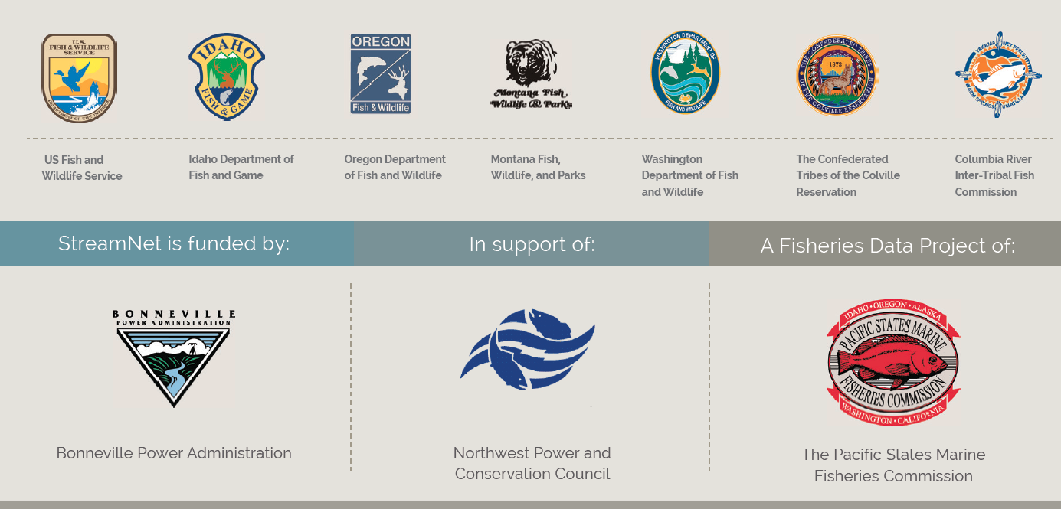

During 2017 StreamNet continued to help lead the Coordinated Assessments (CA) project. CA focuses on the key indicators and metrics for salmon and steelhead populations identified as priorities for reporting progress on implementation of the Federal Columbia River Power System Biological Opinion (BiOp). In 2017 BPA continued their request that StreamNet prioritize data collection for certain populations they determined were priorities, and StreamNet assisted in this effort.

States and tribes continued to provide available data for these and other indicators to StreamNet in 2017, with an emphasis on the BPA priority populations. The following table shows the data flow for all populations, including Endangered Species Act - listed populations as identified by the Technical Recovery Teams (TRT);
Published Coordinated Assessments Records As of December 29, 2017
High Level Indicator | Agency | Populations | Records Validated | Records w/HLIs | Records  w/o HLIs
NOSA Natural Origin Spawner Abundance | ODFW | 72 | 2,189 | 2,141 | 48
 | WDFW | 67 | 2,053 | 1,003 | 1,050
 | IDFG | 24 | 1,195 | 1,120 | 75
 | CCT | 1 | 12 | 12
 | All Agencies | 158 | 5,449 | 4,276 | 1,173
R/S  Recruits per Spawner | ODFW | 42 | 1,799 | 1,728 | 71
 | IDFG | 18 | 1,001 | 890 | 111
 | WDFW | 27 | 293 | 292 | 1
 | CCT | 1 | 2 | 2
 | All Agencies | 87 | 3,095 | 2,912 | 183
SAR  Smolt to Adult Return Rate | PSMFC | 26 | 663 | 663
 | ODFW | 5 | 80 | 73 | 7
 | WDFW | 3 | 24 | 24
 | CCT | 1 | 7 | 7
 | All Agencies | 35 | 774 | 767 | 7
Juvenile Outmigrants | IDFG | 21 | 472 | 462 | 10
 | WDFW | 25 | 319 | 307 | 12
 | ODFW | 5 | 100 | 92 | 8
 | CCT | 1 | 9 | 9
 | All Agencies | 52 | 900 | 870 | 30
Presmolt Abundance | ODFW | 4 | 81 | 65 | 16
 | CCT | 1 | 31 | 31
 | WDFW | 2 | 20 | 20
 | All Agencies | 7 | 132 | 116 | 16
All HLIs | All Agencies |  | 10,350 | 8,941 | 1,409

“All Agencies” population numbers do not sum because of shared populations between agencies. The total number of populations with HLI data is currently 188.

Staff at Pacific States Marine Fisheries Commission and subcontracting agencies also continued implementation of the BPA secure data repository initiative, and StreamNet maintained the Data Store as a Repository for any BPA projects without available secure repositories. Staff provided leadership and support for a third workshop on hand held technology for fish data projects, in collaboration with the Western Forestry Association, the Pacific Northwest Aquatic Monitoring Partnership and Sitka Technologies. StreamNet partner staff participated in or presented findings at this workshop.

A wide variety of data types were disseminated through the StreamNet website in 2017 (www.streamnet.org). Overall use of the site has been relatively stable over the last few years, except that automated data exchange via Application Programming Interface (API) has increased dramatically. This is an encouraging trend in that it indicates that StreamNet partners are building networks to exchange information efficiently and that data users are building automated systems to utilize that data.

