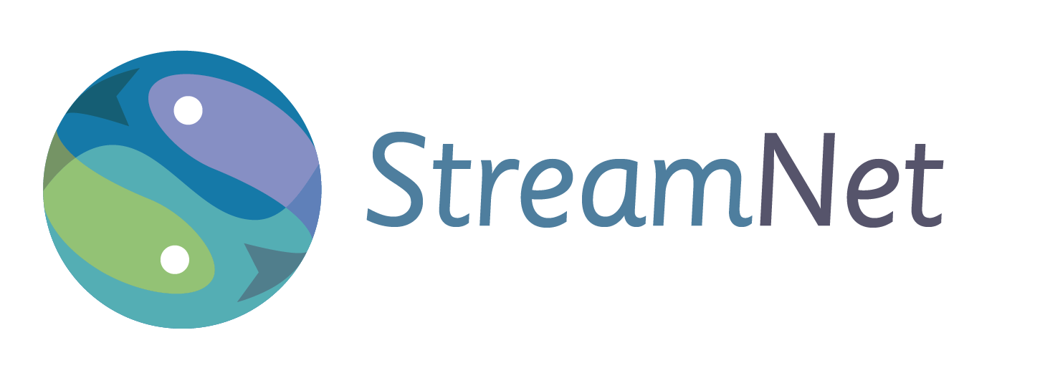

**StreamNet**

StreamNet provides access to regional fish data by maintaining a coordinated, standardized, web-based distributed information network. The need for regionally coordinated and readily accessible salmon and steelhead data has been identified by the Northwest Power and Conservation Council (NPCC), the Bonneville Power Administration (BPA) and the National Oceanic and Atmospheric Administration’s National Marine Fisheries Service. StreamNet works cooperatively with the agencies that create the data by supporting technical staff inside these agencies and by leading or coordinating a number of initiatives to implement regional approaches to data management.

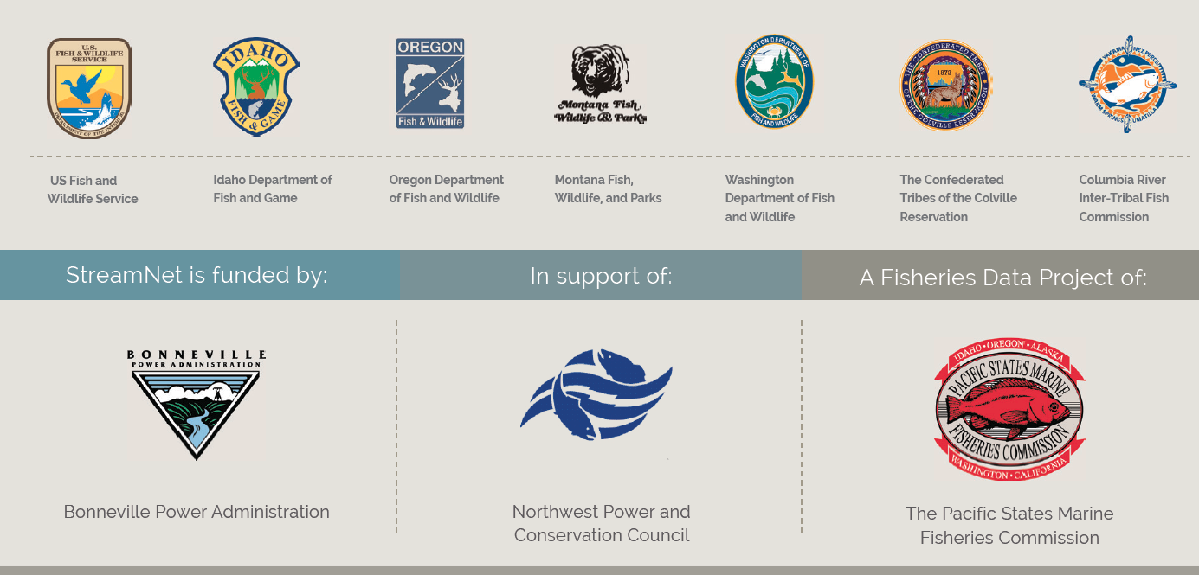

During 2018, StreamNet continued to help lead the Coordinated Assessments (CA) project. CA is focused on the key population-level indicators and metrics that have been identified as priorities for reporting progress on implementation of the Federal Columbia River Power System (FCRPS) Biological Opinion (BiOp). StreamNet’s funder, BPA, has identified a need to gather as much data as possible for 69 populations they have determined are priorities.

States and Tribes continued to provide available CA data to StreamNet in 2018, with an emphasis on the BPA priority populations. Updates of other standard data “trends” related to the CA project or feeding the NPCC’s dashboards were also a priority. The following table shows the CA data available for all salmon and steelhead populations as of the end of 2018.

|  |  |  |  |  |
| --- | --- | --- | --- | --- |
| **Published Coordinated Assessments Records**  **As of December 31, 2018** | | | | |
| **High Level Indicator (HLI)** | **Agency** | **Populations** | **Records w/HLIs** | **Records**  **w/o HLIs** |
| **NOSA**  **Natural Origin Spawner Abundance** | Colville Tribes | 1 | 13 |  |
| CTUIR | 3 | 3 |  |
| CTYIN | 1 | 33 |  |
| IDFG | 24 | 1151 | 75 |
| ODFW | 78 | 2,293 | 54 |
| USFWS | 2 | 33 |  |
| WDFW | 67 | 1,044 | 1,060 |
| **All Agencies** | 166 | 4,570 | 1,189 |
|  |  |  |  |  |
| **R/S**  **Recruits per Spawner** | Colville Tribes | 1 | 9 |  |
| IDFG | 18 | 909 | 111 |
| ODFW | 42 | 2,066 | 87 |
| USFWS | 2 | 12 | 1 |
| WDFW | 27 | 311 |  |
| **All Agencies** | 87 | 3,307 | 199 |
|  |  |  |  |  |
| **SAR**  **Smolt to Adult Return Rate** | Colville Tribes | 1 | 9 |  |
| ODFW | 14 | 225 | 10 |
| PSMFC | 28 | 759 |  |
| USFWS | 2 | 16 |  |
| WDFW | 2 | 42 |  |
| **All Agencies** | 47 | 1,051 | 10 |
|  |  |  |  |  |
| **Juvenile Outmigrants** | Colville Tribes | 1 | 11 |  |
| IDFG | 23 | 484 | 11 |
| ODFW | 17 | 297 | 11 |
| WDFW | 25 | 328 | 19 |
| **All Agencies** | 66 | 1,120 | 41 |
|  |  |  |  |  |
| **Presmolt Abundance** | Colville Tribes | 1 | 40 |  |
| ODFW | 4 | 69 | 16 |
| Terraqua Inc. | 2 | 24 |  |
| **All Agencies** | 7 | 133 | 16 |
|  |  |  |  |  |
| **PNI**  **Proportionate Natural Influence** | WDFW | 4 | 144 | 2 |
| **All Agencies** | 4 | 144 | 2 |
|  |  |  |  |  |
| **All HLIs** | **All Agencies** | **212** | **10,325** | **1,457** |
| “All Agencies” population numbers do not sum because of shared populations between agencies. The total number of populations with HLI data is currently 212. | | | | |

|  |  |  |  |
| --- | --- | --- | --- |
|  |  |  |  |
|  |  |  |  |

Staff at Pacific States Marine Fisheries Commission and subcontracting organizations also continued implementation of the BPA secure data repository initiative, and StreamNet maintained the Data Store as a repository for BPA projects without other available secure repositories. Partner organizations funded through StreamNet are the Confederated Tribes of the Colville Reservation (Colville Tribes), Idaho Department of Fish and Game (IDFG), Montana Fish, Wildlife & Parks (MFWP), Oregon Department of Fish and Wildlife (ODFW), and Washington Department of Fish and Wildlife (WDFW). Approximately 75% of StreamNet funding is passed directly to the partners to support their data management activities.

A wide variety of data types were disseminated through the StreamNet website (**www.streamnet.org**) in 2018. Overall use of the site has been relatively stable over the last few years, except that automated data exchange via Application Programming Interface (API) has increased dramatically. This is an encouraging trend in that it indicates that StreamNet partners are building networks to exchange information efficiently and that data users are building automated systems to utilize those data.

