StreamNet
Strategic Plan

January 1, 2021 to December 31, 2026
(adopted September 2, 2020)

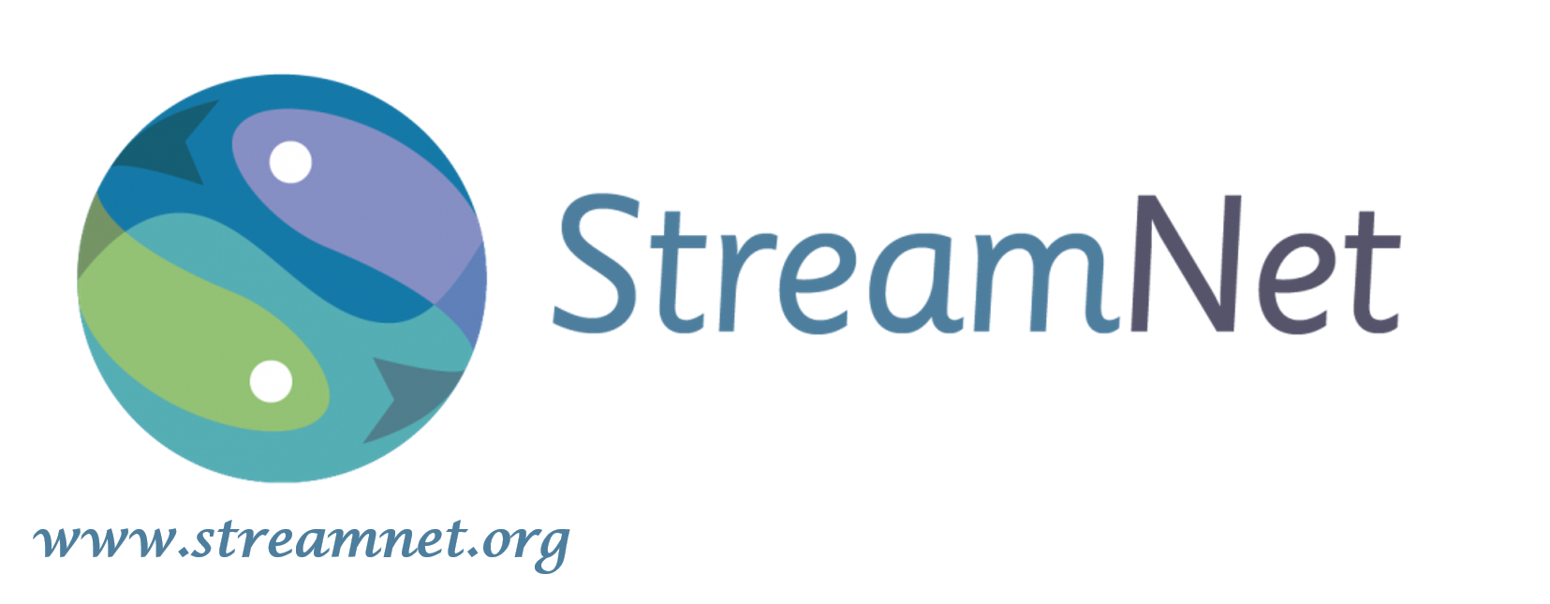

Fish Data for the Northwest

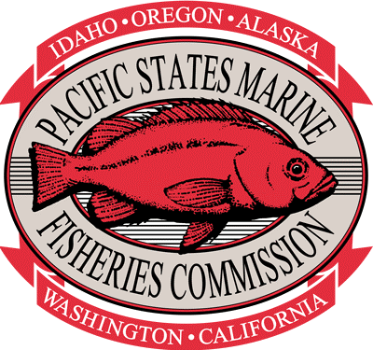

Table of Content

StreamNet Program Overview 3
Goals, Strategies, and Objectives 4
Implementation Approach 6
Milestones 12
SWOT StreamNet Program Analysis 13
Budget 16
Acronyms 18
StreamNet Committee Members 19

Strategic Plan
2021 to 2026

StreamNet Program Overview

Mission Statement | Coordinate and support efforts of state, tribal and federal agencies to collect, manage, and share fish and aquatic habitat information in the Pacific Northwest, with an emphasis on the Columbia River Basin (Basin), to support public understanding and wise decision making.
Vision Statement | Support regional status assessments and decision-making processes by making scientifically-sound, standardized data accessible.
General Approach | Develop and nurture a collaborative partnership to support sharing of best available information in a standardized format and manner, leveraging technology advancements for efficient data sharing.  Coordinate and assist efforts to strengthen partner data management infrastructure and augment their data sharing capacity to benefit natural resource management.
Summary | StreamNet originated in the 1980s following the integration of the Coordinated Information System and the Northwest Environmental Database, serving as the first regional forum for standardized fish, wildlife, and aquatic habitat information to inform Basin assessments, reports, and decision-making processes. Today StreamNet supports sharing of fish population health indicators in the Pacific Northwest by co-sponsoring the Coordinated Assessments Partnership (CAP). StreamNet also serves as Bonneville Power Administration's (BPA) system of record for fish distribution and facilities, providing a comprehensive location for partners’ information.  StreamNet reports to and implements the direction of the StreamNet Executive Committee, in a manner that is consistent with measures in the Northwest Power and Conservation Council (NPCC) Columbia River Basin Fish and Wildlife Program (FW-Program) and guidance from state, tribal, and federal fish and wildlife management plans, including Federal ESA recovery plans and biological opinions. StreamNet is funded by BPA as part of the FW-Program.

Strategic Plan
2021 to 2026

Goals, Strategies, and Objectives

 | Goal 1  Serve as a primary regional coordination forum for fish and aquatic habitat information management and data sharing. | Strategy: Work collaboratively with partners to provide efficient flow of quality information to inform decision and policy makers, in a timely manner on key fish and aquatic habitat indicators.  Objective:  1.1 – Develop and maintain partnerships  1.2 – Identify and prioritize key indicators and metrics  1.3 – Document and link metadata to data  1.4 – Develop and update data exchange standards (DES)  1.5 – Provide efficient quality review of data and system
 | Goal 2  Support data management infrastructure (personnel, hardware, software, systems) within PSMFC, agencies and tribes for the sharing of fish and aquatic habitat information. | Strategy: Assist partners with improving the efficiency of data collection, data management systems and data sharing capacity.  Objective:  2.1 – Fund data stewards, programmers, database administrators, GIS analysts and technicians, and others possessing required expertise.  2.2 – Support development of data management systems that efficiently capture data informing key indicators and metrics.  2.3 – Prioritize and facilitate automated data flow between partner and regional data systems.
 | Goal 3  Develop and maintain efficient data collection and management practices including related data storage systems that support regional information sharing in standardized formats. | Strategy: Support new technologies and regional standards.  Objectives:  3.1 – Promote development and use of technologies to advance data collection, management and sharing.  3.2 – Assist partners in converting key indicator and metric data to regionally adopted DES.  3.3 – Improve quality of metadata by connecting and refining existing connections between data systems and to PNAMP’s monitoringresources.org and Columbia Basin Fish & Wildlife Library.  3.4 – Collaborate with regional initiatives developing guidance and advancing the use of data management technologies and standards.
 | Goal 4  Promote information sharing and display key indicators for resource managers and the public. | Strategy: Support wise data sharing approaches, and develop public user-friendly data access and visualization tools.  Objectives:  4.1 – Promote proper use of regional data through data sharing agreements, end-user license agreements, and by including metadata documentation.  4.2 – Ensure that regional data are georeferenced to allow linkage to other data sets and systems.  4.3 – Display graphical visualization of standardized information on the StreamNet website.  4.4 – Encourage discovery of partner tools by providing links to data visualization, systems, and archival repositories.  4.5 – Maintain publicly searchable and secure data archival repositories for non-standardized data sets (fish, wildlife, habitat).
 | Goal 5  Help partners adapt to changing data management and sharing priorities as directed by regional fish and wildlife managers. | Strategy: Track changes in the regional information needs of BPA, National Oceanic and Atmospheric Administration Fisheries (NOAA-F), NPCC and US Fish and Wildlife Service (USFWS) and align our work plan to guide StreamNet efforts.  Objectives:  5.1 – Assess how StreamNet can respond to emergent regional needs for indicators and related data (trends) by regional entities.  5.2 – Evaluate and prioritize regional needs to inform adjustments to the work plan.
Strategic Plan
2021 to 2026

Implementation Approach

StreamNet is a collaborative program of Pacific States Marine Fisheries Commission (PSMFC), tribes, and federal and state agencies that participate in committees and teams and submit data to the StreamNet data systems. StreamNet also engages with regional efforts (projects/partnerships) that contribute to the StreamNet Program’s goals. The data managed by StreamNet supports regional decision making as well as providing data to NOAA-F’s status reviews, NPCC FW-Program tools, and BPA tools and reports (Figure 1).

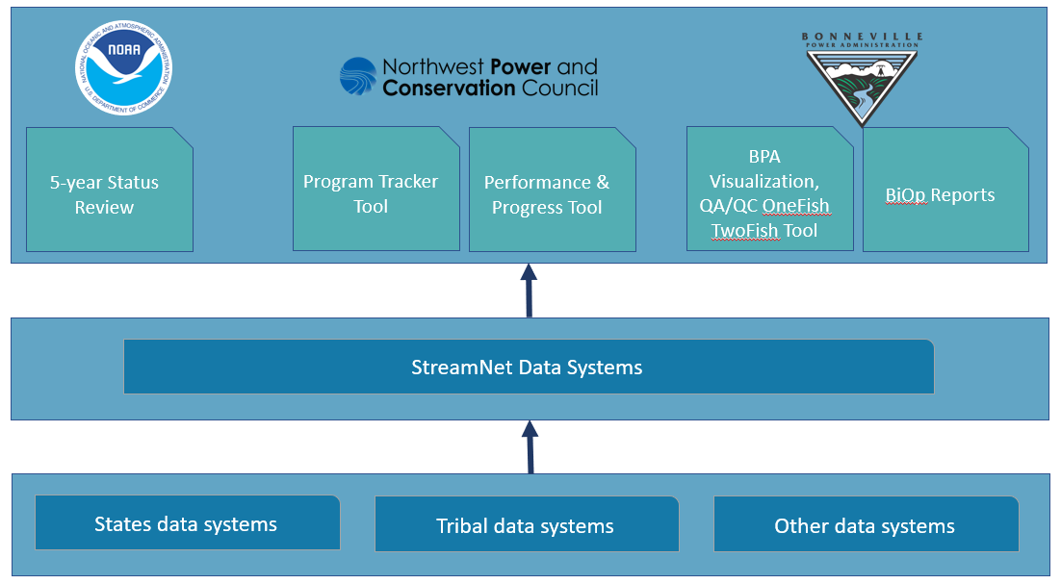
Figure 1: The current flow of data from state, tribal and local data systems to the StreamNet data systems in support of regional decision-making tools.

StreamNet activities are implemented using funds provided primarily through a contract between BPA and PSMFC. PSMFC StreamNet also subcontracts to partner agencies and tribes to support data stewards and staff, whom along with StreamNet PSMFC-staff, have expertise in GIS, database management, web development, and programming. Current StreamNet subcontracted partners consist of the Confederated Tribes of the Colville Reservation (Colville Tribes), Idaho Department of Fish and Game (IDFG), Montana Fish, Wildlife & Parks (MFWP), Oregon Department of Fish and Wildlife (ODFW), and Washington Department of Fish and Wildlife (WDFW). These subcontracted partners implement StreamNet’s workplan and serve as advisors on committees and teams.

Organization Structure - Committees and Teams

The organizational structure of StreamNet includes an Executive Committee and a Steering Committee. Implementation of StreamNet also relies on two teams: the Data Exchange Standard Development Team and a Technical Team (Figure 2). Members of the Committees and Teams includes PSMFC StreamNet staff, StreamNet funded staff within partner entities, and staff from other tribal, state and federal agencies and organizations' representatives.
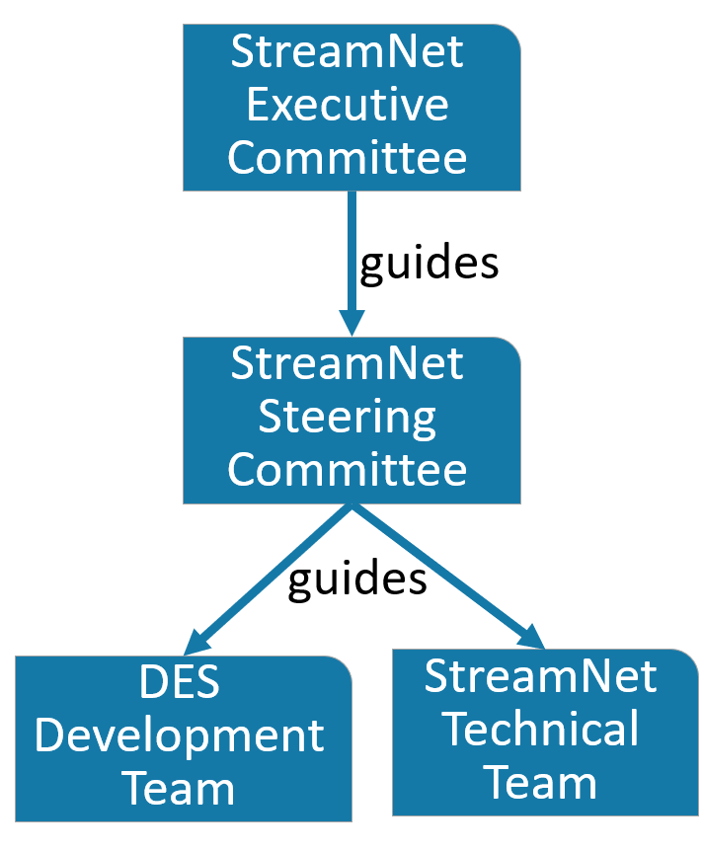  Figure 2: StreamNet committees and teams | StreamNet Executive Committee (SN ExCom) – The SN ExCom provides policy-level guidance and decision-making for StreamNet and the CAP. The primary role of the SN ExCom is to ensure alignment with regional data management and sharing needs, that tasks are focused on achieving strategic goals, and that resources are allocated to regional and agency priorities.  - Members: Basin policy-level staff and leaders from tribal, federal, state and other organizations managing and using fisheries data.  - Chair: PSMFC Executive Director, or their designee (the StreamNet Program Manager).  - Meetings: once a year.  - Additional information: See documents https://www.streamnet.org/resources/documents-and-publications/streamnet-executive-committee/.
StreamNet Steering Committee (SN SC) – The SN SC provides support, guidance and oversight of progress for the StreamNet Program. The Steering Committee’s role is to provide advice on implementation, ensure delivery of outputs and achievement of outcomes, and implementation of SN ExCom decisions, including the Basin tasks in the CAP 5-year Plan and what is within the StreamNet BPA contracted scope of work.
- Members: Data manager-level representatives of the StreamNet partners, as well as representatives from BPA, NPCC, NOAA-F, USFWS, and other tribal, federal and state organizations managing and using fisheries data.
- Chair: PSMFC StreamNet Program Manager.
- Meetings: Held a minimum of two times a year, with a third meeting as feasible with funding.
- Additional Information: See documents https://www.streamnet.org/resources/documents-and-publications/streamnet-steering-committee/.

CAP Data Exchange Standard Development Team (DDT) – The DDT determines Coordinated Assessments DES fields and definitions, and import/export guidelines for fish related data housed in the CAP’s Coordinated Assessments Exchange (CAX) data system. The DES is the document that defines the structure of population-scale. and other appropriate-scales, data submitted to the CAX.
- Members: Data management professionals and biologists who are responsible for calculating indicators and metrics. Specific members of the DDT reflect the species/indicators/geography focus of the DES sections under development.
- Chair: PSMFC StreamNet Biologist and Database Administrator.
- Meetings: Held as needed throughout the year.
- Additional information: See updated Coordinated Assessments DES https://www.streamnet.org/coordinated-assessments-des/

StreamNet Technical Team – This group is responsible for the technical details necessary to adequately flow data from partner data systems to the StreamNet systems. The Technical Team also functions as the DES development team for "trends" and other non-CAX data.
- Members: PSMFC and state and tribal agency staff, including partner entities funded through the StreamNet Program who implement data management actions.
- Chair: PSMFC StreamNet staff.
- Meetings: Held as needed throughout the year.
- Additional information: See updated StreamNet DES https://www.streamnet.org/resources/documents-and-publications/

Regional Efforts and StreamNet
PSMFC StreamNet and members also rely on regional efforts that contribute to StreamNet’s mission and vision statements (Figure 3), including Columbia River Inter-Tribal Fish Commission’s (CRITFC) Inter-Tribal Monitoring Data (ITMD) project, Columbia Basin Fish & Wildlife Library, the Pacific Northwest Aquatic Monitoring Partnership (PNAMP), and the CAP Core Team.
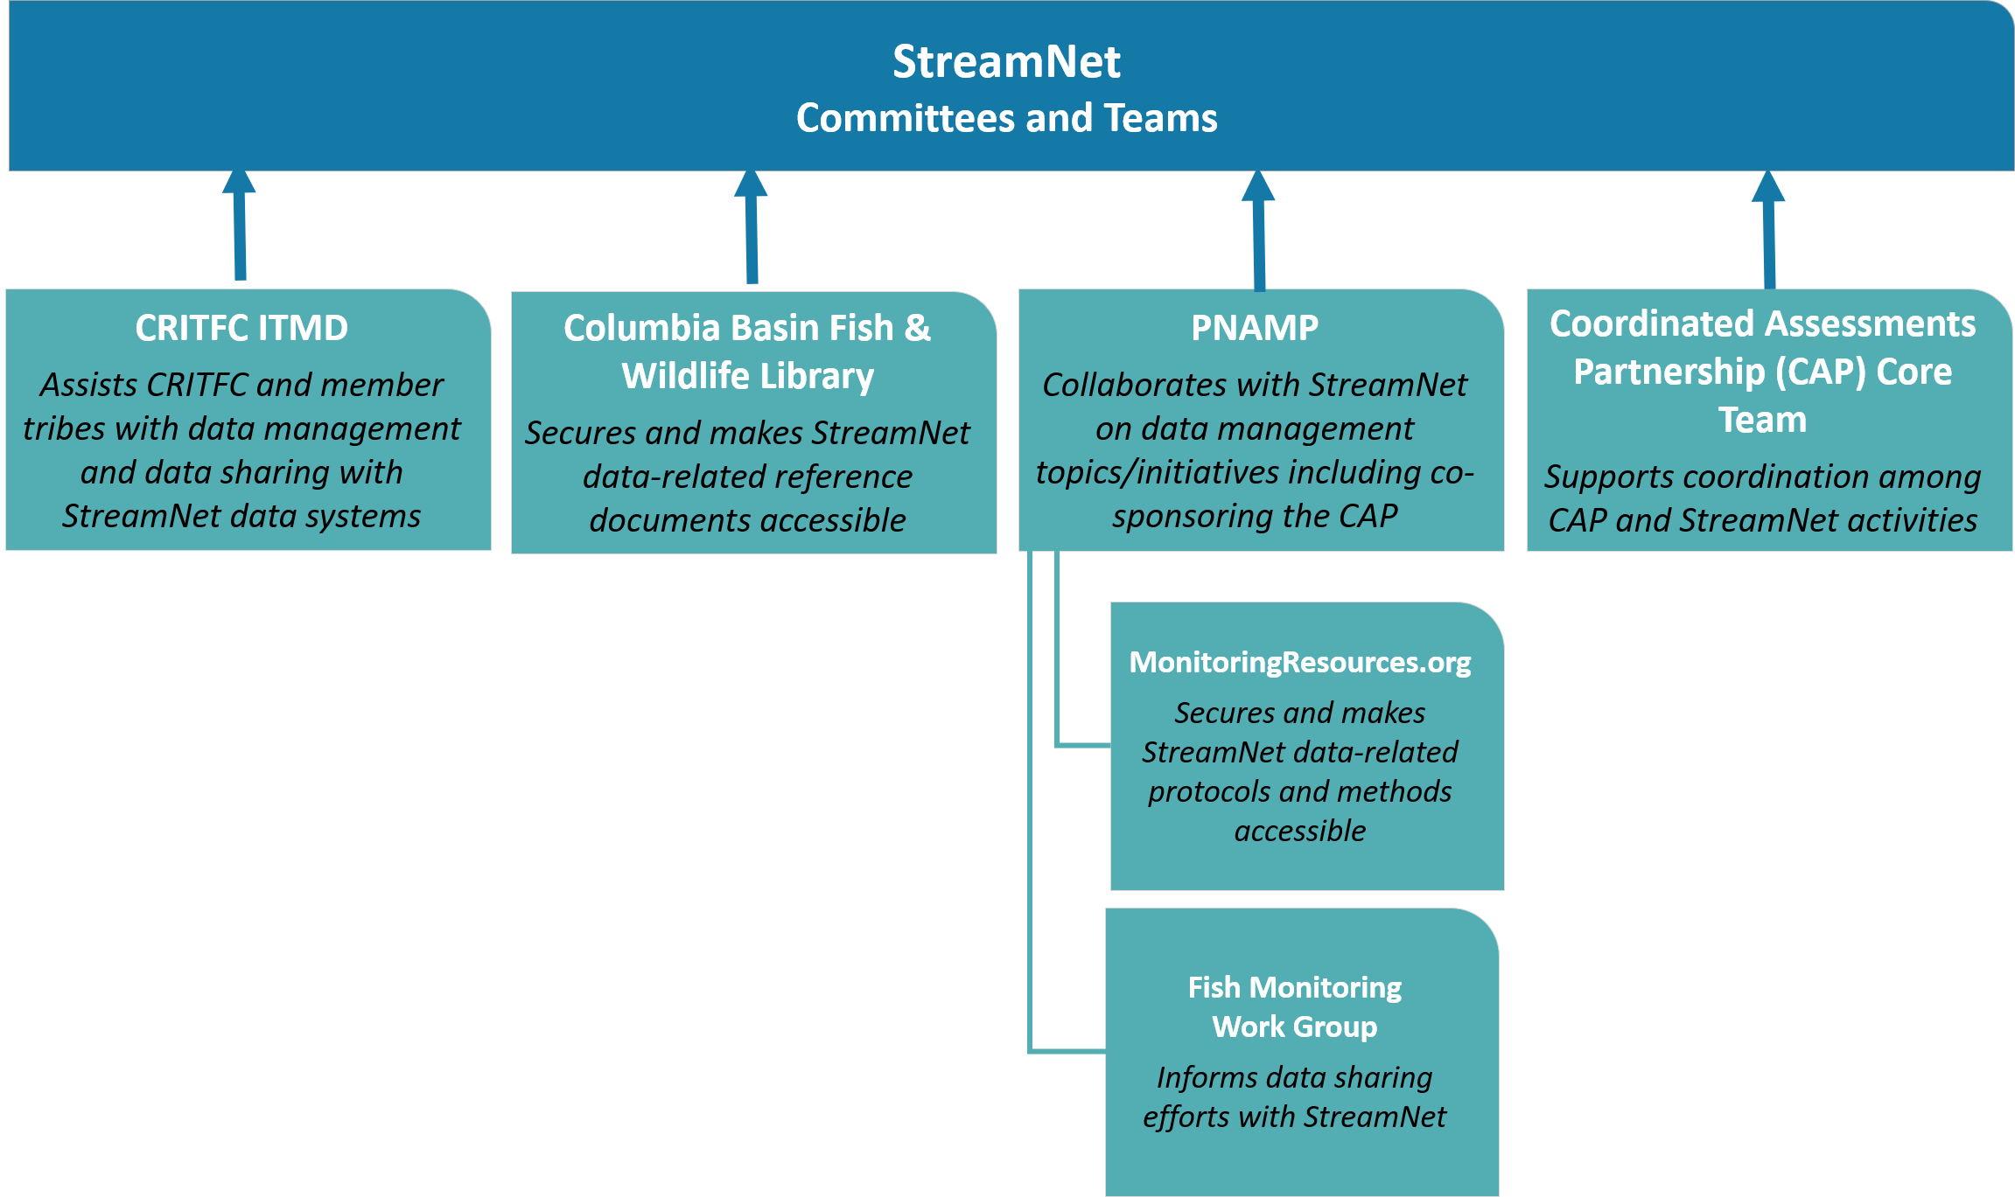
Figure 3: Regional efforts that contribute to StreamNet’s task guidance and implementation.
CRITFC ITMD Project –The purpose of CRITFC’s ITMD project is to assist CRITFC and its member tribes in the timely and accurate capture, storage, processing, and dissemination of data for management of anadromous fish and their habitats. The CRITFC ITMD, by coordinating and integrating appropriate activities with the CAP, ensures consistent data sharing with the CAX data system for Basin salmon and steelhead high level indicators and related trend data.
- Members: Data managers, data stewards, systems administrators, and programmers from CRITFC and its four-member tribes: Nez Perce Tribe, Confederated Tribes of the Umatilla Indian Reservation, Confederated Tribes and Bands of the Yakama Nation, and Confederated Tribes of Warm Springs Reservation of Oregon.
- Coordinator: Project Lead or other Tribal or CRITFC staff assigned the role.
- Additional Information: https://www.critfc.org/tribal-data-network-workshop-documents/
Columbia Basin Fish & Wildlife Library - The Library, a CRITFC program, serves as a centralized repository for the information created by tribal organizations, federal, state, and local agencies, private and contract researchers, and advocacy groups on Basin fish and wildlife projects and issues. The StreamNet program relies on the Library to provide access to documents related to the data submitted to the StreamNet data systems. A primary objective of the Library is preserving and providing access to StreamNet source and data reference documents, as well as those related to data for the CAP. StreamNet and Library staff work together to ensure that all StreamNet references have complete and accessible digital records.
- Library Program Lead/Librarian: Tami Wilkerson.
- Entity: CRITFC.
- Additional Information: https://www.streamnetlibrary.org/

Pacific Northwest Aquatic Monitoring Partnership (PNAMP) – PNAMP supports collaboration and coordination around aquatic monitoring, including discussion of data collection, sharing, and documentation. PNAMP contributes to the CAP by facilitating monthly CAP Core Team meetings, the PNAMP Fish Monitoring Work Group and CAP workshops. PNAMP’s MonitoringResources.org houses monitoring metadata. For data sets that have their metadata in MonitoringResources.org, a URL can be linked to the data set submitted to StreamNet data systems, including the CAP data. PNAMP participates in SN SC and ExCom meetings to facilitate coordination on areas of shared interest with StreamNet and CAP.
- Members: Representatives from ACOE, BLM, BPA, CDFW, Colville Tribes, CRITFC, EPA, IDFG, NOAA-F, NPCC, NWIFC, OWEB, PSMFC, USFS, USGS, WDFW, WECY, WGSRO, and WRCO.
- Coordinator: Jen Bayer, USGS-PNAMP Coordinator.
- Meetings: Held usually three times a year.
- Additional Information: https://www.pnamp.org/

PNAMP MonitoringResources.org – This is an online, publicly accessible suite of information and tools for natural resource monitoring programs and professionals. Tools and information include maps and metadata describing existing monitoring projects; a library of standard monitoring methods and protocols; and guidelines and tools to help managers develop new monitoring programs and share existing ones. These resources are intended to promote better documentation and enable more efficiency in collaboration and data sharing between programs. This project houses metadata for some data submitted to a StreamNet data system.
- Contact: Jen Bayer, USGS-PNAMP Coordinator.
- Additional Information: https://www.monitoringresources.org/
PNAMP Fish Monitoring Work Group –The PNAMP Fish Monitoring Work Group contributes to the CAP and StreamNet Program by providing a venue for discussion of topics related to CAP and StreamNet implementation. Membership of this workgroup is fluid, reflecting the appropriate subject matter experts (e.g. fisheries biologists, program managers) to address specific tasks or topics.
- Members: Interested participants from PNAMP member agencies.
- Facilitator: USGS-PNAMP staff.
- Leader: to be determined based on topic.
- Meetings: to be determined based on topic.
- Additional Information: https://www.pnamp.org/project/fish-monitoring-work-group

CAP Core Team - The CAP Core Team serves to efficiently align areas of common interest, e.g. population scale fish indicators between StreamNet and the CAP. The CAP Core Team coordinates implementation of the CAP amongst partners, including partners receiving funding from BPA and other federal grants. The CAP Core team supports discussion between projects/efforts implementing the CAP 5-year Plan, directs requests for work to the appropriate CAP-related team or committee level, monitors implementation, reports to the SN ExCom and SN SC, and generally serves to maintain forward momentum. The CAP Core Team also informs and directs periodic CAP workshops, as needed. The CAP's history and related documents are maintained on the PNAMP Coordinated Assessments webpage, and current documents related to the CAX such as DES versions are available on the StreamNet website (links provided below).
- Members: Representatives vary depending on the work and may include individuals from tribal, federal and state agencies and others. Current members consist of representatives from BPA, CRITFC, NOAA-F, PNAMP, PSMFC, and WDFW.
- Coordinator/Chair: Jen Bayer, USGS-PNAMP Coordinator.
- Meetings: Held at least monthly.
- Additional Information: CAP documents https://www.pnamp.org/project/coordinated-assessments-for-salmon-and-steelhead; CAX and DES: http://www.streamnet.org/coordinated-assessments-xct-development/

Data Providers

Data that are managed by StreamNet and displayed on the StreamNet website are submitted by numerous data providers from other regional efforts (e.g., Fish Passage Center), tribes, federal and state agencies, as well as public and private organizations. Some information submitted consists of or is derived from data provided by multiple entities. For the most accurate list of data providers, each data system listed below can be viewed on the StreamNet website; alternatively, PSMFC StreamNet staff can generate a customized report upon request. Below is highlighted the data providers who regularly submit data to each of the data systems maintained through StreamNet.

StreamNet data systems | Data Source Entities
Data Store | Data sets provided by any entity, with an emphasis on data sets from the Basin and specifically those funded by Bonneville Power Administration.
Trend Query | Information provided by tribes, states and federal agencies and other entities collecting and compiling data on native and non-native fish and other aquatic resources. The emphasis is on the Basin but also includes data from other parts of the states of California, Idaho, Montana, Oregon and Washington.
GIS map layers | Information provided by tribes, states and federal agencies with management authority over fish populations. The emphasis is on the Basin, but also includes data from other parts of the states of California, Idaho, Montana, Oregon and Washington.
Coordinated Assessments Exchange (CAX) data system | Northwestern region of the United States with emphasis on the Basin tribes, states and federal agencies as well as other entities engaged in collecting fish information informing CAP’s high-level indicators for fish populations and related fish trend data. As of 2020 these include Biomark, Colville Tribes, Fish Passage Center, IDFG, Nez Perce Tribe, ODFW, Umatilla Tribes, USFWS, WDFW, Yakama Nation, and Terraqua Inc.
NPCC Subbasin Plans’ documents and data sets | Authors of the NPCC FW-Program adopted Subbasin Plans, as well as new data captured by StreamNet, the Technical Outreach and Assistance to Subbasins Team (TOAST), CRITFC, and the Northwest Habitat Institute that were developed for use in the aquatic portion of each subbasin plan.
NPCC Protected Areas | Documentation and designation of NPCC FW-Program 1988, 1990 and 1992 amendments to the protected river reaches.
NPCC’s Habitat Evaluation Procedures (HEP) | Documents from the Regional HEP Team funded through the BPA Habitat Evaluation Project (2006-006-00; closed in 2016).
Hatchery Scientific Review Group (HSRG) documents | Columbia River Basin Hatchery Reform Project funded by Congress and completed in 2009.

Strategic Plan
2021 to 2026

Milestones

Specific milestones for achieving these goals and objectives are listed in the annual BPA StreamNet Statement of Work, and annual progress is summarized in BPA’s StreamNet Annual Project Report (see https://www.cbfish.org/Project.mvc/Display/1988-108-04).

Overview of Milestones Tracked to Assess Annual Progress

Milestone | Brief description
Manage project activities | Ensure alignment with Strategic Plan and Executive Committee guidance.
Coordination | Coordinate with entities to assure data flow to data systems.
Infrastructure and base operations | Maintain infrastructure and support tasks/training for acquiring, managing and disseminating regionally standardized and georeferenced data, and access to reference documents.
Enhance data efficiency | Assist data providers with data management and sharing. Work with PNAMP and others to advance the use of technology.
Compile high priority traditional StreamNet local scale trends data | Assist data providers submitting to StreamNet local scale “trends” system, integrate with CAX, assure data quality, and maintain StreamNet DES.
Support transfer of data into secure and accessible repositories | Assist BPA project sponsors and others that lack a secure and web-accessible repository to assure that data are archived, securely backed up, and accessible.
CAP CAX data - coordination | Provide leadership and coordination for the CAP, in collaboration with PNAMP, to improve access to high level indicators (HLIs) and metrics. PSMFC StreamNet staff serve on CAP teams and activities.
CAP - DES and CAX data system | Maintain and update the CAX DES, develop new DES to support regional priorities, and assure CAX data quality.
CAX - data exchange | Maintain automated flow via webservices to and from the CAX.
CAX - compile HLIs and metric data | Assist data exchange between data providers and the CAX data system.
Data - dissemination | Disseminate data and associated metadata, including CAX HLIs, by maintaining public reporting and query tools on the StreamNet website and by supporting regional reporting tools. Work with PNAMP and BPA to support their information needs such as for MonitoringExplorer.org. Maintain and implement provisions of Data Sharing Agreements for data access through StreamNet.

Strategic Plan
2021 to 2026

SWOT StreamNet Program Analysis

The strengths, weaknesses, opportunities and threats (SWOT) analysis is a subjective review by StreamNet partners and members focused on identifying SWOT related to the near and long-term success of StreamNet. Existing strengths and weaknesses focus on aspects that are within the control of StreamNet and that could be modified to better achieve our StreamNet Program mission, vision, goals, and objectives. Opportunities and threats are factors that are outside the control of StreamNet but that need to be considered for the continued success of StreamNet.

Strength of StreamNet
30+ years of successfully sharing data with partners.
Proven flexibility to respond to changing regional priorities.
Long-term participation of federal and state fisheries management entities, Colville Tribes, and CRITFC tribal consortium.
Effective short-term subcontracts to advance data management, sharing capacity, and reporting.

Long-term personnel with institutional knowledge that keeps the StreamNet Program functioning smoothly and applying lessons learned gained over time.

Strong participation by regulators (NOAA-F and USFWS), funders consuming these data (BPA and NPCC) and state and tribal entities providing these data, which contribute to effective and efficient sharing of critical data.
Enhances communication and understanding of the role of the StreamNet Program in providing public access to publicly funded data and contributing to informed decision-making by regional partners such as BPA, NOAA-F, and NPCC.
Long running data set series, with some population-scale indicator data sets going back to 1938 and some trend data sets going back as far as 1894.

Weaknesses of StreamNet
Lack of StreamNet funded data steward or other experts in CRITFC and Upper Snake River Tribes Foundation tribes.

Inadequate level of participation in Executive and Steering Committees by tribes not directly funded by StreamNet.

Outreach component not addressing how StreamNet complements other regional data management efforts.

Database public-interface and tools not encouraging broad use of data system to result in StreamNet being perceived as the ‘go to’ source for these data.

Insufficient funding to comprehensively compile available data to address management questions in the Basin.

Shifting regional priorities and limited funding results in some long-term data sets no longer being updated with recent data

Small number of PSFMC-StreamNet staff puts at risk loss of institutional knowledge due to limited potential to have overlap between new and long-term personnel.

Opportunities from External Sources
Engage and assist tribes with data management and sharing capacity.
Increased specification of the data needed to inform regional decision-making process are provided in the 2020 NPCC FW-Program addendum and the NOAA FCRPS BiOps.

Regional bodies (BPA, NPCC, NOAA-F) are acknowledging the importance of StreamNet foundational element for assessing and reporting performance of mitigation and recovery programs, such as value of trend data when population estimates are not feasible and the linking fish data to hydrography layers to inform subbasin and local scale decisions.

Potential to secure grant funding to improve data flow infrastructure to achieve data flow from partners to StreamNet.

Threats from External Sources
Funding primarily from one funder limited to flat (decreasing real value) annual funding amount. Lack of annual commitment from other funding sources.
Perception of StreamNet Program not being responsive to regional needs by increasing expectations without addressing the budget constraints related to flat/declining budget.
Expectation of having up-to-date StreamNet foundational data sets (e.g. hydrography, fish distribution, traditional fish data trends) conflicting with past policy decisions resulting in a decrease in effort invested in these foundational data sets.

Strategic Plan
2021 to 2026

Budget

StreamNet is primarily funded through a contract between BPA and PSMFC, with subcontracts to partner agencies and tribes. The StreamNet Program is implemented and results reported consistently with funding agency requirements. Current and past budgets can be viewed on the publicly accessible BPA project management system (https://www.cbfish.org/Project.mvc/Display/1988-108-04).

Overview of Past Budgets

The nominal value of the BPA funded portion of the StreamNet Program (project #1988-108-04) has ranged from a high of $2,395,802 in fiscal year 2004 to a low of $1,355,606 in fiscal year 2013, with the median budget amount of $2,115,030 during the fiscal year period 2004 to 2021 (Figure 4). The year 2004 is selected as a starting point to match the year that the BPA online project database has a consistent annual budget reported. The change in funding over time relates to different BPA and NPCC funding and project management recommendations, including moving the Library to its own project in 2008 adding funding for the Colville Tribes starting in 2014, defunding the PSMFC-GIS staff support back in 2015 and returning that funding in 2021, funding different amount of PSMFC StreamNet staff, and moving funding for USFWS into a separate agreement in 2020. The work implemented through StreamNet also benefits from cost-share from its partners. The annual cost-share reported to BPA since 2007 has ranged from 6% to 26% of the StreamNet budget, with cost-share amounts provided from 3 to 13 entities depending on the year.

An ongoing challenge of StreamNet has been how to support its state and tribal partners and foundational elements of the StreamNet Program while responding to new data needs from regional decision-makers. StreamNet also continues to explore how to maintain participation by a broader group of partners, both biologists and data stewards, to properly address new priorities. This broader participation is challenged as partners’ funding are stretched thin with cost of living increases and limited funding, which reduces the opportunities for cost-share contributions. To this end, StreamNet and its partners are continuously searching for alternative funding solutions, and in past years were awarded EPA grants, secured funding from NOAA-F, and obtained additional funding from PSMFC. The combination of these funds allowed StreamNet and its partners to improve the data management infrastructure and leverage expertise which improved the flow and range of information from partners to StreamNet.

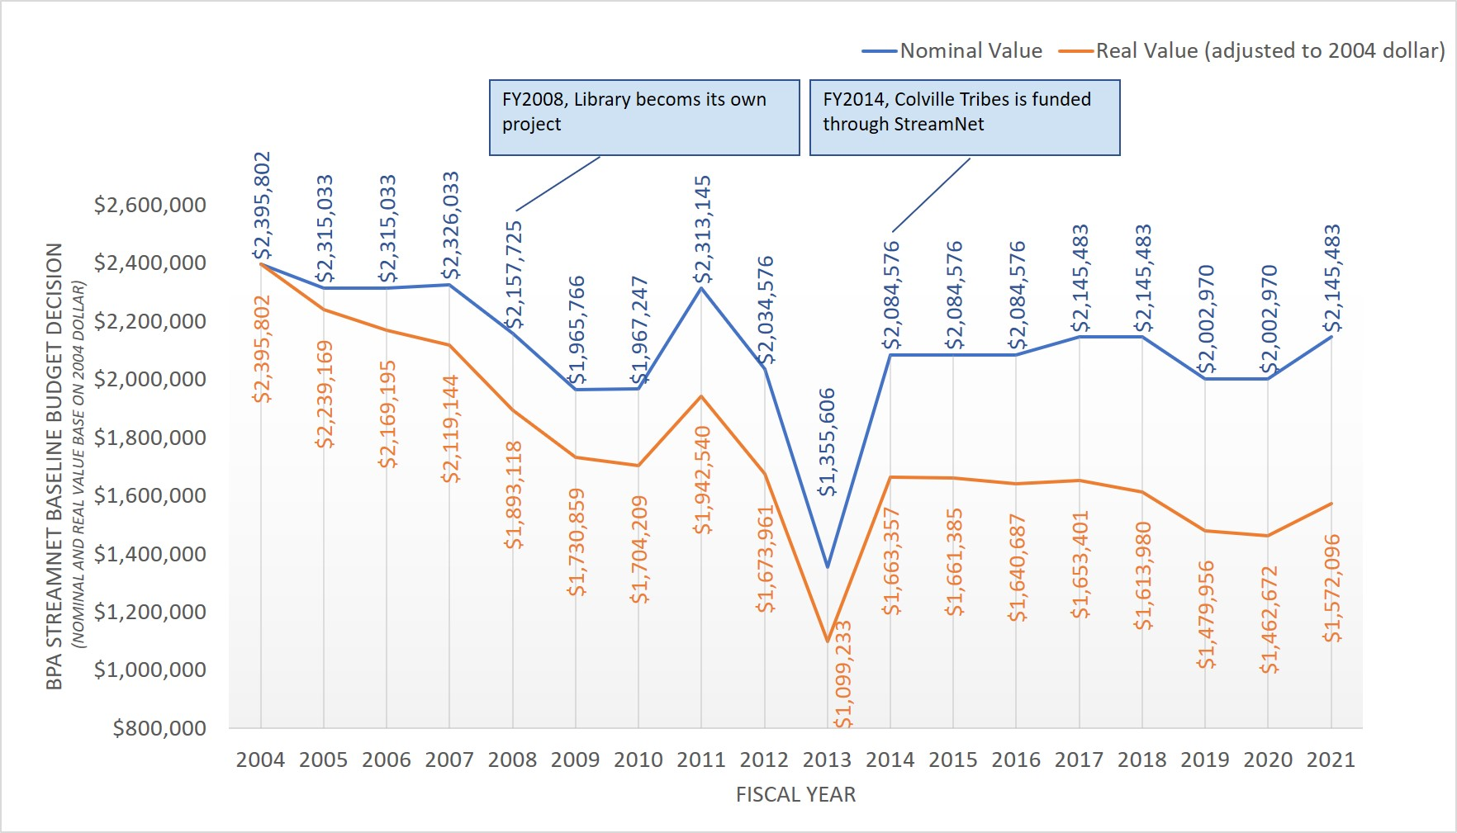
Figure 3: The above budget provides funding (partial to full time equivalent) to PSMFC staff and data stewards within state and tribal partners. Depending on the year the budget may also include funding for additional subcontracts to advance data sharing capacity and data access such as with CRTIFC member tribes and Upper Snake River Tribes Foundation member tribes.

Acronyms

Abbreviation | Full
Basin | Columbia River Basin
BPA | Bonneville Power Administration
CAP | Coordinated Assessments Partnership
CAX | Coordinated Assessments Exchange
Colville Tribes | Confederated Tribes of the Colville Reservation
CRITFC | Columbia River Inter-Tribal Fish Commission
DDT | CAP Data Exchange Standard Development Team
DES | Data exchange standards
FW-Program | Columbia River Basin Fish and Wildlife Program
HEP | Habitat Evaluation Procedures
HSRG | Hatchery Scientific Review Group
IDFG | Idaho Department of Fish and Game
ITMD | Inter-Tribal Monitoring Data
MFWP | Montana Fish, Wildlife & Parks
NOAA-F | National Oceanic and Atmospheric Administration Fisheries
NPCC | Northwest Power and Conservation Council
ODFW | Oregon Department of Fish and Wildlife
PNAMP | Pacific Northwest Aquatic Monitoring Partnership
PSMFC | Pacific States Marine Fisheries Commission
SN ExCom | StreamNet Executive Committee
SN SC | StreamNet Steering Committee
TOAST | Technical Outreach and Assistance to Subbasins Team
USFWS | US Fish and Wildlife Service
WDFW | Washington Department of Fish and Wildlife

StreamNet Committee Members

Members serving as of calendar year 2020. Membership may change and will be reflected on the StreamNet website and annual project progress report to BPA.

StreamNet Executive Committee
Members | Affiliation
Randy Fisher (Chair) and Stan Allen | PSMFC
Zachery (Zach) Penney | CRITFC
Patty O’Toole | NPCC
Jeff Lane (Rodrigo George) and Jody Lando | BPA
Greg Sieglitz | NOAA-Fisheries
Tom Stahl and Art Martin | ODFW
Dan Rawding | WDFW
Lance Hebdon | IDFG
Don Skaar | MFWP
John Arterburn | Colville Tribes
Roy Elicker (retired 2020) | USFWS

StreamNet Steering Committee
Members | Affiliation
Nancy Leonard (Chair) | PSMFC
Denise Kelsey and Tami Wilkerson  (Denise Kelsey replaced Colleen Roe in Feb. 2020) | CRITFC
Mark Fritsch | NPCC
Tom Pansky, Russell Scranton, and Matt Schwartz | BPA
Mari Williams | NOAA-Fisheries
Cedric Cooney | ODFW
Brodie Cox | WDFW
Angie Schmidt and Evan Brown | IDFG
Dawn Anderson | MFWP
George Batten | Sitka Tech representing Colville Tribes
Doug Threloff | USFWS
Jen Bayer | PNAMP

Pacific States Marine Fisheries Commission
205 S.E. Spokane Street, Suite 100
Portland, Oregon 97202-6487
Ph: 503.595.3100
Fax: 503.595.3232

www.psmfc.org

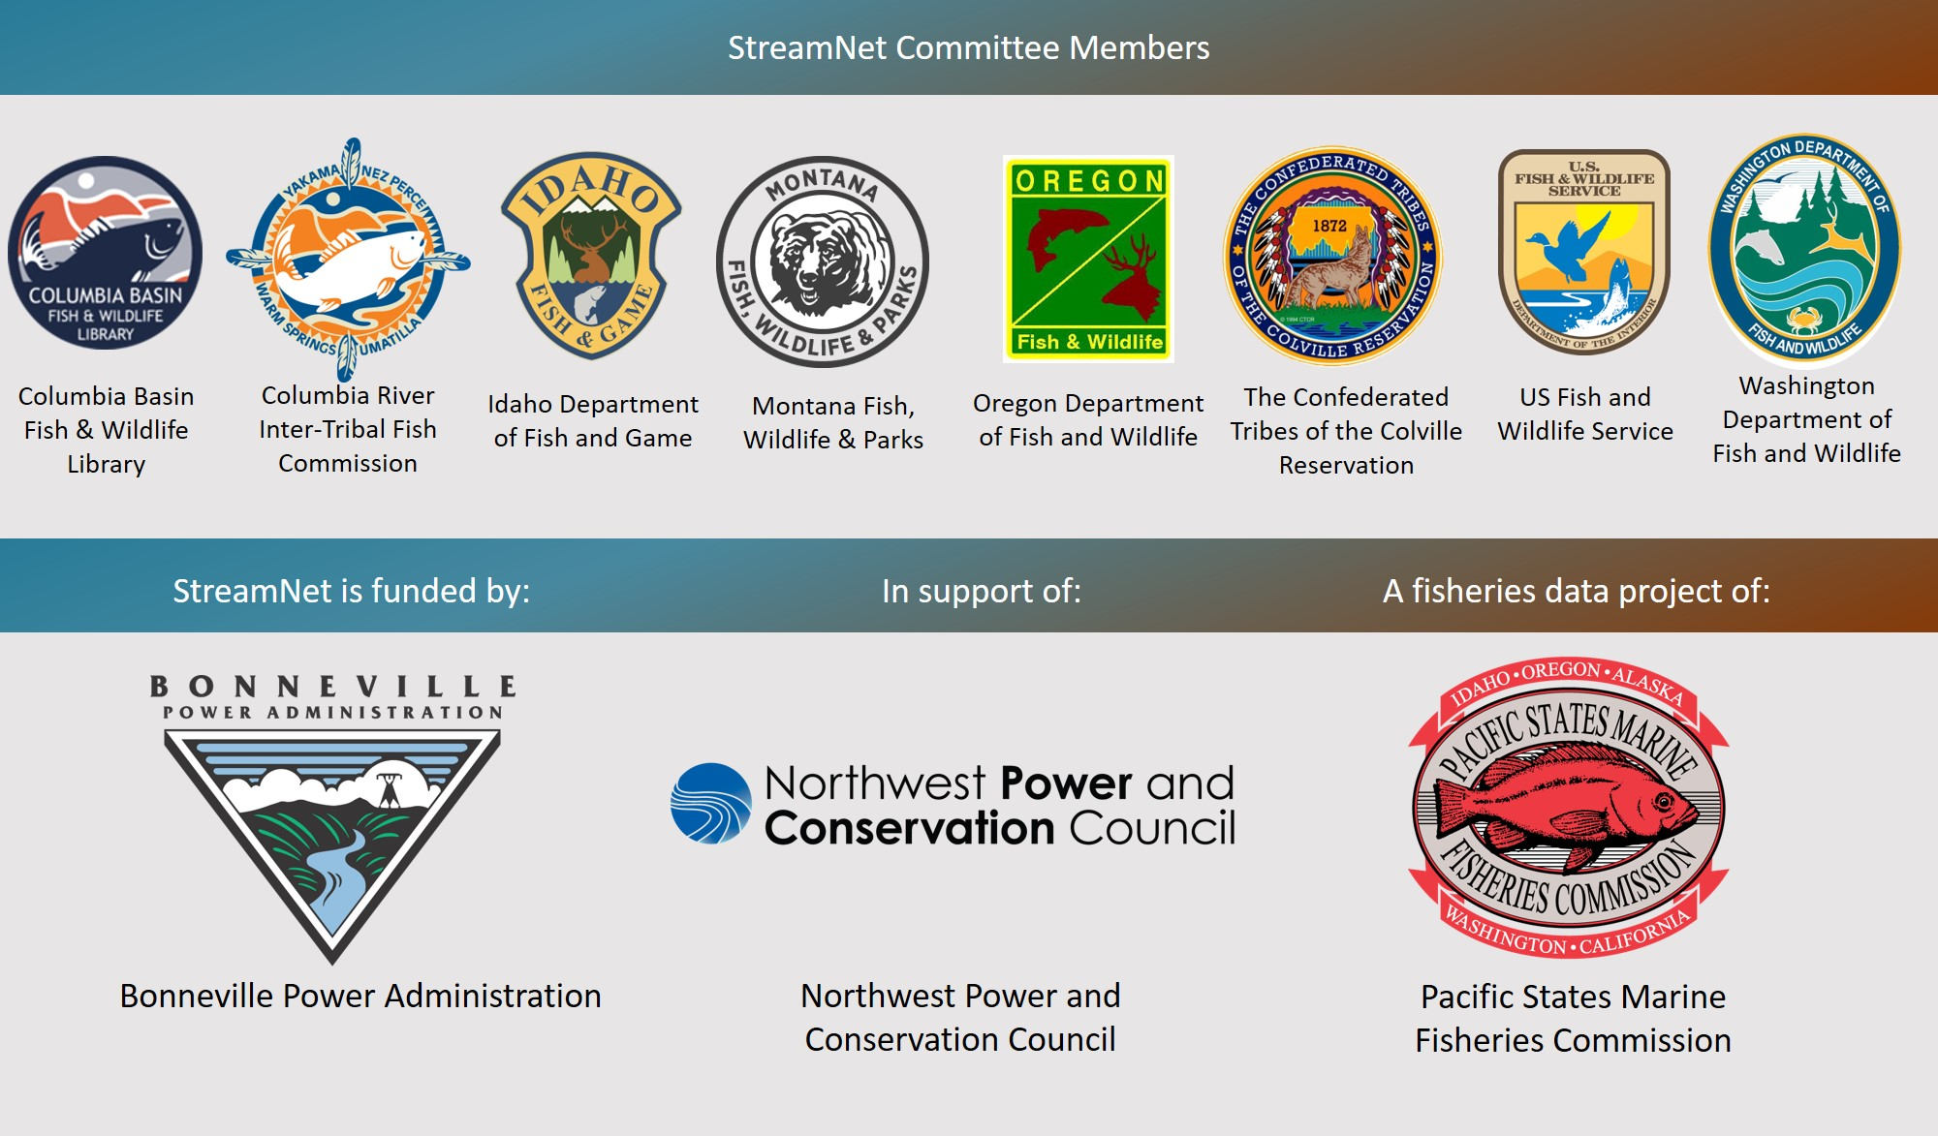

Northwest Environmental Database integrated data from the Hydro Assessment Study, specifically data from the Northwest Hydropower Database and Analysis System, and Pacific Northwest Rivers Study.
Annual StreamNet budget provided by BPA https://www.cbfish.org/ProjectBudget.mvc/ProjectBudget/1988-108-04).
Annual cost share reported to BPA and received from 3 to 13 of the following entities depending on the year: CRITFC, IDFG, MFWP, NOAA, ODFW, Oregon Department of Transportation, Oregon Watershed Enhancement Board, PSMFC, State of Oregon, US Bureau of Land Management, US Bureau of Reclamation, USFWS< USGS, and WDFW https://www.cbfish.org/ProjectCostShare.mvc/ManageProjectCostShare/1988-108-04

